MINISTRY OF EDUCATION
P.O. Box 97, Rarotonga, Cook Islands

Government of the Cook Islands
Phone: (682) 29 - 357 Fax: (682) 28 - 357

POSITION DESCRIPTION

Position Title: | System Administrator (Learning & Student Management)
Division: | Corporate & Operational Services
Responsible To: | Senior Systems Officer
Responsible For: | -
Job Purpose: | To support schools and educators in effectively using technology for teaching, learning, and equitable access across the education system. The Adminsitrator provides in-school, virtual, and group-based professional learning and coaching to enhance digital capability, blended learning practice, and student engagement. A key focus of this role is to improve access to quality learning for students in remote and Pa Enua schools through digital platforms and learning tools. This role does not focus on disability or assistive technologies but supports system-wide digital learning equity and innovation.
Job classification:
Date: | April 2025

MINISTRY VISION:

Akamatutuanga i te au karape, kite, te tu tangata e te irinakianga o te iti tangata Kuki Airani kia rauka ia ratou i taangaanga i ta ratou au tareni ki roto i to ratou oraanga.

Building the skills, knowledge, attitudes, and values of Cook Islanders to put their capabilities to best use in all areas of their lives.

ORGANISATION CHART:

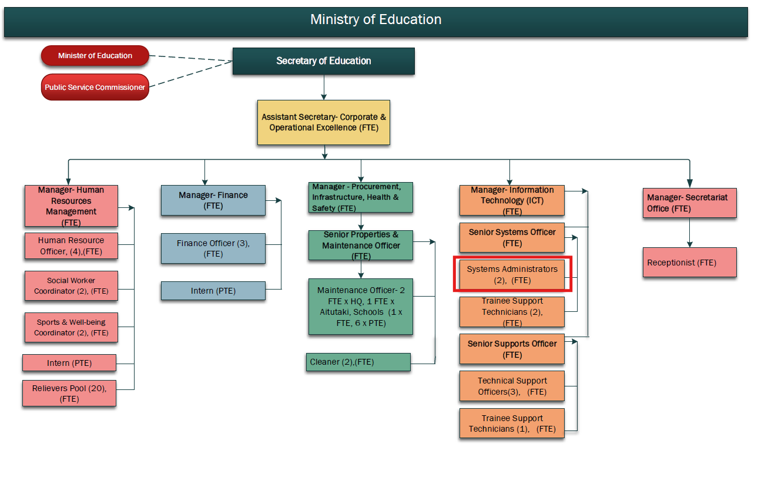

KEY RESULTS AREA:

K.R.A | Key Performance Indicators
1. Digital Pedagogy Support  Build teacher capability in integrating digital tools into teaching and learning. | - Teachers demonstrate increased confidence and use of digital platforms;  - Improved learner engagement; feedback reflects growth.
2. Technology-Enhanced Learning Models  Support schools to implement blended, flipped, or remote learning approaches. | - Schools trial and adopt models suited to context;  - Increased access for Pa Enua learners;  - Positive student learning outcomes
3. Access and Infrastructure Guidance  Work with schools and the Ministry to identify and resolve access and connectivity issues | - Connectivity or access plans in place;  - Hardware/software solutions supported;  - Access gaps reduced.
4. Learning Platform Support and Training  Provide support and training for the use of learning management systems (e.g., Google Classroom, Moodle, etc.). | - Teachers and students actively using platforms;  - System logins and usage increase;  - Troubleshooting support delivered.
5. Resource Development and Curation  Create and curate digital teaching resources that align with curriculum goals and local context. | - Resources developed and shared on national platforms;  - Teacher contributions encouraged;  - Quality and relevance maintained
6. Support for Pa Enua Access Equity  Support island schools in implementing digital solutions that overcome geographic barriers. | - Pa Enua teachers receive regular support;  - Students engage in digital learning;  - Access data monitored and improved.

WORK COMPLEXITY:

Indicate Most challenging duties typically undertaken:
1 | Supporting schools with limited digital infrastructure to implement meaningful technology-enabled learning.
2 | Coaching teachers with a wide range of digital confidence levels, including in multi-level and remote classrooms.
3 | Designing practical, culturally relevant digital learning models that suit Cook Islands learning environments.
4 | Coordinating with IT infrastructure teams while maintaining a learning focus.
5 | Managing time and resources across multiple islands with different needs and readiness levels.

AUTHORITY:
Authority levels expressed in terms of routine expenditure, granting loans, and recruiting and dismissing staff. (Explain the authority if any)

Financial | Nil (Senior Systems Officer in preparing a budget for area of responsibility, sourcing / ordering of relevant resources).
Staff | Nil
Contractual | Nil

FUNCTIONAL RELATIONSHIPS:
The requirement for human relations skills in dealing with other personnel and external contacts. (List the external and internal types of functional relationships)

Internal | Nature of Contact | External | Nature of Contact
Senior Systems Officer | Planning, supervision, and reporting | Internet Service Providers / Tech Vendors | Technical liaison for Pa Enua access or device setup
School Principals and Teachers | Capacity-building, coaching, and professional learning | Regional EdTech providers / Partners | Sharing best practices and accessing professional support
Digital Infrastructure / IT Teams | Coordination for access, connectivity, and device support | Pa Enua communities | Supporting school-family connectivity and awareness
Curriculum and Learning Facilitators | Collaboration to integrate digital tools into core subjects
Quality Assurance Team | Contributing to digital learning indicators and school review follow-ups
Manager – Inclusive Education | Planning, supervision, and reporting

QUALIFICATION:

Level of education required to perform the functions required of the position. This combines formal and informal levels of training and education.

Essential: (least qualification to be competent) | Desirable: (specific qualification for job)
- Teaching qualification (Bachelor of Education or equivalent)  - Experience integrating digital tools into classroom practice  - Confidence using learning platforms (e.g., Google Workspace, Zoom, Microsoft Teams, etc.) | - Training in digital learning, e-learning, or instructional design  - Familiarity with blended/online learning models and tools  - Experience supporting remote or Pa Enua-based schools

Knowledge / Experience
The length of practical experience and nature of specialist or managerial familiarity required. This experience is in addition to formal education.

Essential: (least number of years to be competent) | Desirable: (target number of years you are looking for)
- Minimum 3 years of classroom teaching experience  - Strong digital literacy and confidence with education technology  - Experience providing peer support or PLD in technology or curriculum integration | - Experience developing digital teaching resources or videos  - Knowledge of online safety, digital citizenship, and appropriate use policies  - Familiarity with access challenges in remote island education

Key Skills /Attribute / Behaviours

Level of ability required for the job
Expert:
Advanced | Digital Learning and Platform Use | Uses and supports others to use digital platforms for teaching, collaboration, and student learning.
 | Teacher Coaching and Facilitation | Builds capability through personalised coaching, modelling, and group facilitation.
Working | Connectivity and Access Problem Solving | Understands how to identify and troubleshoot access or infrastructure issues in school contexts.
 | Blended and Remote Learning Design | Supports flexible delivery models suitable for learners across diverse environments.
 | Curriculum Integration | Ensures digital tools enhance—not replace—quality curriculum delivery.
Awareness: | Cultural and Contextual Relevance | Adapts technology use to reflect Cook Islands values, language, and learning environments.

Approved:

Head of Ministry – Secretary of Education Date

Employee Date

