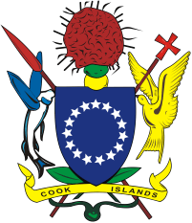

**PALMERSTON ISLAND GOVERNMENT**

**Palmerston Island Administraton**

**PALMERSTON ISLAND OFFICE: Phone 37620.** Email; [palmerstonoffice@gmail.com](mailto:palmerstonoffice@gmail.com)

**PRINCIPAL: PALMERSTON ISLAND LUCKY SCHOOL**

Applications are invited from qualified, experienced, and motivated principals with the relevant qualifications, vision and proven leadership for the position of principal of Palmerston Island Lucky School to start in January 2025.

Applications close on **Friday 20th December 2024** at 3.00pm. Application packs are available from the Palmerston Island Administration and completed forms with CV and references should be sent to:

Executive Officer

Palmerston Island Administration

Palmerston Island

Cook Islands

Ph (682) 37620 or email: [**palmerstonoffice@gmail.com**](mailto:palmerstonoffice@gmail.com)