

**MINISTRY OF EDUCATION**

**P.O. Box 97, Rarotonga, Cook Islands**

**Government of the Cook Islands**

**Phone: (682) 29 - 357 Fax: (682) 28 - 357**

**POSITION DESCRIPTION**

|  |  |
| --- | --- |
| **Position Title:** | **Manager – Early Childhood Education (ECE)** |
| **Division:** | Learning and Educational Excellence |
| **Responsible To:** | Assistant Secretary – Learning and Educational Excellence |
| **Responsible For:** | 3 x FTE staff- ECE Facilitators (2), parenting Programme Coordinator (1) |  |
| **Job Purpose:** | To lead the development, implementation, and monitoring of quality Early Childhood Education (ECE) across the Cook Islands. The Manager – ECE is responsible for ensuring the delivery of inclusive, culturally responsive, and developmentally appropriate ECE programmes aligned with national standards, the Education Masterplan 2024–2034, and the Statement of Intent 2024–2027. The role leads curriculum development, teacher capability building, quality assurance, and strategic partnerships to improve ECE access, participation, and outcomes for all children, especially in Pa Enua. |  |
| **Job classification:** |  |  |
| **Date:** | 08 May 2025 |  |

**MINISTRY VISION:**

Akamatutuanga i te au karape, kite, te tu tangata e te irinakianga o te iti tangata Kuki Airani kia rauka ia ratou i taangaanga i ta ratou au tareni ki roto i to ratou oraanga.

Building the skills, knowledge, attitudes, and values of Cook Islanders to put their capabilities to best use in all areas of their lives.

**ORGANISATION CHART:**

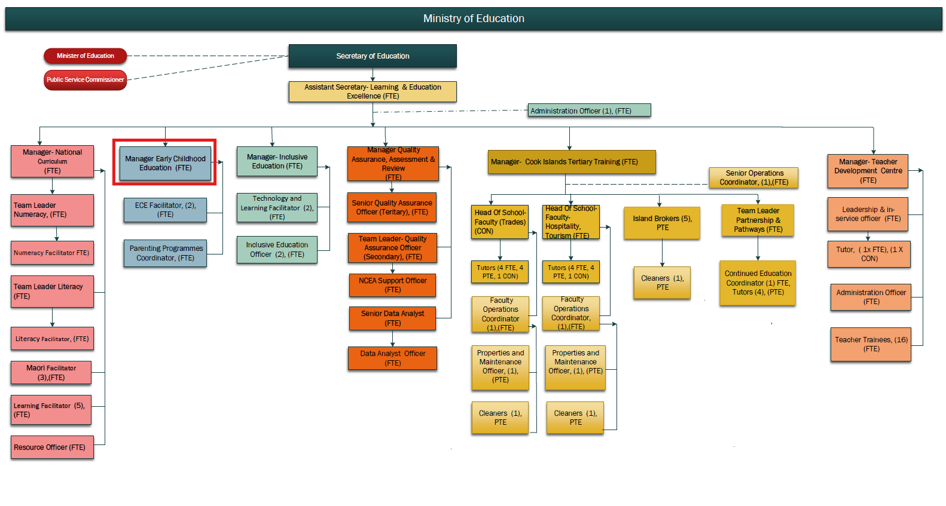

**KEY RESULTS AREA:**

|  |  |
| --- | --- |
| ***K.R.A*** | ***Key Performance Indicators*** |
| **KRA1: ECE System Development** Lead the establishment and implementation of a national ECE curriculum framework and system. | * National ECE curriculum finalised and implemented; * strong alignment with child development milestones; * stakeholder endorsement. |
| **KRA 2: Teaching and Learning Quality** Strengthen ECE teacher capability and pedagogy through professional learning and resource support. | * PLD delivered across all providers; * improved teacher competency and practice; * child progress data shows improvement. |
| **KRA 3: Inclusion and Holistic Development** Promote inclusive ECE practices that support the cognitive, social, emotional, physical, and language development of all children. | * Inclusive practices evident in teaching; * increased engagement of children with additional needs; * positive parental feedback. |
| **KRA 4: Cultural Identity and Language in ECE** Ensure that Māori language and cultural identity are embedded as the language of instruction in all early learning environments. | * Cook Islands Māori is visible and used in daily routines; * cultural activities integrated in ECE delivery; * language revitalisation targets supported. |
| **KRA 5: Quality Assurance and Regulation** In conjunction with PDI team, develop and enforce national standards for ECE provision and conduct quality assurance visits. | * Standards developed, approved, and monitored; * regular quality assurance visits completed; * compliance rates increase. |
| **KRA 6: Community Engagement and Access** Work with communities, churches, and private providers to improve ECE access and parent participation, especially in Pa Enua. | * Increased enrolment and participation; * improved attendance; * new ECE services established in underserved areas. |
| **KRA 7: Team Leadership and Performance Management** Provide effective leadership, supervision, and performance management of staff within the ECE team to ensure a high-performing, collaborative, and accountable culture. | * Staff workplans and goals set and monitored; * regular performance conversations held; * professional development supported; positive team culture observed; * improvement actions taken where necessary. |

**WORK COMPLEXITY:**

|  |  |
| --- | --- |
| *Indicate Most challenging duties typically undertaken:* | |
| 1 | Leading system-wide ECE reform and curriculum development in alignment with national goals. |
| 2 | Supporting diverse and geographically dispersed providers with varied capacity. |
| 3 | Promoting inclusive and culturally grounded practice across all ECE settings. |
| 4 | Managing change while maintaining relationships with churches, NGOs, and community groups delivering ECE. |
| 5 | Addressing teacher shortages, training gaps, and capacity-building across Pa Enua and Rarotonga |
| 6 | * Managing performance, morale, and professional development of a multi-skilled team working across various locations and contexts. |

**AUTHORITY:**

Authority levels expressed in terms of routine expenditure, granting loans, and recruiting and dismissing staff. (*Explain the authority if any*)

|  |  |
| --- | --- |
| **Financial** | Will be supporting the Assistant Secretary of Learning in monitoring the divisional budget. |
| **Staff** | Yes, Supervision of staff, including in managing the work plan and performance of staff responsible to directly. |
| **Contractual** | Nil |

**FUNCTIONAL RELATIONSHIPS:**

The requirement for human relations skills in dealing with other personnel and external contacts. *(List the external and internal types of functional relationships)*

|  |  |  |  |
| --- | --- | --- | --- |
| Internal | Nature of Contact | External | Nature of Contact |
| Assistant Secretary – LEE | Direction and reporting | ECE Providers (Public, Private, Church) | Support, compliance, curriculum and capacity-building |
| National Curriculum and Literacy Teams | Alignment of early years curriculum and pedagogy | Parents, Caregivers, Communities | Engagement, consultation, and outreach |
| Inclusive Education Team | Joint support for children with additional needs | House of Ariki / Churches | Partnering on cultural and language revitalisation |
| Teacher Development Centre | Support for pre-service and in-service ECE training | Pa Enua Island Councils | Planning and support for rural and remote ECE delivery |
| Policy and Innovation Team | Alignment with ECE policy and early childhood research | International Partners | Technical assistance, funding, and capacity-building |

**QUALIFICATION:**

###### Level of education required to perform the functions required of the position. This combines formal and informal levels of training and education.

|  |  |
| --- | --- |
| **Essential: (least qualification to be competent)** | **Desirable: (specific qualification for job)** |
| * Bachelor’s degree in Early Childhood Education or Education. * Extensive experience in ECE teaching and leadership. * Current or eligible Cook Islands Teacher Registration. | * Postgraduate qualification in Educational Leadership, Early Childhood Policy, or Curriculum Development. * Training or experience in inclusive education or bilingual education. |

**Knowledge / Experience**

The length of practical experience and nature of specialist or managerial familiarity required. This experience is in addition to formal education.

|  |  |
| --- | --- |
| **Essential: (least number of years to be competent)** | **Desirable: (target number of years you are looking for)** |
| * At least 5 years of experience in ECE teaching, coordination, or system leadership * Proven ability to lead curriculum development and professional learning in early years * Strong understanding of child development and culturally responsive pedagogy * Experience supporting quality assurance or compliance in educational settings | * Experience working with church and community-based providers * Familiarity with Pacific or indigenous early childhood education frameworks * Knowledge of bilingual or immersion approaches in early learning |

**Key Skills /Attribute / Behaviours**

|  |  |
| --- | --- |
| **Level of ability required for the job** |  |
| **Expert** | * ECE Leadership: Demonstrated leadership in early years curriculum, pedagogy, and professional development. |
| **Advanced** | * Strategic Programme Planning: Ability to lead and monitor national initiatives and implement systemic improvements. * Communication and Stakeholder Engagement: Strong skills in building trust, delivering messaging, and partnering with providers and communities. |
| **Working:** | * Communication and Stakeholder Engagement: Strong skills in building trust, delivering messaging, and partnering with providers and communities. * Cultural Responsiveness: Application of language, culture, and values in early learning practice. |
| **Awareness** | * Digital and Blended Learning: Understanding of how digital tools can be used to support early childhood education. |

**Approved:**

Head of Ministry – Secretary of Education Date

Employee Date