

**MINISTRY OF EDUCATION**

**P.O. Box 97, Rarotonga, Cook Islands**

**Government of the Cook Islands**

**Phone: (682) 29 - 357 Fax: (682) 28 - 357**

**POSITION DESCRIPTION**

|  |  |
| --- | --- |
| **Position Title:** | **Manager – Inclusive Education** |
| **Division:** | Learning and Educational Excellence |
| **Responsible To:** | Assistant Secretary – Learning and Educational Excellence |
| **Responsible For:** | 4 x FTE staff (2x Inclusive Education Facilitators and 2 x Technology & Learning Facilitator) |  |
| **Job Purpose:** | To lead and coordinate the Ministry’s Inclusive Education strategy, ensuring that all learners—particularly those with diverse learning needs, disabilities, or barriers to education—can access and participate in quality learning experiences across all levels. This includes responsibility for overseeing the integration of technology-enabled learning solutions that promote equity, especially for learners in the Pa Enua. The Manager leads staff, collaborates across agencies, and strengthens inclusive teaching practice, access systems, and learner wellbeing support services aligned with national goals. |  |
| **Job classification:** |  |  |
| **Date:** | 15 May 2025 |  |

**MINISTRY VISION:**

Akamatutuanga i te au karape, kite, te tu tangata e te irinakianga o te iti tangata Kuki Airani kia rauka ia ratou i taangaanga i ta ratou au tareni ki roto i to ratou oraanga.

Building the skills, knowledge, attitudes, and values of Cook Islanders to put their capabilities to best use in all areas of their lives.

**ORGANISATION CHART:**

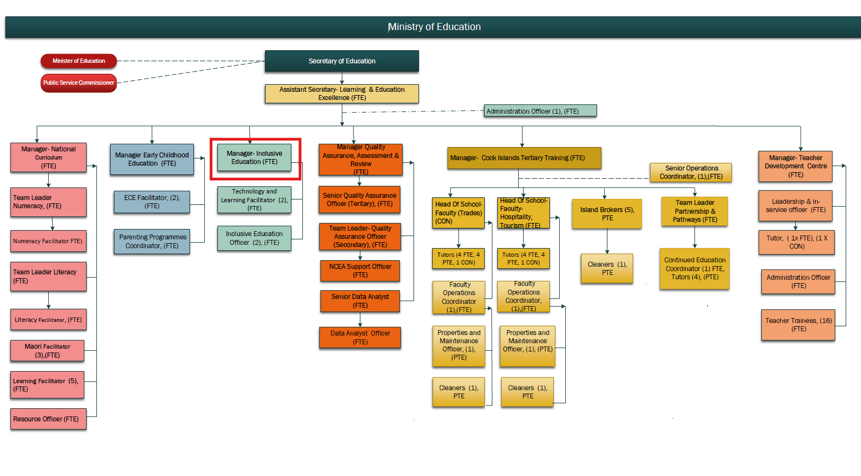

**KEY RESULTS AREA:**

|  |  |
| --- | --- |
| ***K.R.A*** | ***Key Performance Indicators*** |
| **KRA 1: Inclusive Education Strategy and Implementation** Lead the development and delivery of an inclusive education framework that supports equitable learning for all | * Strategy finalised and implemented; * inclusive practice embedded in schools; * increased learner participation and achievement. |
| **KRA 2: Specialist Learner Support Systems and Access Tools** Coordinate inclusive support systems and ensure access through technology-enabled learning platforms, especially for Pa Enua learners. | * Digital access tools rolled out; * schools in remote locations supported; * improvement in learner participation and engagement in Pa Enua contexts. |
| **KRA 3: Educator Capability Building** Design and implement professional learning programmes to equip teachers and leaders with inclusive strategies | * Workshops and PLD delivered; * improved teacher confidence and classroom practices; * reduction in referrals. |
| **KRA 4: Partnerships with Families and Agencies** Strengthen partnerships with parents, caregivers, and service providers to support wraparound learner support | * Collaboration agreements in place; * increased parent engagement; * cross-agency case support delivered. |
| **KRA 5: Inclusion Monitoring and Reporting** Monitor inclusion indicators across schools and use data to inform ongoing improvements. | * Data collected and analysed; regular reporting shared; * responsive programme adjustments made. |
| **KRA 6: Advocacy and System Change** Promote a shift toward inclusive mindsets across the education sector | * Schools adopt inclusive language and practice; * public campaigns and resources developed; * visible commitment to equity. |
| **KRA 7: Staff Leadership and Performance Management** Lead, support, and manage Inclusive Education Facilitators to ensure high-quality delivery and accountability | * Staff workplans and reviews completed; * collaborative team culture fostered; * performance aligned to outcomes. |
| **KRA 8: Inclusive Digital Learning and Technology Access**  Lead the development and deployment of digital learning tools and assistive technologies that remove barriers to learning, particularly for remote and underserved learners | * Technology-enabled learning options available across islands; * assistive tools trialled and evaluated; * improved access and achievement for target groups. |

**WORK COMPLEXITY:**

|  |  |
| --- | --- |
| *Indicate Most challenging duties typically undertaken:* | |
| 1 | Leading system-wide change in attitudes and practices around inclusion and learner diversity. |
| 2 | Supporting schools to integrate technology and assistive tools in a way that complements inclusive teaching practice. |
| 3 | Working across sectors (health, disability, social welfare) to coordinate individualised support. |
| 4 | Balancing pedagogical, technical, and equity considerations in the rollout of remote and blended learning platforms. |
| 5 | Ensuring consistency of support in Pa Enua settings where access to specialist services is limited. |

**AUTHORITY:**

Authority levels expressed in terms of routine expenditure, granting loans, and recruiting and dismissing staff. (*Explain the authority if any*)

|  |  |
| --- | --- |
| **Financial** | Will be supporting the Assistant Secretary of Learning in monitoring the divisional budget. |
| **Staff** | Yes, Supervision of staff, including in managing the work plan and performance of staff responsible to directly. |
| **Contractual** | Nil |

**FUNCTIONAL RELATIONSHIPS:**

The requirement for human relations skills in dealing with other personnel and external contacts. *(List the external and internal types of functional relationships)*

|  |  |  |  |
| --- | --- | --- | --- |
| Internal | Nature of Contact | External | Nature of Contact |
| Assistant Secretary – LEE | Strategy alignment, reporting, leadership input | School Principals and Teachers | Inclusive practice support, referrals, PLD |
| Inclusive Education Facilitators | Supervision, coaching, programme delivery | Parents, Whānau, and Caregivers | Consultation, advocacy, shared support planning |
| Curriculum and Teaching Teams | Collaborative support in inclusive curriculum implementation | Ministry of Health, NGOs, and Disability Services | Joint support, referral networks, funding opportunities |
| QA and Review Team | Data sharing and post-review support for schools | Counsellors / Social Support Workers | Collaborative support for learner wellbeing and engagement |
| ECE and Pa Enua Teams | Ensuring inclusive education reaches all islands and ages |  |  |
| IT and Digital Learning Teams | Collaboration on inclusive tech access, remote learning tools, and device deployment |  |  |

**QUALIFICATION:**

###### Level of education required to perform the functions required of the position. This combines formal and informal levels of training and education.

|  |  |
| --- | --- |
| **Essential: (least qualification to be competent)** | **Desirable: (specific qualification for job)** |
| * Bachelor’s degree in Education, Special Education, or related field * Demonstrated experience in learner support, inclusion, or educational leadership * Current or eligible Cook Islands Teacher Registration | * Postgraduate qualification in Inclusive Education, Educational Psychology, or Leadership * Formal training in learner support coordination, case management, or SENCO roles * Experience working in the Pacific or in cross-sector social development environments |

**Knowledge / Experience**

The length of practical experience and nature of specialist or managerial familiarity required. This experience is in addition to formal education.

|  |  |
| --- | --- |
| **Essential: (least number of years to be competent)** | **Desirable: (target number of years you are looking for)** |
| * At least 5 years in education, with experience supporting students with additional learning needs * Knowledge of inclusive pedagogy, Universal Design for Learning (UDL), and learner support frameworks * Experience delivering PLD or coaching for educators * Familiarity with whole-school inclusion strategies and cross-agency collaboration. | * Knowledge of monitoring tools, learner data analysis, and reporting systems * Understanding of Cook Islands Māori values and cultural views on disability and inclusion * Prior experience working with Pa Enua schools and communities. |

**Key Skills /Attribute / Behaviours**

|  |  |
| --- | --- |
| **Level of ability required for the job** |  |
| **Expert:** | * Inclusive Education Leadership; * Leads system change to embed inclusive practice across the education sector. |
| **Advanced:** | * Staff Supervision and Coaching; * Effectively manages and supports a team of facilitators to achieve strategic goals. |
|  | * Interagency Collaboration * Navigates relationships across government and community to provide wraparound learner support. |
|  | * Professional Learning Design * Develops and delivers impactful teacher development in inclusive strategies. |
|  | * Leads strategies to ensure equitable access to learning through technology, especially for underserved schools and learners. * Digital Equity and Remote Access. |
| **Working:** | * Uses data to monitor learner progress and inform targeted support; * Data-Informed Practice; * Understands how to implement and support the use of learning technologies for students with specific needs. |
| **Awareness:** | * Understands the cultural dimensions of learner identity and inclusive practice. |

**Approved:**

Head of Ministry – Secretary of Education Date

Employee Date