

**MINISTRY OF EDUCATION**

**P.O. Box 97, Rarotonga, Cook Islands**

**Government of the Cook Islands**

**Phone: (682) 29 - 357 Fax: (682) 28 - 357**

**POSITION DESCRIPTION**

|  |  |
| --- | --- |
| **Position Title:** | Manager – National Curriculum |
| **Division:** | Learning & Educational Excellence (Te Mato 1) |
| **Responsible To:** | Assistant Secretary – Learning & Educational Excellence |
| **Responsible For:** | 13 FTE staff - Team Leader Numeracy, Team Leader Literacy, Maori Facilitator (3), Learning Facilitators (7), Resource Officer |  |
| **Job Purpose:** | To lead the implementation and delivery of the national curriculum across schools, ensuring its practical application drives measurable improvements in learner outcomes. The role focuses on embedding inclusive, relevant, and culturally responsive curriculum content into classroom teaching, supporting educators through professional learning and guidance, and aligning curriculum delivery with the Ministry’s strategic focus on literacy, numeracy, and holistic student development. This position plays a central role in ensuring curriculum frameworks directly support quality teaching and learning in all schools. |  |
| **Job classification:** | Band J |  |
| **Date:** | 03 April 2025 |  |

**MINISTRY VISION:**

Akamatutuanga i te au karape, kite, te tu tangata e te irinakianga o te iti tangata Kuki Airani kia rauka ia ratou i taangaanga i ta ratou au tareni ki roto i to ratou oraanga.

Building the skills, knowledge, attitudes, and values of Cook Islanders to put their capabilities to best use in all areas of their lives.

**ORGANISATION CHART:**

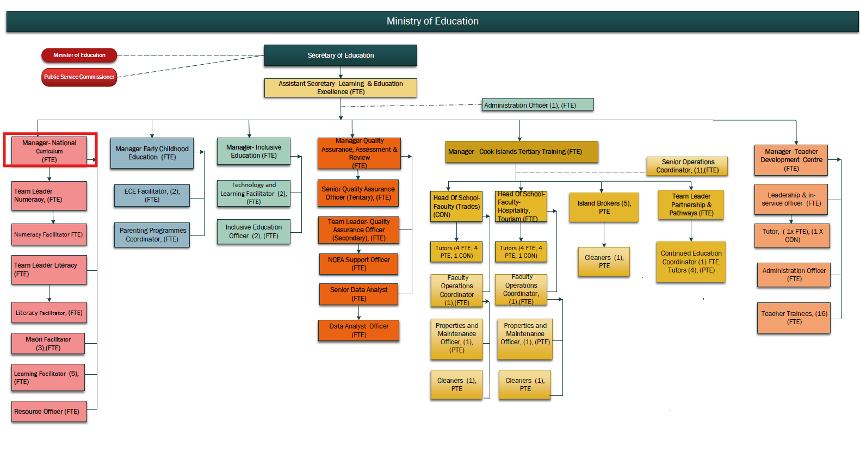

**KEY RESULTS AREA:**

|  |  |
| --- | --- |
| ***K.R.A*** | ***Key Performance Indicators*** |
| **KRA 1: Curriculum Design and Development**   1. Lead the national curriculum refresh to reflect learner progressions, cultural identity, inclusive practices, and relevance to local and global contexts. 2. Develop and maintain curriculum frameworks and key stage learning outcomes from ECE to secondary levels. 3. Ensure cross-curricular integration and vertical alignment of learning expectations. | * A national curriculum framework is refreshed and finalised, incorporating learner progressions and reflecting Cook Islands identity, inclusive practices, and global relevance. * Key stage learning outcomes for ECE to secondary levels are clearly defined, communicated, and used consistently across schools. * Curriculum materials are vertically and horizontally aligned and regularly updated based on school feedback and student achievement data. * Subject pathways, including STEM and literacy/numeracy progression, are well-articulated within the national curriculum. |
| **KRA 2: Implementation and Support**   1. Provide implementation guidance and support materials for schools and teachers. 2. Collaborate with the Teacher Development Centre to deliver targeted professional learning. 3. Ensure all curriculum rollouts are supported by measurable success indicators. | * All curriculum documents are supported by clear implementation guidelines and teaching resources for use in classrooms. * A programme of ongoing professional development is delivered annually in partnership with the Teacher Development Centre to build educator capacity in curriculum delivery. * Implementation plans are co-designed with schools and Pa Enua communities to ensure contextual relevance. * Curriculum rollout effectiveness is monitored, with school-level support provided where implementation gaps are identified. |
| **KRA 3: Curriculum Quality Assurance**   1. Work closely with the Quality Assurance team to monitor curriculum effectiveness and inform adjustments. 2. Align curriculum assessment components with national learning benchmarks and literacy/numeracy priorities. | * Curriculum effectiveness is reviewed annually using feedback from Quality Assurance, Assessment, and Learning teams, and adjustments are implemented accordingly. * Alignment between curriculum outcomes and national assessments (including e-Astle and NCEA) is maintained and strengthened. * Curriculum review reports and school feedback are compiled biannually to inform policy and programme refinements. * Evidence of improved learner outcomes (e.g., literacy and numeracy achievement) is linked to enhanced curriculum design and delivery. |
| **KRA 4: Cultural Integration and Inclusivity**   1. Integrate Cook Islands Māori language and indigenous knowledge into curriculum content. 2. Coordinate with the Manager – Language & Cultural Revitalisation to ensure appropriate cultural representation | * All curriculum documents reflect Cook Islands Māori values, language, and cultural content where appropriate. * Partnerships with the Manager – Language & Cultural Revitalisation are evident in joint development of culturally relevant content. * Culturally inclusive teaching guides and exemplars are available for all learning areas. * The curriculum supports equitable learning outcomes for students from diverse backgrounds, including those with additional needs. |
| **KRA 5: Collaboration and Stakeholder Engagement**   1. Lead stakeholder consultations, including educators, communities, and Aronga Mana. 2. Collaborate with other Ministry divisions to maintain policy and curriculum alignment without duplication | * Annual consultation cycles are completed with educators, Aronga Mana, churches, and island representatives to review curriculum progress and inform updates as required. * Collaboration with other divisions, particularly Policy & Innovation and Language & Culture, avoids duplication and ensures cohesion across planning and implementation. * Feedback loops with teachers and school leaders are formalised and used to refine content and delivery approaches. * Clear records of consultation processes, feedback received, and actions taken are maintained and reported annually |
| |  |  | | --- | --- | | **KRA 6: Monitoring and Continuous Improvement** |  |  |  |  | | --- | --- | | 1. Establish a process for regular curriculum review and feedback from schools, teachers, and quality assurance teams. |  |  |  |  | | --- | --- | | 1. Use assessment data, classroom observations, and educator insights to inform curriculum improvements. |  |  |  |  | | --- | --- | | 1. Support a culture of responsiveness and continuous improvement in curriculum delivery. |  |  |  | | --- | | 1. Ensure curriculum refinements lead to measurable improvements in learner achievement. | | * Annual curriculum review cycles are completed using data from assessments, classroom observations, and educator feedback. * Adjustments to curriculum are implemented in a timely and responsive manner based on evidence. * A feedback culture is fostered where teachers and schools actively contribute to improving curriculum relevance and impact. * Curriculum improvements directly correlate with measurable gains in learner achievement. |
| **KRA 7: Staff Management, Professional Development and Conduct**   * + 1. Lead, motivate, and develop a high-performing team, ensuring alignment with Ministry’s goals and objectives.     2. Ensure the completion of the performance appraisals when due for the responsible staff.     3. Willing to learn new skills and be up to date with current changes in NZ Curriculum. | * Develop and manage the work plan of the staff reporting directly. * Monitor team performance and resolve any conflicts or issues promptly to maintain a productive and harmonious work environment. * Performance is reviewed annually and development opportunities provided to enhance effectiveness. * Identify training needs and implement strategies to upskill team members. * Attendance at planned training (HRM training register). |

**WORK COMPLEXITY:**

|  |  |
| --- | --- |
| *Indicate Most challenging duties typically undertaken:* | |
| 1 | **Balancing curriculum coherence and flexibility** across multiple education levels (ECE to secondary) while ensuring cultural relevance, inclusivity, and academic rigour. |
| 2 | **Coordinating national curriculum implementation** across all islands, including Pa Enua, with varying levels of infrastructure, resources, and professional capacity. |
| 3 | **Responding to and integrating stakeholder feedback** (e.g., educators, cultural leaders, Aronga Mana, Policy division) into curriculum revisions without compromising national standards or timelines. |
| 4 | **Ensuring alignment between curriculum content and national assessment tools** (e.g., literacy, numeracy, NCEA, e-Asttle), and using data to inform continuous improvement. |
| 5 | **Working cross-divisionally** with Policy, Innovation, Language Revitalisation, Inclusive Education, and IT teams to ensure curriculum delivery is integrated with broader education reforms and system-wide changes. |

**AUTHORITY:**

Authority levels expressed in terms of routine expenditure, granting loans, and recruiting and dismissing staff. (*Explain the authority if any*)

|  |  |
| --- | --- |
| **Financial** | Will be supporting the Assistant Secretary of Learning in monitoring the divisional budget. |
| **Staff** | Yes, Supervision of staff, including in managing the work plan and performance of staff responsible to directly. |
| **Contractual** | Nil |

**FUNCTIONAL RELATIONSHIPS:**

The requirement for human relations skills in dealing with other personnel and external contacts. *(List the external and internal types of functional relationships)*

|  |  |  |  |
| --- | --- | --- | --- |
| Internal | Nature of Contact | External | Nature of Contact |
| Assistant Secretary – Learning & Educational Excellence | Direct reporting, strategic direction, and performance accountability | School Principals and Senior Teachers | Support for curriculum delivery, training needs, and classroom implementation |
| Manager – Inclusive Education | Collaboration to ensure curriculum is inclusive and accessible for all learners | Island Education Coordinators and Pa Enua School Leaders | Localised curriculum delivery, consultation, and feedback loops |
| Manager – Quality Assurance, Assessment & Review | Alignment between curriculum and national assessment standards and evaluation data | Aronga Mana, churches, cultural and language experts | Stakeholder input into curriculum relevance and cultural integrity |
| Māori Language Facilitators and Manager – Language & Cultural Revitalisation | Integration of cultural content, language revitalisation, and contextually relevant curriculum design | External curriculum specialists and consultants | Expert advice and review contributions during curriculum development and refresh |
| Teacher Development Centre | Coordination of professional learning and curriculum implementation support | Regional education agencies and networks | Sharing best practices, aligning with Pacific regional frameworks, and professional collaboration |
| Technology & Learning Facilitators | Integration of digital tools and content delivery aligned with curriculum design |  |  |
| Policy Development & Innovation Division | Coordination to ensure curriculum implementation reflects current and future policy directions |  |  |
| ECE and Learning Facilitators | Curriculum alignment and delivery support across early years and general education levels |  |  |
| Data & Evaluation Team | Use of assessment and performance data to guide curriculum refinement |  |  |

**QUALIFICATION:**

###### Level of education required to perform the functions required of the position. This combines formal and informal levels of training and education.

|  |  |
| --- | --- |
| **Essential: (least qualification to be competent)** | **Desirable: (specific qualification for job)** |
| * Bachelor’s degree in Education, Curriculum & Instruction, or a related field. * Registered or eligible for registration as a teacher in the Cook Islands. * Proven experience in curriculum development and delivery within a school or national education system. * Knowledge of inclusive education practices and culturally responsive pedagogy. | * Postgraduate qualification in Education, Curriculum Design, or Educational Leadership. * Training or experience in Pacific or indigenous curriculum models. * Familiarity with the New Zealand Curriculum and NCEA framework. * Knowledge of Cook Islands Māori language and culture |

**Knowledge / Experience**

The length of practical experience and nature of specialist or managerial familiarity required. This experience is in addition to formal education.

|  |  |
| --- | --- |
| **Essential: (least number of years to be competent)** | **Desirable: (target number of years you are looking for)** |
| * Minimum of 5 years of teaching experience, with at least 2 years in a curriculum development or education advisory role. * Demonstrated experience leading curriculum design, implementation, or review processes. * Strong understanding of learning progressions, assessment practices, and integration of cultural and inclusive elements. * Ability to lead projects, manage teams, and facilitate professional development.a | * Experience working across early childhood, primary, and secondary levels. * Previous experience working in or with Pa Enua schools. * Experience managing multi-stakeholder consultations or national-level initiatives. |

**Key Skills /Attribute / Behaviours**

|  |  |
| --- | --- |
| **Level of ability required for the job** |  |
| **Expert** | * **Curriculum Design and Educational Expertise** Demonstrated ability to lead the development, review, and implementation of curriculum across all education levels, ensuring alignment with cultural values, learner progressions, and inclusive practices. * **Commitment to Continuous Improvement** Strong focus on using monitoring, evaluation, and data insights to refine curriculum content and enhance student learning outcomes across the system |
| **Advanced** | * **Leadership and Team Coordination** Capable of guiding and motivating facilitators and cross-functional teams, coordinating project timelines, and ensuring curriculum objectives are delivered efficiently. * **Strategic Thinking and Problem Solving** Able to analyse complex educational challenges, respond to school and community feedback, and develop responsive, forward-thinking curriculum strategies. * **Communication and Consultation** Strong written and oral communication skills; able to lead stakeholder consultations and convert input into tangible improvements in curriculum design and delivery. * **Collaboration and Relationship Management** Builds and sustains effective working relationships with schools, Ministry divisions, cultural groups, and external partners to support successful curriculum implementation. |
| **Working:** | * **Cultural Competency** Respectful of Cook Islands Māori language, values, and traditions, and able to embed these into curriculum frameworks and teaching guidance in collaboration with cultural leaders. * **Digital Literacy** Comfortable using digital learning tools, platforms, and resources to support the delivery of modern curriculum content, and able to collaborate with IT specialists and facilitators to support schools. |
| **Awareness** | * **Emerging Educational Technologies**   Awareness of global trends in AI, adaptive learning, and curriculum innovation, with the ability to collaborate with relevant divisions for informed future integration (when relevant to context). |

**Approved:**

Head of Ministry – Secretary of Education Date

Employee Date