Government of the Cook Islands
Phone: (682) 29-357 Fax: (682) 28-357
MINISTRY OF EDUCATION
P O Box 97, Rarotonga, Cook Islands

POSITION DESCRIPTION

Position Title: | Tutor (Programmes): Accredited Programmes – NZQA/LCAG
Division: | Cook Islands Tertiary Training Institute
Responsible To: | Learning and Development Manager
Responsible For:
Job Purpose: | To provide quality and effective learning and teaching to students enrolled in a specific programme of study; including developing course and assessment materials relevant to industry in the Cook Islands ensuring.
Job Classification:
Date: | April 2021

MINISTRY VISION:

The Ministry of Education values the unique nature of the Cook Islands. We contribute to the effective governance of our country and are recognised as leaders in education throughout the region.

The Ministry of Education provides a dynamic and professional environment which promotes lifelong learning through the provision of quality services.

ORGANISATION CHART:
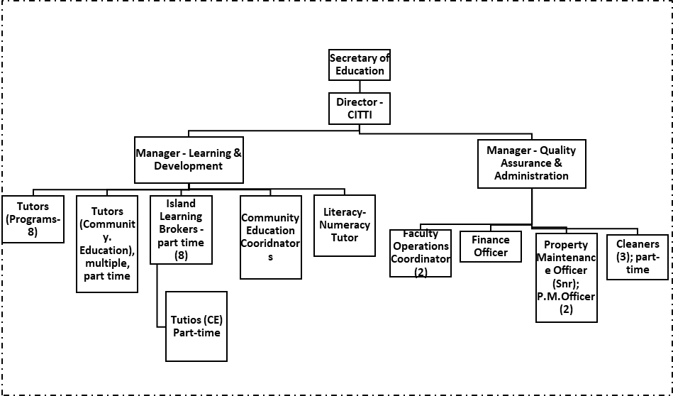

KEY RESULTS AREA:

Key Results Area | Key Performance Indicators
Teaching Practice  - To plan, prepare and deliver quality programmes as prescribed by the curriculum  - Supply effective teaching and learning strategies to promote effective learning consistent with individual student learning needs  - Use assessment data to inform future planning and intervention strategies  - To provide regular and meaningful feedback on student progress and achievement.  - To utilise and manage all learning and teaching resources, effectively and efficiently | - Plans, prepares, implements and evaluates programs that incorporate unit and Standards Based Assessment standards  - A high standard of learning & teaching is maintained, informed through a range of assessment practices at a level appropriate to the ability of all students  - Students receive tutorial support that is individualized to their learning styles.  - Student progress and achievement are regularly analysed and intervention strategies implemented to raise achievement levels to meet expected student and program goals – credit tracking  - Students receive appropriate feedback on their progress and level of achievement and are informed of areas where extra support would be beneficial  - Students’ learning opportunities are maximised through access to appropriate and properly maintained resources
Quality Management Systems (Managing International Qualifications)  - To verify/moderate assessment materials in area of expertise according to NZQA processes  - To ensure the institute maintains its accreditation to offer NZQA accredited programs of learning according to scope of accreditation and relevant MOU.  - To develop, review and implement programmes of learning and respond to feedback | - Complies with external audit requirements and guidelines including pre, post and external moderation, Further Assessment Opportunities, records retention and reporting guidelines  - Verified results entered in SMS and submitted, students receive record of learning and/or achieve qualification.  - Implements outcomes of external audit reviews and requirements within given timelines  - Assist new staff with meeting the requirements of NZQA. CITTI’s accreditation as a provider of NZQA qualifications is upheld and not placed at risk  - Participates in the institutes QMS committees and external audit reviews  - Programs are evaluated and reviewed, coursework is developed and implemented.
Administration  - Discharge administrative responsibilities integral to Tutors work including keeping up to date records and evidence of student achievement  - To operate within the policy framework and legislative obligations of CITTI  - To maintain good networks with the local industry | - All teaching plans, assessment procedures and teaching resources are completed and up to date  - The CITTI Quality Management System is upheld and all accreditation is maintained; All policy and procedures are abided by  - Training is industry appropriate, industry is consulted six monthly
Professional Knowledge and Development  - To have current knowledge of content and best practice principles and pedagogy that can be applied to the learning situation.  - To be competent and to keep up to date in the subject area | - Keeps abreast of changes in subject area through subject associations, advisors, online (ITO, NZQA), colleagues in other institutes  - Regularly reflects on and reviews personal performance  - Demonstrates a commitment to personal growth and knowledge development  - Contributes to ongoing curriculum, assessment and policy review and evaluation.  - If applicable, to work towards and gain an adult teaching qualification, including US 4098.
Student Management  - To initiate and manage recruitment of students  - Provides a supportive, creative, stimulating and safe environment for students  - To monitor student attendance, progress and achievement.  - To implement sound strategies in managing student behaviour effectively and within CITTI policy | - Programs commence with a full complement of students  - Uses positive reinforcement to encourage desired behaviors  - Effective classroom layout, displays; health and safety procedures are implemented  - Responds effectively and in a timely manner to individual student needs  - Communicates effectively with students, staff and parents and caregivers  - Establishes and maintains clear and effective classroom routines
Contribution to CITTI  - To be an active team member within the faculty and institute  - To establish and maintain effective and cooperative working relationships with and between colleagues | - Participates effectively and contributes to faculty and institute professional meetings and activities  - Actively supports decisions taken by the faculty and institute  - Carries out all assigned duties effectively  - Reasonable request for information are met in a timely and obliging manner
Professional Conduct  - Demonstrate professional conduct as expected by an employee of the Cook Islands Public Service  - Participate fully and effectively in the institutes performance management system | - Demonstrates professional conduct at all times  - Complies with the values and code of conduct of the CIPS  - Complies with the requirements of the MOE performance management system  - Meets all expected deadlines and reporting requirements as directed by the Senior Managers.

WORK COMPLEXITY:

The most challenging duties typically undertaken by a tutor will include:
1 | A comprehensive knowledge and understanding of relevant curricula and demonstrating effective pedagogical practice
2 | Self-reflection to inform planning and alternative delivery approaches and methodologies
3 | Establishing and organising programme of courses including learning plans, course content and assessments
4 | Ensuring diverse needs of learners are met; recruiting students and maintaining enrolment numbers
5 | Demonstrate planning skills that provide connections to prior learning and experiences, and display competency in evaluation for future planning
6 | Managing relationships with industry, employers, community groups and relevant government agencies
7 | Ability to contextualise students’ learning to their own environment to give it relevance and enhance student understanding
8 | Able to use a range of assessment methods (eg norm referenced, standards based etc) for diagnostic, formative and summative evaluation of student achievement to inform interventions which will improve student outcomes
9 | Comply with moderation and assessment requirements of NZQA, London City and Guilds and other accrediting bodies

AUTHORITY:

The Programme Tutor will have the following levels of authority:

Financial | No Authority (All tutors are required to follow the financial practices as set down by the Ministry of Education with regard to purchasing, inventory control and asset management, input into faculty budget in teaching area)
Staff | No Authority (Tutors in technical subjects may supervise the work of technicians assisting in work-shops, kitchens and job sites. Senior tutors may supervise and support beginning tutors & other tutors requiring up skilling to ensure they meet the standards required by accrediting bodies)
Contractual | No authority.

FUNCTIONAL RELATIONSHIPS:

Tutors are required to demonstrate effective Human Resources Management skills in dealing with all internal and external relationship matters:

Internal | Nature of Contact: | External | Nature of Contact
Senior management team – Director, Managers | Institute operations and management, compliance, reporting, attendance, leave, student management, area of responsibility, other matters as required (Light) | Community Services, government agencies, NGOs | Resource provision, learning enhancement opportunities, health & safety and other matters as required  (Routine)
Other institute staff including support staff | Provision of administration, collegial and professional support, planning, student progress & achievement, pastoral care, other relevant matters  (Medium) | Industry and Employers | Training programs, student placements, administration specific to the curriculum area, and other matters as required.  (Routine)
Students | Learning and Teaching, pastoral care, other relevant matters  (Heavy) | External Tertiary Providers | Subject specific resources, assessment support and current initiatives  (Routine)
Ministry of Education central administration office | Employment matters including payroll, leave, professional development, performance, competency, and curriculum support and other matters as required. (Medium) | Accrediting and standard setting bodies (NZQA, ITO, LC&G) | Policy and processes, subject specific support, reporting and other matters  (Minimal)

PERSON SPECIFICATION:

Qualification

The Programme Tutor will be required to have the following formal level of training and educational qualifications and experience:

Essential: (least qualification to be competent) | Desirable: (specific qualification for job)
- Bachelor’s Degree with majors in specific teaching area  - Cook Islands teacher registration (with adult teaching qualification) | Post graduate qualification in teaching area.

Knowledge/Experience:

The length of practical experience and nature of specialist or managerial familiarity required. This experience is in addition to formal education.

Essential | Desirable
- 3 or more years’ experience in delivery of industry training.  - 7 or more years practical industry experience at an advanced level. | - At least 3 years’ experience in delivery of industry training including standards based assessment (SBA)

Key Skills /Attributes/Behaviours

Expert | - Effective delivery of curricula relevant to specialist teaching area  - The relevant and appropriate application of learning and assessment theory  - Clear and effective communication in a range of situations  - The relevant contextualisation of teaching and learning to students’ own environment
Advanced | - A range of student behaviour and pastoral care management strategies  - Ongoing monitoring, evaluation and self-review of one’s own performance and practice  - Collaborative and collegial teaching style; honest, motivated, flexible, adaptable, innovative and reliable  - Managing institute resources effectively  - High level of oral and written communication and reporting skills  - Always assessing and planning to minimise risks to students’ physical safety and taking appropriate action  - Promoting indigenous culture and language
Working | - Further developing one’s own knowledge and skills  - Actively participating in professional development  - Undertaking professional reading relevant to education.  - IT Level 3 competency achievement  - Ability to be professional and approach challenges professionally
Awareness | - Knowledge of external developments and innovation in education that are relevant to the specialist subject area  - Government legislation and policies particularly those related to education

CHANGE TO JOB DESCRIPTION:
Changes to the Job description may be made from time to time in response to the changing nature of the Ministry’s work environment - including technological or statutory changes.

Secretary of Education Date

Employee Date

