

**MINISTRY OF EDUCATION**

**P.O. Box 97, Rarotonga, Cook Islands**

**Government of the Cook Islands**

**Phone: (682) 29 - 357 Fax: (682) 28 - 357**

**POSITION DESCRIPTION**

|  |  |
| --- | --- |
| **Position Title:** | Manager – Human Resources |
| **Division:** | Corporate & Operational Services |
| **Responsible To:** | Assistant Secretary – Corporate & Operational Services |
| **Responsible For:** | 7 FTE and 21 PTE staff |  |
| **Job Purpose:** | To lead the human resources function within the Ministry of Education, ensuring that staffing, professional development, employee relations, and welfare programs support the Ministry’s goals. The role is responsible for the development and implementation of HR policies, recruitment, and staff training. |  |
| **Job classification:** | FTE |  |
| **Date:** | 15 May 2025 |  |

**MINISTRY VISION:**

Akamatutuanga i te au karape, kite, te tu tangata e te irinakianga o te iti tangata Kuki Airani kia rauka ia ratou i taangaanga i ta ratou au tareni ki roto i to ratou oraanga.

Building the skills, knowledge, attitudes, and values of Cook Islanders to put their capabilities to best use in all areas of their lives.

**ORGANISATION CHART:**

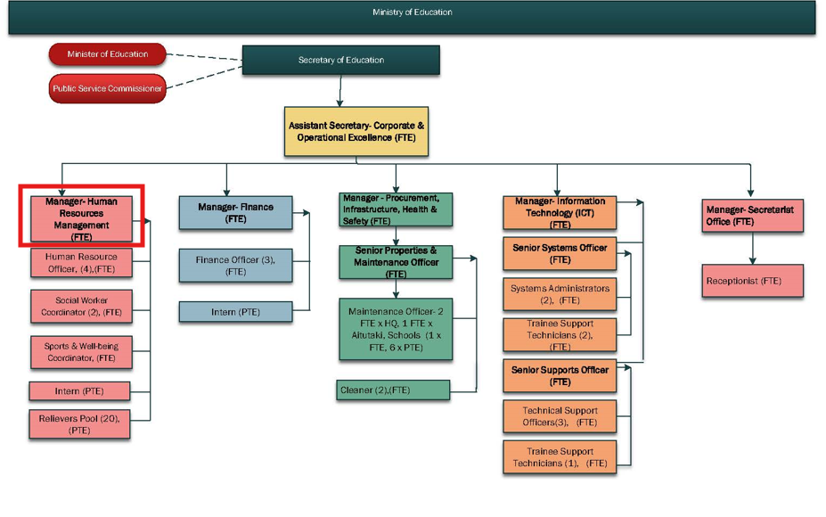

**KEY RESULTS AREA:**

|  |  |
| --- | --- |
| ***K.R.A*** | ***Key Performance Indicators*** |
| **KRA 1: HR Policy Development**   1. Ensure HRM Annual Plan is developed & reviewed. 2. MOE Staff manual is reviewed and updated in a timely manner. | * Developing and implementing HR policies that support the Ministry’s strategic goals. * Human Resources plan is in use and reviewed. * The MOE handbook completed and reviewed annually. |
| **KRA 2: Recruitment and Retention**   1. Ensure well planned recruitment and selection processes and practices are evident and implemented. 2. School staffing levels across all positions inform vacancies. 3. Ensure recruitment, selection and appointments processes are professional, efficient, robust, meet staffing needs of the Ministry and comply with MOE/PSC recruitment guidelines. | * Ensuring the recruitment and retention of qualified staff across the Ministry. * Recruitment guidelines sets out process for recruitment, induction and orientation of new staff and is reviewed * Job advertisements are clear, transparent and fair * Appropriately qualified applicants apply * Selection panels are formed to carry out recruitment maintaining a high level of integrity in the process. * All applicants are notified promptly and all necessary next steps are carried out * All relevant documents are signed prior to commencement of employment. * Contracts of employment for all employees are current. |
| **KRA 3: Professional Development**   1. The Ministry of Education operates a Human Resources Plan which contains personnel forecasting, succession planning and training and development. 2. HRM Annual Plan developed & reviewed. 3. MOE Staff manual reviewed. 4. Annual Professional and Personal Development Plan and Register. 5. Oversee the Cook Islands Government Scholarships and Grants Program “Te Reinga Akataunga’anga”. | * Providing opportunities for staff training and career development. * The PD register is established and updated. * Scholarship/grants program implemented, monitored and reviewed by Scholarships Committee. |
| **KRA 4: Documentation and Review**   1. To ensure that all employees have current job descriptions and contracts of employment that are clearly defined, understood and agreed upon. 2. All jobs are sized and remunerated in accordance with PSC guidelines. 3. To oversee and authorise the preparation and issue of appropriate contractual documentation in relation to appointments, variations to employment and terminations 4. Employee Records are current, confidential and are maintained in a safe and secure environment in accordance with OIA requirements. 5. Collate, analyse employee retention data. | * Job Descriptions document the key tasks, expected outcomes and measures to be taken by individual MOE employees * All job descriptions reviewed and updated with clearly defined capabilities and skills * Employees are paid according to job size as stipulated by PSC guidelines or policies * Personal files and records are maintained, updated and kept confidential in a safe and secure place * Data is maintained and analysed in a confidential manner |

**WORK COMPLEXITY:**

|  |  |
| --- | --- |
| *Indicate Most challenging duties typically undertaken:* | |
| 1 | Managing HR functions across a diverse workforce, ensuring compliance with national labor laws and policies. |
| 2 | Balancing the need for staff development and career progression with operational and budgetary constraints. |
| 3 | Developing and implementing policies that address the unique needs of the educational workforce. |
| 4 | Addressing employee relations issues while fostering a positive and productive workplace culture. |

**AUTHORITY:**

Authority levels expressed in terms of routine expenditure, granting loans, and recruiting and dismissing staff. (*Explain the authority if any*)

|  |  |
| --- | --- |
| **Financial** | In collaboration with Assistant Secretary - Corporate, oversees all financial expenditure of the Division, particularly as it relates to operations & achieving divisional objectives. |
| **Staff** | In conjunction, participate and manage the recruitment of staff, oversee the completion of staff Performance Appraisals, and inform Assistant Secretary – Corporate and HOM of all significant matters relating to staff, in particular staff leave, discipline, conduct and performance. |
| **Contractual** | Able to negotiate routine maintenance and improvement contracts in conjunction with Assistant Secretary – Corporate |

**FUNCTIONAL RELATIONSHIPS:**

The requirement for human relations skills in dealing with other personnel and external contacts. *(List the external and internal types of functional relationships)*

|  |  |  |  |
| --- | --- | --- | --- |
| Internal | Nature of Contact | External | Nature of Contact |
| **Assistant Secretary – Corporate & Operational Services** | Reporting on HR initiatives, staff issues, and policy development. | **Government HR and Labor Departments** | Ensuring compliance with national labor regulations and HR best practices. |
| **Other Ministry Divisions** | Coordinating HR services and policies across all divisions. | **External HR Consultants** | Engaging with consultants for specialized HR support. |

**QUALIFICATION:**

###### Level of education required to perform the functions required of the position. This combines formal and informal levels of training and education.

|  |  |
| --- | --- |
| **Essential: (least qualification to be competent)** | **Desirable: (specific qualification for job)** |
| Bachelor’s degree in Human Resource Management, Business Administration, or related field. | Master’s degree in Human Resources or Organizational Development. |

**Knowledge / Experience**

The length of practical experience and nature of specialist or managerial familiarity required. This experience is in addition to formal education.

|  |  |
| --- | --- |
| **Essential: (least number of years to be competent)** | **Desirable: (target number of years you are looking for)** |
| Minimum of 10 years of experience in HR management. | 12+ years of experience with a focus on HR policy development and employee relations. |

**Key Skills /Attribute / Behaviours**

|  |  |
| --- | --- |
| **Level of ability required for the job** |  |
| **Expert** | * Excellent understanding of the policy development and management cycles * Excellent understanding of the role and development of strategic and operational plans within the government sector. * Excellent understanding of Monitoring and Evaluation frameworks and their use as a planning tool * Strengths-based leadership, with the ability to collaborate with others, across the spectrum of Ministry functions, to achieve mutually agreed goals |
| **Advanced** | * Superior understanding of Quality Management Systems – development, implementation, audit and review. * Strong interpersonal skills including advocacy, public speaking and presenting. * Collaborative approach to the development of quality standards and frameworks. * Ability to build an effective team * Ability to retain and build the capacity of staff * Superior project management skills * Ability to focus on strategic rather than operational issues. * Ability to think holistically about systems and processes. * Genuine desire to build an empowering and achieving work   environment   * Undertake challenging tasks in pursuit of long term positive outcomes. |
| **Working:** | * Ability to deal with risk and crisis management in a structured and calm manner * Ability to balance practical requirements with leading edge innovation. * Sensitivity towards and understanding of Cook Islands culture. * Sound research & report writing skills (including the collection of both quantitative and qualitative data) * Understanding the use of technology to support the provision of information * Ability to rise to the challenge of new and difficult tasks in pursuit of long term positive outcomes * Commitment towards positive outcomes in providing high quality education for all. |
| **Awareness** | * Other government and non-government agency/organisation mandates, relevant legislation and QMS * Regional agencies, their function and requirements |

**Approved:**

Head of Ministry – Secretary of Education Date

Employee Date