

**MINISTRY OF EDUCATION**

**P.O. Box 97, Rarotonga, Cook Islands**

**Government of the Cook Islands**

**Phone: (682) 29 - 357 Fax: (682) 28 - 357**

**POSITION DESCRIPTION**

|  |  |
| --- | --- |
| **Position Title:** | Manager – Information Technology (ICT) |
| **Division:** | Corporate & Operational Excellence |
| **Responsible To:** | Assistant Secretary – Corporate & Operational Excellence |
| **Responsible For:** | 10 x FTE staff |  |
| **Job Purpose:** | To lead and manage the Ministry of Education’s Information Technology (IT) systems, ensuring the effective use of technology to support educational and operational goals. The role involves overseeing IT infrastructure, network security, and the integration of educational technology in schools. |  |
| **Job classification:** | IT Support |  |
| **Date:** | 02 April 2025 |  |

**MINISTRY VISION:**

Akamatutuanga i te au karape, kite, te tu tangata e te irinakianga o te iti tangata Kuki Airani kia rauka ia ratou i taangaanga i ta ratou au tareni ki roto i to ratou oraanga.

Building the skills, knowledge, attitudes, and values of Cook Islanders to put their capabilities to best use in all areas of their lives.

**ORGANISATION CHART:**

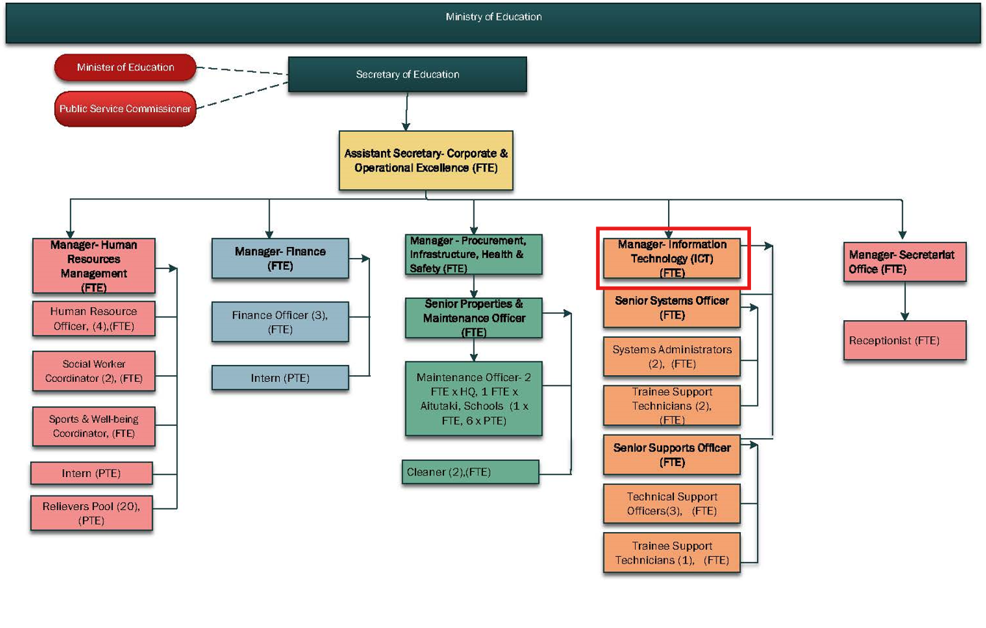

**KEY RESULTS AREA:**

| ***K.R.A*** | ***Key Performance Indicators*** |
| --- | --- |
| **KRA 1: IT Systems Administration & Maintenance**   1. Manage, maintain and administer the Ministry of Education and Schools computers, servers and networks. 2. Ensure the Ministry of Education and schools serves and networks are up to date, secure and stable. 3. Ensure connectivity to the local Internet Service Provider (ISP) is available, secure and reliable. 4. Ensure connectivity to the Ministry of Educations own Local Area Network is available, secure and reliable. 5. Ensure backups of all servers are carried out 6. Diagnose and troubleshoot server and network problems and provide solutions in consultation with schools and known stakeholders 7. Maintain system configuration documentation for servers and network devices. 8. Ensure user accounts, passwords, email and internet services are administered. | * Managing and maintaining IT systems and infrastructure to ensure reliability and security. * User –documentation and operational procedures are available. * Systems and networks are reviewed, designed and implemented. * Licencing, updates, antivirus and other subscription offerings are well managed * Design, implement and manage VOIP and PABX services. * ICT Maintenance is scheduled on regular basis. * Networks are modified/upgraded to meet educational sector goals. |
| **KRA 2: ICT Research and Development**   1. Conduct ICT research and trends analysis. 2. Conduct research into ICT that supports educational goals and expectations. 3. Research, develop or procure, install, configure and evaluate new applications, servers and network appliances and configurations for use in education. 4. Provide technical advice and recommendations for new systems or education software. 5. Keep up to date with trends and developments in ICT and application of ICT in Education. 6. Build and manage relationships with key stakeholders. | * Develop innovative solutions for the education sector by working in collaboration with teaching and education staff. * Administration, training and support for all of Education’s IT systems solutions and processes. * A high level of technical knowledge is maintained that meets the needs of the Education Sector. * Assist L&T Division with implementation (connectivity, hardware and software requirements) of educational software into learning. |
| **KRA 3: Planning and Development**   * Review and implement the ICT governance framework. * Review and implement the ICT strategic plan and investment plan. * Assess and monitor the adherence by schools and the Ministry of Education to statutory requirements regarding the use of ICT. * Build and deploy real time and near to real time reporting for priority areas across the Ministry of Education. * Proactively engage in sustainable and environmentally friendly ICT initiatives, practices and technologies in partnership with key stakeholders. * Manage ICT project implementation including budgeting, timeline and resource allocation. * Manage Network, Systems and ICT Security Audits. * Monitor and evaluate ICT plans and strategies. | * ICT Governance Framework reviewed annually. * ICT Strategic Plan reviewed annually. * 5 Year ICT Investment plan completed and prioritized. * ICT needs analysis conducted and report produced annually. * ICT Assets Replacement Schedule prepared and implemented. * Annual ICT Budget prepared and approved. * Annual ICT Report produced. * ICT Maintenance and security audit schedule and register. |
| **KRA 4: IT Asset Management Plan**   1. Develop and manage an ICT portfolio (hardware, software). 2. Maintain assets & inventory records of all ICT applications and equipment. 3. Liaise with suppliers on behalf of MoE and schools. 4. Procurement of ICT equipment for MoE and schools. 5. Provide guidance/assistance relating to the use of standard computer applications (Microsoft Office) and electronic equipment (digital camera). 6. Monitor and evaluate ICT investments and assets. | * Proactive maintenance, checks, tests and servicing is carried out. * ICT investment and replacement plan. * Assets/inventory register maintained. * Assets replaced according to plan. * Asset disposal meets environmental disposal plan. * Monthly ICT reports. |
| **KRA 5: Cybersecurity and Data Management**   1. Lead security awareness and training for cyber threats. 2. Conduct random system vulnerability tests. 3. Cybersecurity incident detection and response. | * Workshops and training held. * Identify and migrate identified vulnerabilities. * Monitor system, develop action plan for incident response. |
| **KRA 6: Staff Management, Professional Development and Conduct**   1. Lead, motivate, and develop a high-performing team, ensuring alignment with Ministry’s goals and objectives. 2. Ensure the completion of the performance appraisals when due for the responsible staff. 3. Willing to learn new skills and increase knowledge on other Funding and Planning aspects, while keeping up to date with current changes. | * Develop and manage the work plan of the staff reporting directly. * Monitor team performance and resolve any conflicts or issues promptly to maintain a productive and harmonious work environment. * Performance is reviewed annually and development opportunities provided to enhance effectiveness. * Identify training needs and implement strategies to upskill team members. * Attendance at planned training (HRM training register). |

**WORK COMPLEXITY:**

|  |  |
| --- | --- |
| *Indicate Most challenging duties typically undertaken:* | |
| 1 | Overseeing IT systems across multiple schools and Ministry offices, ensuring reliability and security. |
| 2 | Audit, design and deploy systems to ensure that IT infrastructure is robust, secure, stable, flexible, scalable, accessible, available and sustainable. |
| 3 | Ensuring cybersecurity protocols are in place to protect the Ministry’s systems and data. |
| 4 | Managing IT staff and ensuring their professional development aligns with Ministry goals. |

**AUTHORITY:**

Authority levels expressed in terms of routine expenditure, granting loans, and recruiting and dismissing staff. (*Explain the authority if any*)

|  |  |
| --- | --- |
| **Financial** | Yes, managing budget for IT infrastructure and systems upgrades in collaboration with Assistant Secretary- Corporate. |
| **Staff** | Yes, will need to assist Assistant Secretary- Corporate in managing the work plan and performance of other ICT staff and will be part of the recruitment panel whenever required. |
| **Contractual** | Authority to engage with IT service providers and vendors for system maintenance and upgrades. |

**FUNCTIONAL RELATIONSHIPS:**

The requirement for human relations skills in dealing with other personnel and external contacts. *(List the external and internal types of functional relationships)*

|  |  |  |  |
| --- | --- | --- | --- |
| Internal | Nature of Contact | External | Nature of Contact |
| **HOM, Assistant Secretaries, ITC Division staff, HRM, Finance and MOE central administration staff** | Reporting on IT infrastructure, systems, and educational technology integration. | Government Ministries, SOE’s Agencies inclusive of | ICT policy and planning queries & compliance; provision of valid and reliable data/reports; supplying/requesting data and information; MOU for IT support, MFEM- assets (CAPEX) queries, (Vodafone) and other matters of national interest as required  (Routine) |
| **Schools and Ministry Divisions** | Provision of ICT advice, guidance and support services, IT assets management and procurements, training and development, IT connectivity, security, reporting and feedback to queries (Heavy) | Government Ministries, SOE’s Agencies inclusive of | ICT policy and planning queries & compliance; provision of valid and reliable data/reports; supplying/requesting data and information; MOU for IT support, MFEM- assets (CAPEX) queries, (Vodafone) and other matters of national interest as required (Routine) |
| Principals/CITTI Managers and management teams including private schools, PTA/BOT and school community’s | Provision of ICT advice, guidance and support services, IT assets management and procurements, training and development, IT connectivity, security, reporting and feedback to queries (Heavy) | Local/online media outlets (CITV, CI News, Radio etc), NGO, private sector | Provision of public release information & materials, supplying/requesting data and information to organisations promote educational goals and programs(Promoting) |
| School/provider staff, consultants-contract workers | Provision of assistance & IT support services to school staff, guest, consultants and contract workers (Heavy) | Local and overseas vendors and suppliers | Daily and continual contact with suppliers fostering long-term positive relationships to benefit the MOE/schools  (**Routine**) |

**QUALIFICATION:**

###### Level of education required to perform the functions required of the position. This combines formal and informal levels of training and education.

|  |  |
| --- | --- |
| **Essential: (least qualification to be competent)** | **Desirable: (specific qualification for job)** |
| Bachelor’s degree in Information Technology, Computer Science, or related field. | Masters in Information Technology, Computer Science, or related field. |

**Knowledge / Experience**

The length of practical experience and nature of specialist or managerial familiarity required. This experience is in addition to formal education.

|  |  |
| --- | --- |
| **Essential: (least number of years to be competent)** | **Desirable: (target number of years you are looking for)** |
| Minimum of 10 years of experience in IT management. | 11+ years with a focus on educational technology and system integration. |

**Key Skills /Attribute / Behaviours**

|  |  |
| --- | --- |
| **Level of ability required for the job** |  |
| **Expert** | IT Systems Management, Cybersecurity, Educational Technology |
| **Advanced** | Network Administration, IT Project Management |
| **Working:** | Cross-Departmental Collaboration, Staff Development |
| **Awareness** | N/A |

**Approved:**

Head of Ministry – Secretary of Education Date

Employee Date