

**Government of the Cook Islands**

**Phone: (682) 29-357 Cell: (682) 52410 Fax: (682) 28-357**

**MINISTRY OF EDUCATION**

**P O Box 97, Rarotonga, Cook Islands**

**POSITION DESCRIPTION**

|  |  |
| --- | --- |
| Job Title: | Faculty Operations Coordinator |
| Division: | Cook Islands Tertiary Training Institute |
| Responsible To: | Head of Faculty |
| Responsible For: |  |
| Job Purpose: | To coordinate, organise and administer the operations of the Faculty and institute, providing quality student and tutor support services, data collection and entry and administration services. |
| Job Classification |  |
| Date updated: | April 2021 |

**MINISTRY VISION:**

The Ministry of Education values the unique nature of the Cook Islands. We contribute to the effective governance of our country and are recognised as leaders in education throughout the region.

The Ministry of Education provides a dynamic and professional environment which promotes lifelong learning through the provision of quality services.

**ORGANISATION CHART:**

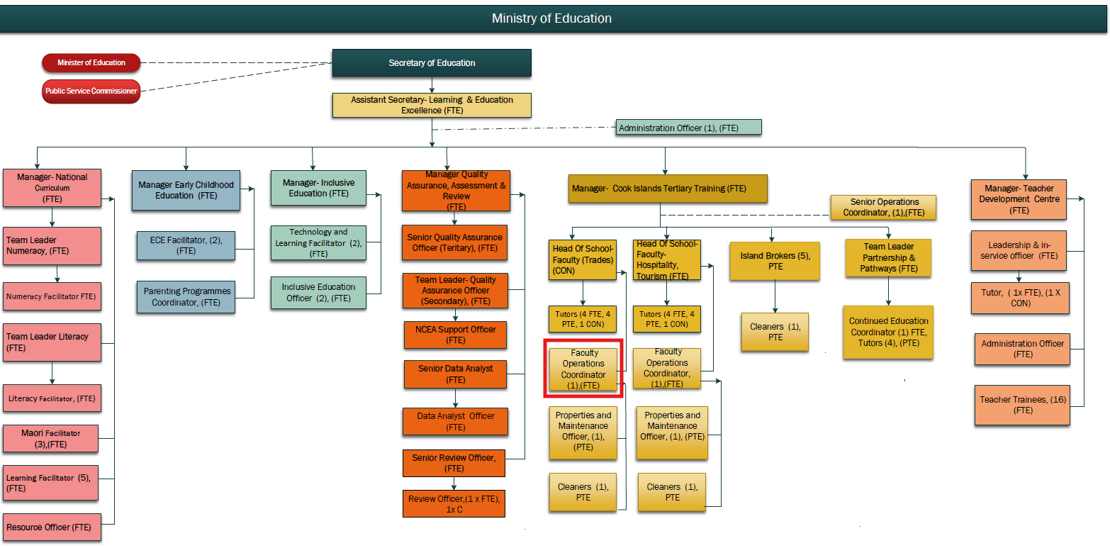

**KEY RESULTS AREAS:**

|  |  |
| --- | --- |
| Key Results Areas | Key Performance Indicators |
| **Administration & Reception**   * To ensure visitors or callers to the institute are greeted appropriately and enquiries dealt with efficiently and with maturity. * To provide secretarial and administrative support and assistance to the senior management team as appropriate * To ensure that all administrative material produced is of a high standard and appropriately reflects the institutes aim for excellence. * To ensure that the photocopying equipment printers and other office equipment are functioning effectively | * Visitors to the institute are treated professionally, with courtesy and respect * Incoming calls and inquiries are answered promptly and professionally * Office and surroundings are maintained in a clean, tidy and safe state in collaboration with cleaning/maintenance staff. * All files are accessible, secure and managed according to the OIA * Faculty mail is handled in an efficient manner * Secretarial and administrative duties for the senior management team are performed to a high standard – correspondence, minutes of meetings etc * Newsletters, resources, reports and other educational material are of a high standard. * Faults are reported immediately to technicians and repairs are carried out. |
| **Tutor/Curriculum Support**   * To ensure that teaching staff have access to printed resources for their classes. * To communicate with relevant standards accrediting organisations regarding faculty programs * To assist tutors with the ordering and transportation of resources to other centres * To provide support for tutors with regards to room setup, exam supervision and deployment of IT resources * Assist with raising awareness and the marketing of courses including online | * All photocopying for staff is completed to schedule and to a high standard * All correspondence is professional, concise and a record of decisions made with SSB. * Resources, rooms are available in a timely manner ensuring programs are delivered accordingly * Course information, prospectus, community education information disseminated |
| **Student Management Systems and Support**   * To ensure that the CITTI student management database is current and accurately records student data * To ensure that student attendance is monitored in order to meet course attendance & participation requirements. * To contact students or caregivers to verify absenteeism or in case of an emergency * To ensure that the use of student management software is maximised to aid the administrative functions of the institute * To ensure that technology is used to its full potential to aid the smooth operations of the institute. | * Database is current and information is used for school wide monitoring and planning - admissions, results, pastoral, exam times etc.   (EDGE/Tertiary Based Student Management System)   * All student management systems entry and output deadlines are adhered to. * Students’ timetables, attendance and progress records are accessible, accurate and up-to-date. * Students and the institute have up to date records and access to Records of Learning * Provide support to staff with the use of EDGE/Tertiary Based Student Management System. * Faults with software are reported and repairs arranged |
|  |  |
| **Financial Management**   * To operate sound financial cash management systems and practices * To keep and provide sound and accurate financial records which show a true and fair view of the financial situation of the institute. * To ensure that interested parties have access to current and accurate financial data. * All institute assets and inventory are recorded, tracked and maintained according to MOE asset management processes | * Balance the receipt book with the banking * All banking is regular and large amounts of money are not kept on the premises * Institute and bank records are reconciled * All payments are supported with receipts and monitored, including following up on due fees * There are current financial records of inwards and outwards cash that are kept electronically. * Assets/ Inventory register |
| **QMS Support**   * Contribute to institutional committees including but not limited to quality assurance and health and safety. * Monitor and review the progress of students through questionnaires and discussions with tutors and managers * To assist with the organisation and management of meetings and special events | * Attendance at full staff and committee meetings, taking minutes of meetings. * Program evaluation questionnaires are administered and summative reports produced * Calendar of meetings and events adhered to and supported |
| **Professional Conduct**   * Demonstrate professional conduct as expected by an employee of the Cook Islands Public Service * Participate fully and effectively in the performance management system | * Demonstrates professional conduct at all times * Complies with the values and code of conduct of the CIPS * Complies with the requirements of the MOE performance management system * Participates in relevant professional development opportunities * Meets all expected deadlines and reporting requirements as directed by the Manager. |

**WORK COMPLEXITY:**

The most challenging duties typically undertaken will include:

|  |  |
| --- | --- |
| 1 | Collecting, recording and maintaining student data and records - results, assessment/ moderation evidence and personal/ pastoral care |
| 2 | Ensuring diverse needs of students are met, provide a student support function/service, advice and guidance on pastoral care matters |
| 3 | Inwards and outwards correspondence - organising office files and information either electronically, digitally or with paper filing systems |
| 4 | Maintaining accurate records of various faculty wide meetings |
| 5 | Sound working knowledge of computerised student management systems (SMS) for student record keeping, achievement, programs etc. |
| 6 | Ensuring the operation of sound financial management systems and practices with regards to fees/funds management, purchasing, inventory control and asset management |
| 7 | Customer service skills are essential as the first point of contact for enquiries, public relations and issues regarding the school’s staff, students and services. Receptionist duties - responsible for operating the phone system used at the institute. |

**AUTHORITY:**

The Faculty Operations Coordinator will have the following levels of authority:

|  |  |
| --- | --- |
| **Financial** | Nil (Comply with the financial practices as set down by the Ministry of Education with regard to fees/funds management, purchasing, inventory control and asset management) |
| **Staff** | Nil. |
| **Contractual** | Nil |

**FUNCTIONAL RELATIONSHIPS:**

The Faculty Operations Coordinator are required to demonstrate effective Human Resources Management skills in dealing with all internal and external relationship matters:

|  |  |  |  |
| --- | --- | --- | --- |
| Internal | Nature of Contact | External | Nature of Contact |
| Manager QAA, Manager Learning and Development | Administrative support, student management, leave, performance, PD and other matters as required (Light) | Community services, government agencies, NGOs | Administration and curriculum support, health and safety and other matters as required (Routine) |
| Tutors and other CITTI staff | Administrative support, photocopying, schedules, resources and other matters as required (Medium) | Industry and employers | Administration support for student placements, tutor enquiries other matters as required.(Routine) |
| Students | Administrative support – attendance, financial administration, pastoral care, relaying messages other matters as required (Heavy) | Local and overseas suppliers | Request quotes, invoices, collection and contact to resolve administration matters (Routine) |
| Ministry of EducationCentral Administration staff | Employment matters including payroll, leave, responding to and providing information, other matters as required. (Medium) | Accrediting & standard setting bodies | Assessment, reporting, quality management systems support, ongoing communications as agreed with Manager(Minimal) |
|  |  |  |  |

**PERSON SPECIFICATION:**

**Qualification**

The Faculty Operations Coordinator will be required to have the following formal level of training and educational qualifications and experience:

|  |  |
| --- | --- |
| **Essential: (least qualification to be competent)** | **Desirable: (specific qualification for job)** |
| * A Diploma in Business Administration/Computing | * A Degree in Business Administration/Computing or Accounting |

**Knowledge/Experience:**

The length of practical experience and nature of specialist or managerial familiarity required. This experience is in addition to formal education.

|  |  |
| --- | --- |
| **Essential:**  Maturity and a minimum of 5 years administration experience with an understanding of the indigenous language and culture. Inclusive of   * Knowledge of administrative policies and procedures. * Organisational and planning skills. * Sound leadership and motivational skills. * Sound computer skills | **Desirable:**   * More than 3 years’ experience in a Senior Administrative position. * Experience working in an educational establishment in senor secondary/TVET |

**Key Skills /Attribute / Behaviours**

|  |  |
| --- | --- |
| **Expert** | **Customer Focus** - Working to achieve total customer satisfaction (includes internal and/or external customers).  **Database management** – sound working knowledge of student and financial management systems operating in a tertiary institute |
| **Advanced** | **Quality and Accuracy** - Accomplishing tasks with concern for the standard produced; checking own or others’ work to ensure accuracy, adherence to procedures and completeness. Improves processes to ensure improvement in quality of outputs over time.  **Interpersonal Skills** - Establishing and maintaining relationships with staff, customers and suppliers to improve the overall effectiveness of the position.  **Communication Skills** - Expressing ideas effectively in individual and group situations; adjusting language or terminology to the characteristics and needs of the audience. Keeps information confidential  **Decision making /Problem Solving** - Making timely decisions; judgements; taking action when appropriate and committing to a position or direction. |
| **Working** | **Collaboration** - Working effectively with others in the institute, the wider community and stakeholders to accomplish institute goals.  **Safety Awareness** - Acting to improve conditions that affect employee safety.  **Attention to detail** – ability to accurately check processes, tasks and /or information no matter how small over time yet still showing concern for all the other aspects of the job.  ITC - be able to carry out word processing, use spreadsheets, databases or other software as appropriate, to Level 3  An ability to respond to changing situations in a flexible manner in order to meet current needs. |
| **Awareness** | **Commercial Awareness** - Considers financial implications and risk of proposed actions/decisions, applies business, accounting and marketing models to decisions.  Knowledge of Education Sector mandates (Education Act, EMP, SOI) |

**Approved:**

Head of Ministry of Education (Secretary) Date

Employee Date