

**MINISTRY OF EDUCATION**

**P.O. Box 97, Rarotonga, Cook Islands**

**Government of the Cook Islands**

**Phone: (682) 29 - 357 Fax: (682) 28 - 357**

**POSITION DESCRIPTION**

|  |  |
| --- | --- |
| **Position Title:** | **Learning Facilitator** |
| **Division:** | Learning and Educational Excellence |
| **Responsible To:** | **Manager National Curriculum** |
| **Responsible For:** |  |  |
| **Job Purpose:** | To support the implementation of high-quality teaching and learning practices across primary and secondary schools in the Cook Islands. The Learning Facilitator provides direct support and coaching to teachers, both individually and through group sessions, to ensure effective curriculum delivery, learner progress, and culturally responsive pedagogy. The role responds to school needs identified through curriculum changes, school reviews, and national learning priorities, supporting schools to raise learner achievement across key learning areas. |  |
| **Job classification:** |  |  |
| **Date:** | 15 April 2025 |  |

**MINISTRY VISION:**

Akamatutuanga i te au karape, kite, te tu tangata e te irinakianga o te iti tangata Kuki Airani kia rauka ia ratou i taangaanga i ta ratou au tareni ki roto i to ratou oraanga.

Building the skills, knowledge, attitudes, and values of Cook Islanders to put their capabilities to best use in all areas of their lives.

**ORGANISATION CHART:**

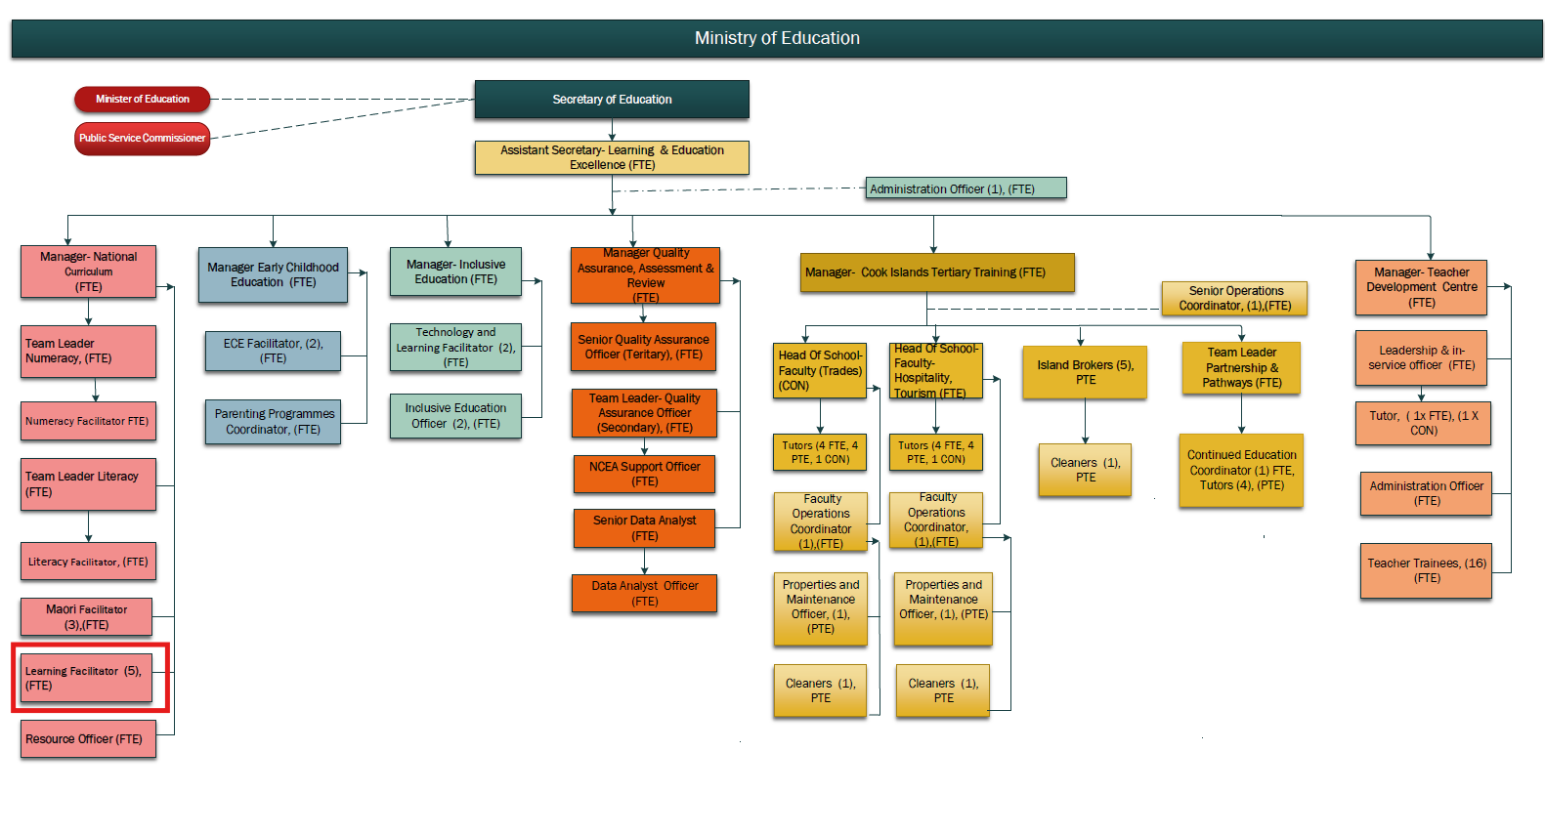

**KEY RESULTS AREA:**

|  |  |
| --- | --- |
| ***K.R.A*** | ***Key Performance Indicators*** |
| **1. School-Based Learning Support** Provide in-school coaching and support to teachers in curriculum delivery, instructional strategies, and learner-centred practices. | Visits documented; teacher feedback positive; evidence of improved planning and pedagogy. |
| **2. Professional Learning Facilitation** Plan and deliver high-quality professional learning sessions for teachers across learning areas. | Workshops held regularly; increased teacher participation; improved outcomes in observed practice. |
| **3. Curriculum Implementation** Support teachers to implement national curriculum progressions, key stage outcomes, and assessment practices. | Teachers apply national progressions; consistent use of curriculum resources and assessment tools. |
| **4. Differentiation and Personalised Learning** Support teachers in adapting learning to meet the needs of diverse learners, including high and low achievers. | Individualised learning approaches observed; improved engagement and outcomes across learner levels. |
| **5. School Review and Improvement Follow-up** Work with schools to address recommendations from school review visits in relation to teaching and learning. | Targeted support plans implemented; improved review findings over time; feedback from QA and school leaders. |
| **6. Collaboration Across Curriculum and Support Teams** Collaborate with Māori, ECE, Inclusive Education, Numeracy and Literacy teams to promote coherent and integrated learning. | Cross-team initiatives delivered; integration of learning support across subject and cultural areas. |

**WORK COMPLEXITY:**

|  |  |
| --- | --- |
| *Indicate Most challenging duties typically undertaken:* | |
| 1 | Supporting teachers across multiple levels (primary and secondary) with varying needs and curriculum familiarity. |
| 2 | Aligning teacher support with national curriculum reforms and frameworks. |
| 3 | Sustaining improvement through coaching and follow-up beyond initial workshops. |
| 4 | Working across geographic and cultural contexts, including Pa Enua. |
| 5 | Supporting subject-specific learning while promoting cross-curricular and culturally relevant practices. |

**AUTHORITY:**

Authority levels expressed in terms of routine expenditure, granting loans, and recruiting and dismissing staff. (*Explain the authority if any*)

|  |  |
| --- | --- |
| **Financial** | Nil |
| **Staff** | Nil |
| **Contractual** | Nil |

**FUNCTIONAL RELATIONSHIPS:**

The requirement for human relations skills in dealing with other personnel and external contacts. *(List the external and internal types of functional relationships)*

|  |  |  |  |
| --- | --- | --- | --- |
| Internal | Nature of Contact | External | Nature of Contact |
| Manager-National Curriculum | Reporting, planning, direction | School Principals and Teachers | Capacity building and coaching |
| Curriculum Development and Assessment Teams | Curriculum interpretation, alignment | Pa Enua Teachers | Remote and in-person support for curriculum delivery |
| Māori, ECE, and Inclusive Ed Facilitators | Collaboration on cross-cutting themes | Parents and Community (as needed) | Support for home–school learning partnerships |
| Teacher Development Centre | Professional learning delivery |  |  |
| QA and School Review Team | Alignment with school improvement plans |  |  |

**QUALIFICATION:**

###### Level of education required to perform the functions required of the position. This combines formal and informal levels of training and education.

|  |  |
| --- | --- |
| **Essential: (least qualification to be competent)** | **Desirable: (specific qualification for job)** |
| * Bachelor of Education or subject-specific teaching degree * Current or eligible Teacher Registration | * Postgraduate qualification in Curriculum, Education Leadership, or a specialist subject area * Training in teacher mentoring or adult facilitation |

**Knowledge / Experience**

The length of practical experience and nature of specialist or managerial familiarity required. This experience is in addition to formal education.

|  |  |
| --- | --- |
| **Essential: (least number of years to be competent)** | **Desirable: (target number of years you are looking for)** |
| * Minimum 3–5 years of teaching experience in primary or secondary education * Strong understanding of curriculum design and learner progressions * Experience delivering professional learning or peer mentoring | * Experience working across a range of school types and learning levels * Familiarity with national assessment tools such as e-Asttle * Knowledge of Cook Islands cultural context and education priorities |

**Key Skills /Attribute / Behaviours**

|  |  |
| --- | --- |
| **Level of ability required for the job** |  |
| **Expert** |  |
| **Advanced** | * Curriculum Delivery and Planning: Supports teachers in designing and delivering effective lessons aligned with national curriculum. * Teacher Coaching and Facilitation: Effectively guides adult learners through modelling, feedback, and collaborative inquiry. |
| **Working:** | * Assessment and Learner Progression: Applies learner progressions and data to guide student learning and teacher decision-making. * Differentiated and Inclusive Teaching: Supports teachers in planning for diverse learner needs and strengths. * Collaboration and Relationship Management: Builds strong partnerships with teachers and across Ministry teams. |
| **Awareness:** | * Cultural and Language Integration: Recognises the importance of language and identity in classroom learning. |

**Approved:**

Head of Ministry – Secretary of Education Date

Employee Date