

**MINISTRY OF EDUCATION**

**P.O. Box 97, Rarotonga, Cook Islands**

**Government of the Cook Islands**

**Phone: (682) 29 - 357 Fax: (682) 28 - 357**

**POSITION DESCRIPTION**

|  |  |
| --- | --- |
| **Position Title:** | **Maori Facilitator** |
| **Division:** | Learning and Educational Excellence |
| **Responsible To:** | **Manager National Curriculum** |
| **Responsible For:** | Nil |  |
| **Job Purpose:** | To strengthen the teaching and revitalisation of the Cook Islands Māori language and cultural knowledge across schools by providing targeted support and advice to teachers both individually and through structured group sessions at the Teacher Development Centre (TDC). The Numeracy Facilitator will deliver ongoing, responsive support that aligns with the national curriculum and addresses needs identified through school review visits, curriculum changes, or teacher development goals. The role is central to sustaining continuous professional learning, embedding effective numeracy pedagogy, and supporting school improvement. |  |
| **Job classification:** |  |  |
| **Date:** | 08 May 2025 |  |

**MINISTRY VISION:**

Akamatutuanga i te au karape, kite, te tu tangata e te irinakianga o te iti tangata Kuki Airani kia rauka ia ratou i taangaanga i ta ratou au tareni ki roto i to ratou oraanga.

Building the skills, knowledge, attitudes, and values of Cook Islanders to put their capabilities to best use in all areas of their lives.

**ORGANISATION CHART:**

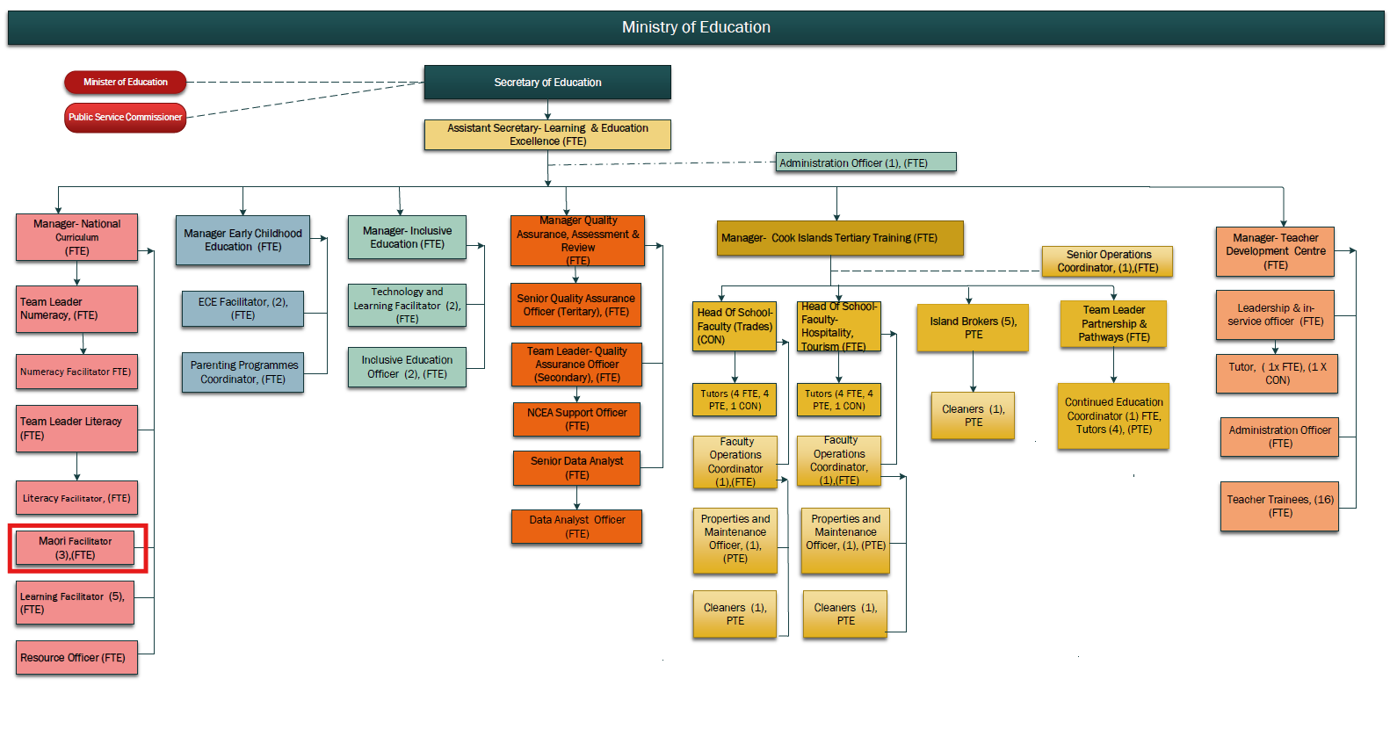

**KEY RESULTS AREA:**

|  |  |
| --- | --- |
| ***K.R.A*** | ***Key Performance Indicators*** |
| **KRA 1: School-Based Language Support** Provide in-class coaching and language revitalisation support tailored to teacher and school needs. | * Growth in teacher reo Māori use; * integration of cultural protocols; * positive learner engagement. |
| **KRA 2:Group Professional Development** Deliver workshops through the Teacher Development Centre to build language confidence and cultural knowledge among educators. | * High participation in reo Māori workshops; * evidence of applied learning in classrooms. |
| **KRA3: Response to School Reviews and Curriculum Direction** Support schools to implement curriculum elements related to language, culture, and identity, especially areas raised during reviews. | * Schools supported with targeted reo Māori plans; * increased student proficiency; * visible integration of cultural practices. |
| **KRA4: Collaborative Cultural Practice** Coordinate with facilitators and cultural leaders to promote culturally embedded teaching across the curriculum | * Team-led resources developed; * increased school-community cultural activities. |
| **KRA 5: Promote Māori Language in All Schools** Ensure equitable access to reo Māori teaching, including in Pa Enua schools. | * Resource use in Pa Enua; * growth in immersion/bilingual opportunities; * improved language attitudes. |

**WORK COMPLEXITY:**

|  |  |
| --- | --- |
| *Indicate Most challenging duties typically undertaken:* | |
| 1 | Varying levels of fluency and confidence among teachers in using the Māori language |
| 2 | Supporting schools to shift from token use to embedded cultural practices |
| 3 | Working in communities where language transmission has been disrupted |
| 4 | Building sustained language programmes within mainstream and immersion models |

**AUTHORITY:**

Authority levels expressed in terms of routine expenditure, granting loans, and recruiting and dismissing staff. (*Explain the authority if any*)

|  |  |
| --- | --- |
| **Financial** | Nil (Assist Curriculum Manager in preparing a budget for area of responsibility, sourcing / ordering of relevant resources). |
| **Staff** | Nil |
| **Contractual** | Nil |

**FUNCTIONAL RELATIONSHIPS:**

The requirement for human relations skills in dealing with other personnel and external contacts. *(List the external and internal types of functional relationships)*

|  |  |  |  |
| --- | --- | --- | --- |
| Internal | Nature of Contact | External | Nature of Contact |
| Manager-National Curriculum | Reporting, planning, direction | Local experts and advisors | Content co-development or delivery |
| Manager Language & Cultural Revitalisation | Planning and Direction | * House of Ariki and Aronga Mana | Support |
| Teachers and Principals | Coaching, support, needs identification | Pa Enua community | Remote support and follow-up |
| Teacher Development Centre Team | Workshop planning and delivery |  |  |
| ECE, Inclusive Ed, and Curriculum teams | Joint facilitation, strategic alignment |  |  |
| School Review & QA Team | Receiving review findings; informing support approach |  |  |

**QUALIFICATION:**

###### Level of education required to perform the functions required of the position. This combines formal and informal levels of training and education.

|  |  |
| --- | --- |
| **Essential: (least qualification to be competent)** | **Desirable: (specific qualification for job)** |
| * Diploma or Degree in teaching. * Fluency in Cook Islands Māori * Strong understanding of Māori language learning and cultural transmission | * Qualifications in reo Māori or Pacific Studies * Experience teaching in immersion or bilingual settings * Training in second language acquisition or cultural curriculum development |

**Knowledge / Experience**

The length of practical experience and nature of specialist or managerial familiarity required. This experience is in addition to formal education.

|  |  |
| --- | --- |
| **Essential: (least number of years to be competent)** | **Desirable: (target number of years you are looking for)** |
| * At least 3 years teaching experience, including demonstrated success in delivering numeracy programmes * Experience supporting peers or participating in school-based professional learning * Familiarity with the NZ Curriculum and numeracy learning progressions | * Experience in teacher facilitation or adult learning settings * Understanding of review-based school improvement planning * Experience working in or with Pa Enua schools |

**Key Skills /Attribute / Behaviours**

|  |  |
| --- | --- |
| **Level of ability required for the job** |  |
| **Expert** | * Extensive experience in the development, implementation and review of specific learning and teaching programmes; * Experience and skills teaching and pedagogy; * Experience in the provision of professional development programmes for principals and teachers; * Knowledge and understanding of a range of modalities for delivering programmes and the ability to apply them appropriately within cultural context. |
| **Advanced** | * Reo Māori Fluency: High-level fluency in Cook Islands Māori, with the ability to model and teach others. * Cultural Facilitation: Ability to embed cultural practices into school programmes and build teacher confidence in cultural knowledge. |
| **Working:** | * Professional Learning Design: Skilled in facilitating language-focused professional development. * Resource Development: Develop or adapt reo Māori resources and guides for different school levels. |
| **Awareness:** | * Language Revitalisation Strategy: Understanding of revitalisation principles and strategies in a school or community context. |

**Approved:**

Head of Ministry – Secretary of Education Date

Employee Date