

**MINISTRY OF EDUCATION**

**P.O. Box 97, Rarotonga, Cook Islands**

**Government of the Cook Islands**

**Phone: (682) 29 - 357 Fax: (682) 28 - 357**

**POSITION DESCRIPTION**

|  |  |
| --- | --- |
| **Position Title:** | **Numeracy Facilitator** |
| **Division:** | Learning and Educational Excellence |
| **Responsible To:** | **Team Leader – Numeracy** |
| **Responsible For:** |  |  |
| **Job Purpose:** | To strengthen numeracy teaching and learning across schools by providing targeted support and advice to teachers both individually and through structured group sessions at the Teacher Development Centre (TDC). The Numeracy Facilitator will deliver ongoing, responsive support that aligns with the national curriculum and addresses needs identified through school review visits, curriculum changes, or teacher development goals. The role is central to sustaining continuous professional learning, embedding effective numeracy pedagogy, and supporting school improvement. |  |
| **Job classification:** |  |  |
| **Date:** | April 2025 |  |

**MINISTRY VISION:**

Akamatutuanga i te au karape, kite, te tu tangata e te irinakianga o te iti tangata Kuki Airani kia rauka ia ratou i taangaanga i ta ratou au tareni ki roto i to ratou oraanga.

Building the skills, knowledge, attitudes, and values of Cook Islanders to put their capabilities to best use in all areas of their lives.

**ORGANISATION CHART:**

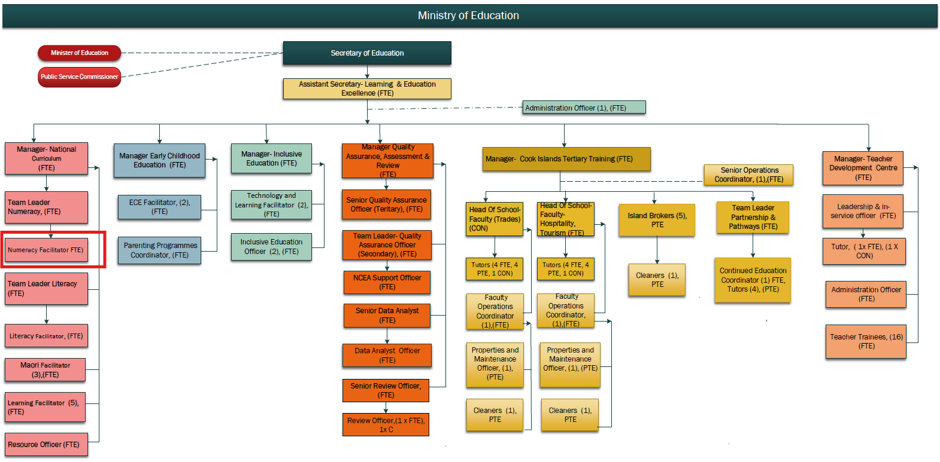

**KEY RESULTS AREA:**

|  |  |
| --- | --- |
| ***K.R.A*** | ***Key Performance Indicators*** |
| **1. School-Based Support** Deliver targeted, in-school support and coaching to teachers in numeracy pedagogy. | Support plans co-developed with schools; visible shifts in classroom practice; positive teacher feedback. |
| **2. Group Professional Development** Plan and deliver high-quality numeracy workshops and training through the Teacher Development Centre (TDC). | Regular workshops held; increasing teacher participation; session evaluations reflect learning impact. |
| **3. Curriculum and Review Responsiveness** Ensure facilitation reflects curriculum changes and specific needs identified through school reviews. | Facilitator programmes adapted in response to reviews; improved school follow-up outcomes; feedback from QA team |
| **4. Collaborative Practice and Resource Sharing** Work with other facilitators to share best practices and build cohesive system-wide numeracy support. | Co-developed resources; integrated workshops; cross-discipline initiatives developed and implemented. |
| **5. Promoting Equitable Access** Ensure teachers across all islands, including Pa Enua, receive ongoing, accessible support in numeracy. | Visit records and virtual support logs maintained; teachers in Pa Enua report improved access to PLD. |

**WORK COMPLEXITY:**

|  |  |
| --- | --- |
| *Indicate Most challenging duties typically undertaken:* | |
| 1 | Adapting facilitation approaches to support individual teacher needs in remote or resource-constrained environments. |
| 2 | Delivering follow-up support based on school review findings, often requiring differentiated responses. |
| 3 | Balancing multiple facilitation responsibilities – including school visits, workshop delivery, resource development, and review follow-ups. |
| 4 | Aligning practice with evolving curriculum direction while ensuring accessibility and cultural relevance |

**AUTHORITY:**

Authority levels expressed in terms of routine expenditure, granting loans, and recruiting and dismissing staff. (*Explain the authority if any*)

|  |  |
| --- | --- |
| **Financial** | Nil |
| **Staff** | Nil |
| **Contractual** | Nil |

**FUNCTIONAL RELATIONSHIPS:**

The requirement for human relations skills in dealing with other personnel and external contacts. *(List the external and internal types of functional relationships)*

|  |  |  |  |
| --- | --- | --- | --- |
| Internal | Nature of Contact | External | Nature of Contact |
| Team Leader – Numeracy | Reporting, planning, direction | Local experts and advisors | Content co-development or delivery |
| Teachers and Principals | Coaching, support, needs identification | Pa Enua community educators | Remote support and follow-up |
| Teacher Development Centre Team | Workshop planning and delivery |  |  |
| Curriculum, Literacy, and Inclusive Ed Teams | Joint facilitation, strategic alignment |  |  |
| School Review & QA Team | Receiving review findings; informing support approach |  |  |

**QUALIFICATION:**

###### Level of education required to perform the functions required of the position. This combines formal and informal levels of training and education.

|  |  |
| --- | --- |
| **Essential: (least qualification to be competent)** | **Desirable: (specific qualification for job)** |
| * Bachelor of Education or equivalent teaching qualification * Eligible for or currently holding Cook Islands Teacher Registration | * Postgraduate study in Education, Numeracy, or Adult Learning * Qualification or training in teacher professional learning facilitation |

**Knowledge / Experience**

The length of practical experience and nature of specialist or managerial familiarity required. This experience is in addition to formal education.

|  |  |
| --- | --- |
| **Essential: (least number of years to be competent)** | **Desirable: (target number of years you are looking for)** |
| * At least 3 years teaching experience, including demonstrated success in delivering numeracy programmes * Experience supporting peers or participating in school-based professional learning * Familiarity with the NZ Curriculum and numeracy learning progressions | * Experience in teacher facilitation or adult learning settings * Understanding of review-based school improvement planning * Experience working in or with Pa Enua schools |

**Key Skills /Attribute / Behaviours**

|  |  |
| --- | --- |
| **Level of ability required for the job** |  |
| **Expert** |  |
| **Advanced** | * Numeracy Pedagogy: Proficient in effective numeracy teaching and the ability to model and mentor others. * Facilitation & Coaching: Skilled in designing and delivering adult learning, including group workshops and one-on-one support. |
| **Working:** | * Review Responsiveness: Able to interpret school review reports and align facilitation to support identified needs. * Communication and Collaboration: Strong interpersonal skills to engage teachers and coordinate with Ministry teams. * Curriculum Alignment: Ability to support teachers in understanding and applying national curriculum shifts. |
| **Awareness** | * Cultural Context and Inclusion: Recognises the value of culture, language, and context in shaping numeracy learning and delivery. |

**Approved:**

Head of Ministry – Secretary of Education Date

Employee Date