

**MINISTRY OF EDUCATION P.O. Box 97, Rarotonga, Cook Islands**

**Government of the Cook Islands**

**Phone: (682) 29 - 357 Fax: (682) 28 - 357**

**POSITION DESCRIPTION**

|  |  |
| --- | --- |
| **Position Title:** | **Manager** |
| **Division:** | Cook Islands Tertiary Training Institute |
| **Responsible To:** | Assistant Secretary- Learning & Educational Excellence |
| **Responsible For:** | More than 20 teaching and support staff  (Senior managers, Island Learning Brokers, community education, tutors, office and maintenance staff) |  |
| **Job Purpose:** | To lead, facilitate and co-ordinate all aspects of institute management to ensure the provision of high quality tertiary vocational and community education in order to maximise student learning opportunities and achieve the goals of the institute and Education Master Plan. |  |
| **Job Classification** |  |  |
| **Date:** | April 2021 |  |

**MINISTRY VISION:**

The Ministry of Education values the unique nature of the Cook Islands. We contribute to the effective governance of our country and are recognised as leaders in education throughout the region.

The Ministry of Education provides a dynamic and professional environment which promotes and supports lifelong learning through the provision of quality services.

**ORGANISATION CHART:**

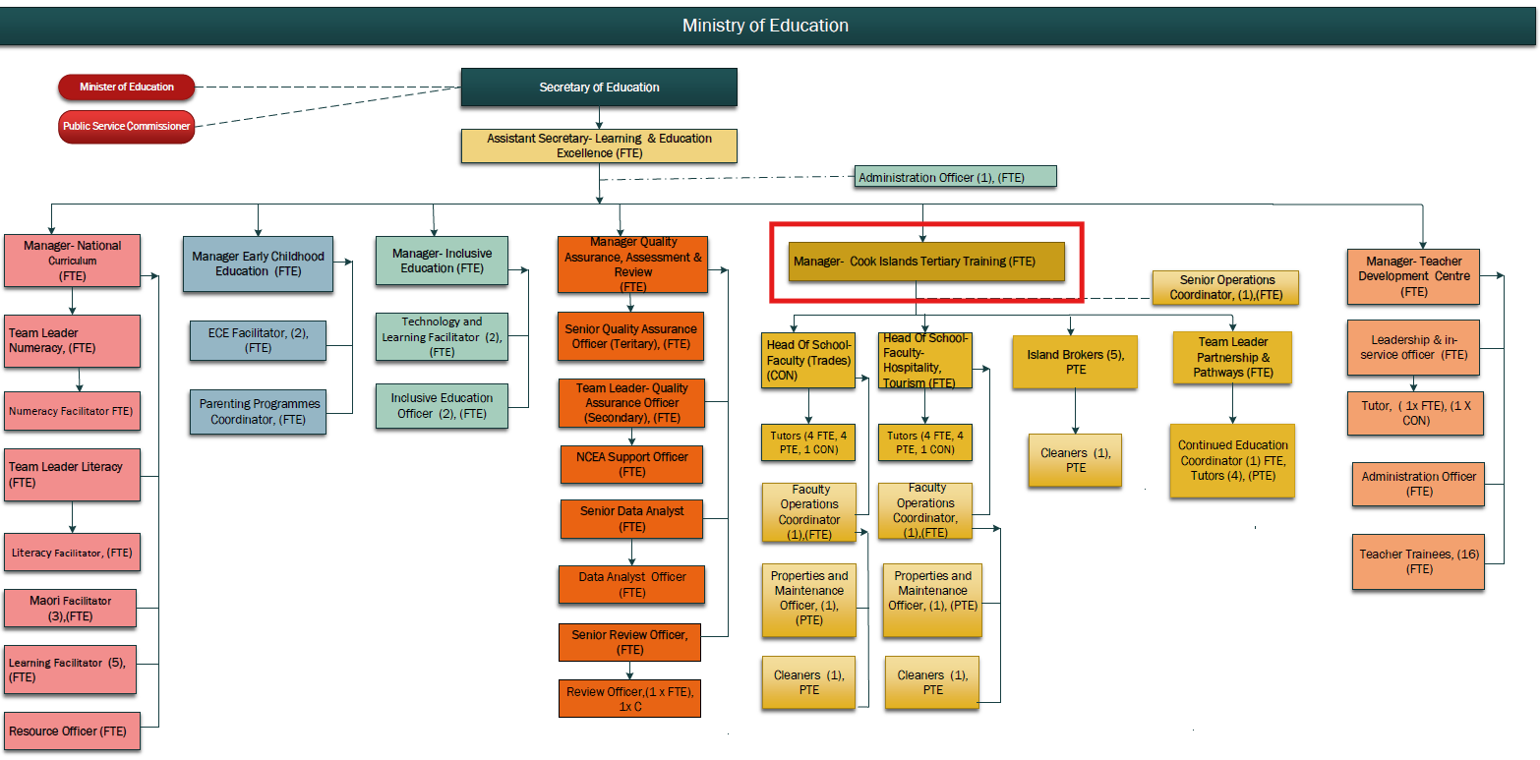

**KEY RESULTS AREAS:**

|  |  |
| --- | --- |
| ***K.R.A*** | ***Key Performance Indicators*** |
| **Professional Leadership**   * To lead, co-ordinate and facilitate the development of quality learning programs and training modalities including quality assurance processes * To establish and maintain an institute culture where learning is highly valued by all members of the community * To provide professional direction to the work of others by encouraging initiative and innovation in teaching practice and institute organisation | * Learning programme packages are developed in consultation with different stakeholder groups; published prospectus * Learning modalities are coordinated and implemented with student cohorts * Pa Enua learners are supported through a range of different strategies including blended learning * The institutes quality management systems are reviewed and improved to meet purpose and intent, responding to recommendations from external audit * Students receive quality instruction that meet their needs, interests and abilities * The institute is effectively and efficiently managed, including the day to day operations of the institute. |
| **Strategic Leadership**   * To lead, co-ordinate and facilitate the institute’s strategic planning * To review, refine and share a clear vision for the institute, to enable priorities to be identified that will ensure success and highest standards of achievement for all * Develop and manage the institutes business plan aligned with the Ministry of Education’s business plan with a focus on quality. * To develop, review and implement quality policies and practices for the effective management of the institute | * Performance measures detailed in Charter and business plans are met. * Staff and the community have a clear understanding of future development and are committed to work towards achieving institute goals through the strategic plan framework * Up to date curriculum is delivered in a climate of change that meet the achievement goals of the institute * Significant decisions are made based on evidence, consultation with relevant parties and careful evaluation of alternative options. * Monitoring tool to meet divisional outputs - mid-term and annual reports * External review is prepared for and the recommendations/findings are acted upon. |
| **Staff Leadership**   * To lead, organise and manage staff in order to maximize student learning opportunities * To develop an ethos in staff to strive for continual improvement through on-going professional development, reflection on performance and evaluation of their teaching | * Improved learning and achievement for all students * Staff feel valued and supported and work collaboratively and collegially to ensure that student learning outcomes are maximised. * Staff have access to quality current professional development to improve performance * Implement and monitor compliance with the Staff Performance Development System to ensure continued professional growth of staff |
| **Relationship Management**   * To develop and maintain strong positive relationships and partnerships with employers, industry and community groups. * To represent and act for the institute and Ministry in consultations, meetings and conferences in regards to tertiary training and education. | * Industry advisory groups established in tourism, trades and business services sector; regular consultation, briefs, reports * The community is provided with opportunities to be involved in aspects of the institute and learning * Meetings, consultations, conference reports including overseas participation. |
| **Financial and Asset Management**   * To implement and monitor an effective budget planning system * Maintains and manages the institute’s finance, assets and a safe work and learning environment * To meet MOE/MFEM reporting and audit requirements | * Available finances, resources and assets are used to support student learning outcomes * Funds and resources are clearly linked to the priorities documented in the institute’s strategic and annual business plan * Work towards achieving compliance in all health and safety areas; Disaster Risk Management plan in operation * All expenditure and money received is properly approved and receipted and follows the process as set out in the relevant institute and MoE policies. |
| **Statutory Obligations**   * To comply with Ministry of Education instructions, relevant statutes and regulations, and with monitoring reporting requirements | * Senior management team reports addressing non-compliance in consultation with relevant Division Directors and the Secretary of Education. * Quarterly and annual reports, risks and issues analysis reports, SMT minutes. |

**WORK COMPLEXITY:**

|  |  |
| --- | --- |
| *The most challenging duties typically undertaken by the Director include:* | |
| 1 | Total management of the institute with overall responsibility for delivery of post school education and training, including organizational development, industry needs analysis, course design and development, programme delivery, quality assurance of qualifications, managing staff and students. |
| 2 | Providing clear strategic direction for the organisation so that learners, families, employers, the community and government have confidence in the quality and type of training provided. |
| 3 | Relationship management with key industry bodies and major employers to ensure provision of training is fit for purpose. |
| 4 | Leading innovation in the provision of vocational education, taking advantage of new developments around the world. |
| 5 | Providing a safe and challenging learning environment for all learners particularly for those without previous success in the education system. |
| 6 | High level of effective human resources management skills which encourages reflective thought and action and supports and maintains high levels of staff performance as well as the retention of highly skilled and effective tutors and support staff. |
| 7 | Keeping abreast of best educational pedagogical practice and maintaining a culture of learning throughout the institute. |
| 8 | Judicious allocation of available resources (plant, people and equipment) and excellent financial management skills and practice |

**AUTHORITY:**

The Director has the following levels of authority:

|  |  |
| --- | --- |
| **Financial** | In collaboration with the Corporate Division. oversee all financial income and expenditure for the institute, particularly as it relates to institute resources, activities, administration, equipment, building maintenance or assets. |
| **Staff** | In conjunction with the HRM Division, participate in the recruitment of staff, oversee the completion of staff Performance Appraisals, and inform the HOM of all significant matters relating to staff, in particular staff leave, discipline, conduct and performance. |
| **Contractual** | Able to negotiate routine school maintenance and improvement contracts up to $1000 |

**FUNCTIONAL RELATIONSHIPS:**

The Director is required to demonstrate effective Human Resources Management skills in dealing with all internal and external relationship matters:

|  |  |  |  |
| --- | --- | --- | --- |
| Internal Relationships | Nature of Contact | External Relationships | Nature of Contact |
| HOM, Directors and MOE central administration staff | Governance, compliance, learning and teaching, human resources management, financial accountability, ICT resource management, audit and review, other matters as required (Heavy) | Industry Groups (CI Tourism, Chamber of Commerce, Trade bodies), employers, community, island governments | Promotion of CITTI courses, negotiating new course offerings, needs analysis, ongoing liaison, meetings, site visits and other communication modalities.(Promoting) |
| QAA and LD Managers | Institute management, program delivery, quality assurance, performance management and development, planning, monitoring and compliance (Light) | Government agencies, SOE’s, suppliers | Curriculum support, health and safety, resources, inventory, assets ongoing liaison through meetings and communications  (**Routine**) |
| Tutors, Learning Brokers, tutors, literacy numeracy | Leadership, guidance, mentoring, management, ongoing liaison, planning, monitoring and professional development (**Light**) | Schools | Promotion of courses programmes, dual Pathway (secondary/tertiary alignment pathways)(Promoting) |
| Community Education | Leadership, management, ongoing liaison, monitoring and professional development (**Heavy**) | Accrediting & standard setting bodies | Promoting Curriculum, assessment compliance, student data, ongoing liaison (**Promoting**) |
| Students | Enrolment, pastoral care, student progress, retention, completion and achievement, opportunities(Medium) |  |  |

**QUALFICATIONS:**

###### Level of education required to perform the functions required of the position of Director. This combines formal and informal levels of training and education.

###### A principal of a Category E School is required to have the following qualifications:

|  |  |
| --- | --- |
| **Essential: (least qualification to be competent)** | **Desirable: (specific qualification for job)** |
| * Bachelor’s Degree in Education with distinction * Cook Islands Techer Registration (with adult teaching qualification) | Post Graduate Diploma or a Master’s Degree in Educational Leadership inclusive of studies in adult education or teaching |

**EXPERIENCE:**

The length of practical experience and nature of specialist or managerial familiarity required. This experience is in addition to formal education.

|  |  |
| --- | --- |
| **Essential (least number of years considered):** | **Desirable (target number of years preferred):** |
| * Minimum of ten years’ teaching/tutoring experience in the senior secondary/TVET tertiary training institute * Five years’ senior management experience leading and managing a significant business unit within an educational institute * Extensive experience in negotiating and promoting tertiary training with employers, industry groups and the community | More than five years’ senior management experience leading and managing a faculty or school within a large tertiary institute |

**KEY SKILLS/ATTRIBUTES/JOB SPECIFIC COMPETENCIES:**

|  |  |
| --- | --- |
| **Key skill & level of ability required for the Job** | *Key Skills/attributes/competencies* |
| **Expert** | * Extensive knowledge and understanding of current and best practice pedagogy, conduct reviews and implement change * Extensive knowledge and understanding of effective and relevant student support and intervention strategies * Extensive knowledge and understanding of quality assurance, reviews, qualifications structures and accreditation requirements * Strengths-based leadership, with the ability to collaborate with others, across the spectrum of Ministry functions, to achieve mutually agreed goals |
| **Advanced** | * Knowledge and understanding of a range of modalities for delivering programmes and the ability to apply them appropriately within cultural context * Collaborative approach to the development of quality standards and frameworks, leading and managing change * A proven empathy for advancement of indigenous culture and language * Highly effective oral and written communication skills, maintains open, transparent and regular communication with stakeholders, employers, industry and the community * Have a sound understanding of education mandates, policies and regulations from which to base effective decision making. * Analyse and apply student assessment data to provide intervention strategies to address areas of concern and/or strengthen practice. * Strong interpersonal skills including advocacy, public speaking and presenting. |
| **Working** | * Ability to deal with risk and crisis management in a structured and calm manner * Ability to balance practical requirements with leading edge innovation. * Sound research & report writing skills (including the collection of both quantitative and qualitative data) * Sound understanding and application of the use of technology to support the provision of information * Ability to rise to the challenge of new and difficult tasks in pursuit of long term positive outcomes * Commitment towards positive outcomes in providing high quality education for all. * Improving management and leadership skills through further study and research. |
| **Awareness** | * Other government and non-government agency/organisation mandates, relevant legislation and QMS * External educational organisations and institutes developments, programs and opportunities for collaboration |

**CHANGE TO JOB DESCRIPTION:**

Changes to the Job description may be made from time to time in response to the changing nature of the Ministry’s work environment - including technological or statutory changes.

Secretary of Education Date

Employee Date