

**MINISTRY OF EDUCATION**

**P.O. Box 97, Rarotonga, Cook Islands**

**Government of the Cook Islands**

**Phone: (682) 29 - 357 Fax: (682) 28 - 357**

**POSITION DESCRIPTION**

|  |  |
| --- | --- |
| **Position Title:** | Monitoring, Evaluation & Data Officer |
| **Division:** | Policy, Development & Innovation |
| **Responsible To:** | Assistant Secretary – Policy Development & Innovation |
| **Responsible For:** | Nil |  |
| **Job Purpose:** | To lead the Ministry’s Monitoring and Evaluation (M&E) framework, ensuring that outcomes across early childhood, primary, secondary, and tertiary education are systematically tracked and reported. The officer is responsible for data collection, performance monitoring, evaluation coordination, and development of evidence-based performance reports. The role ensures compliance with strategic goals and targets in the Education Masterplan 2024–2034 and the Statement of Intent 2024–2027.  The Monitoring, Evaluation & Data Officer is also the Ministry's formal coordinator for the MERL (Monitoring, Evaluation, Research & Learning) framework, working collaboratively with the Research & Evidence-Based Policy Officer to ensure that findings inform policy and innovation. |  |
| **Job classification:** |  |  |
| **Date:** | 25 July 2025 |  |

**MINISTRY VISION:**

Akamatutuanga i te au karape, kite, te tu tangata e te irinakianga o te iti tangata Kuki Airani kia rauka ia ratou i taangaanga i ta ratou au tareni ki roto i to ratou oraanga.

Building the skills, knowledge, attitudes, and values of Cook Islanders to put their capabilities to best use in all areas of their lives.

**ORGANISATION CHART:**

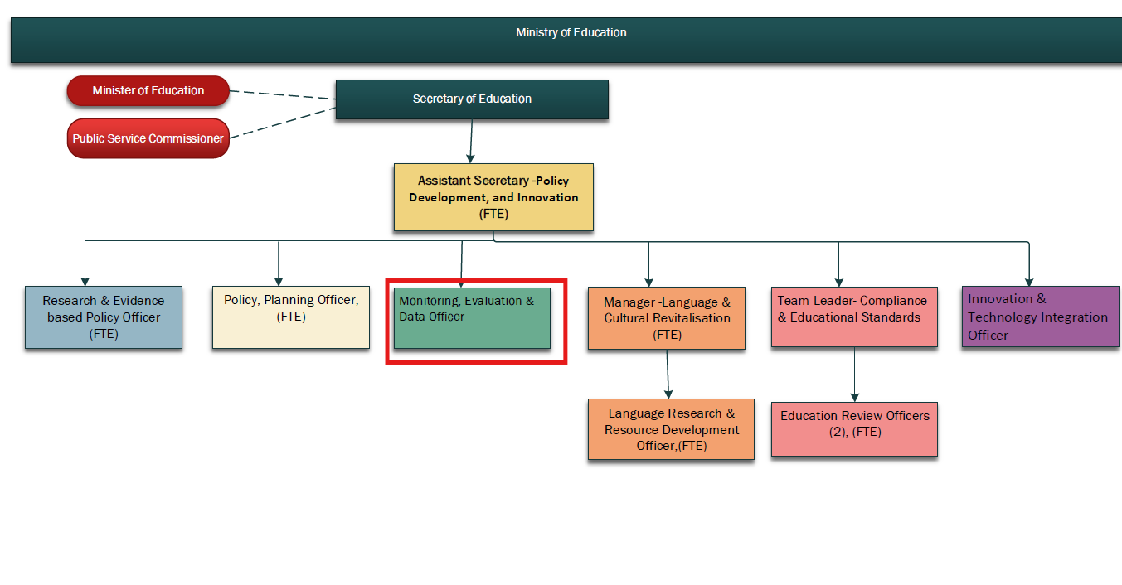

**KEY RESULTS AREA:**

|  |  |
| --- | --- |
| ***K.R.A*** | ***Key Performance Indicators*** |
| **1. M&E System Implementation:** Lead Ministry-wide monitoring and evaluation systems to track performance against strategic targets. | M&E framework operationalised; aligned with Masterplan; reviewed annually. |
| **2. Data Collection and Indicator Tracking:** Coordinate data collection across education sectors and manage Ministry’s performance indicator database. | Data dashboards operational; indicators updated; completeness and timeliness ensured. |
| **3. Performance and Results Reporting:** Develop reports that monitor progress and identify strengths, gaps, and opportunities for improvement. | Reports delivered on time; findings used by leadership and divisions. |
| **4. Evaluation Coordination;** Support and manage evaluations of key programs, reforms, or initiatives. | Evaluation plans implemented; reports archived; findings fed into improvement cycles. |
| **5. MERL Framework Management:** Serve as the lead MERL coordinator across the Ministry, ensuring collaboration across roles. | Annual MERL reporting completed; integration with research and policy confirmed. |
| **6. Capacity Building and Support:** Build internal capacity for evidence-based planning and use of monitoring tools. | Training delivered; staff supported; improved data usage evident. |

**WORK COMPLEXITY:**

|  |  |
| --- | --- |
| *Indicate Most challenging duties typically undertaken:* | |
| 1 | Coordinating cross-sector monitoring and evaluation systems |
| 2 | Ensuring data quality across diverse schools and programmes |
| 3 | Balancing Ministry priorities, deadlines, and evidence needs |
| 4 | Supporting evaluations and their application across divisions |

**AUTHORITY:**

Authority levels expressed in terms of routine expenditure, granting loans, and recruiting and dismissing staff. (*Explain the authority if any*)

|  |  |
| --- | --- |
| **Financial** | Nil |
| **Staff** | Nil |
| **Contractual** | Nil |

**FUNCTIONAL RELATIONSHIPS:**

The requirement for human relations skills in dealing with other personnel and external contacts. *(List the external and internal types of functional relationships)*

|  |  |  |  |
| --- | --- | --- | --- |
| Internal | Nature of Contact | External | Nature of Contact |
| Assistant Secretary | Direction and reporting | Development Partners | Results reporting and benchmarking |
| Data Analysts | Data collation and analysis | Consultants/Researchers | Evaluation design and findings |
| Policy and Curriculum Teams | Indicator design and reporting use |  |  |
| QA & Review Officers | Evaluation findings and alignment |  |  |

**QUALIFICATION:**

###### Level of education required to perform the functions required of the position. This combines formal and informal levels of training and education.

|  |  |
| --- | --- |
| **Essential: (least qualification to be competent)** | **Desirable: (specific qualification for job)** |
| Bachelor’s degree in Education, Development Studies, Public Policy, or related field | Postgraduate qualification in M&E, Statistics, or Development Planning |

**Knowledge / Experience**

The length of practical experience and nature of specialist or managerial familiarity required. This experience is in addition to formal education.

|  |  |
| --- | --- |
| **Essential: (least number of years to be competent)** | **Desirable: (target number of years you are looking for)** |
| Minimum 3 years in monitoring, evaluation, or results-based planning | Experience in education system reporting or MEL framework design |

**Key Skills /Attribute / Behaviours**

|  |  |
| --- | --- |
| **Level of ability required for the job** |  |
| **Expert** | * **M&E Framework Design:** Leads the development, refinement, and implementation of full monitoring and evaluation systems across the education sector. * **Results-Based Management:** Applies strategic planning, monitoring, and reporting aligned to measurable outcomes and indicators. * **Strategic Data Use:** Identifies, prioritises, and interprets data to inform planning, policy, and operational decision-making. |
| **Advanced** | * **Performance Reporting**: Develops high-quality, evidence-based reports that highlight achievements, gaps, and trends across all education levels. * **Dashboard and Tool Development:** Designs and maintains visual tools that support real-time performance tracking. * **Inter-Divisional Coordination:** Collaborates effectively across divisions to ensure data integrity, consistency, and purpose alignment. |
| **Working:** | * **Capacity Building:** Delivers training and support to improve Ministry-wide data literacy and M&E confidence. * **Evaluation Planning:** Designs and coordinates small-to-medium scale evaluations, including data collection tools and methodologies. |
| **Awareness** | * **Policy Influence:** Understands how M&E findings shape national education policy and sectoral reform efforts. * **Research Ethics:** Recognises appropriate data use, protection, and community respect principles in all M&E processes. |

**Approved:**

Head of Ministry – Secretary of Education Date

Employee Date