

**MINISTRY OF EDUCATION**

**P.O. Box 97, Rarotonga, Cook Islands**

**Government of the Cook Islands**

**Phone: (682) 29 - 357 Fax: (682) 28 - 357**

**POSITION DESCRIPTION**

|  |  |
| --- | --- |
| **Position Title:** | Human Resources Officer |
| **Division:** | Corporate Services |
| **Responsible To:** | Manager- Human Resources |
| **Responsible For:** | Not applicable |  |
| **Job Purpose:** | * To provide a high quality and responsive HR service in relation to performance appraisals and development, school staffing appointments, remuneration and employee relations. * To effectively manage and implement the Cook Islands Government Scholarships and Grants Program “Te Reinga Akataunga’anga”, reporting to the National Scholarships Committee, liaising with tertiary providers, students, employers and the community. |  |
| **Job classification:** | Support Services |  |
| **Date:** | 31 March 2025 |  |

**MINISTRY VISION:**

Akamatutuanga i te au karape, kite, te tu tangata e te irinakianga o te iti tangata Kuki Airani kia rauka ia ratou i taangaanga i ta ratou au tareni ki roto i to ratou oraanga.

Building the skills, knowledge, attitudes, and values of Cook Islanders to put their capabilities to best use in all areas of their lives.

**ORGANISATION CHART:**

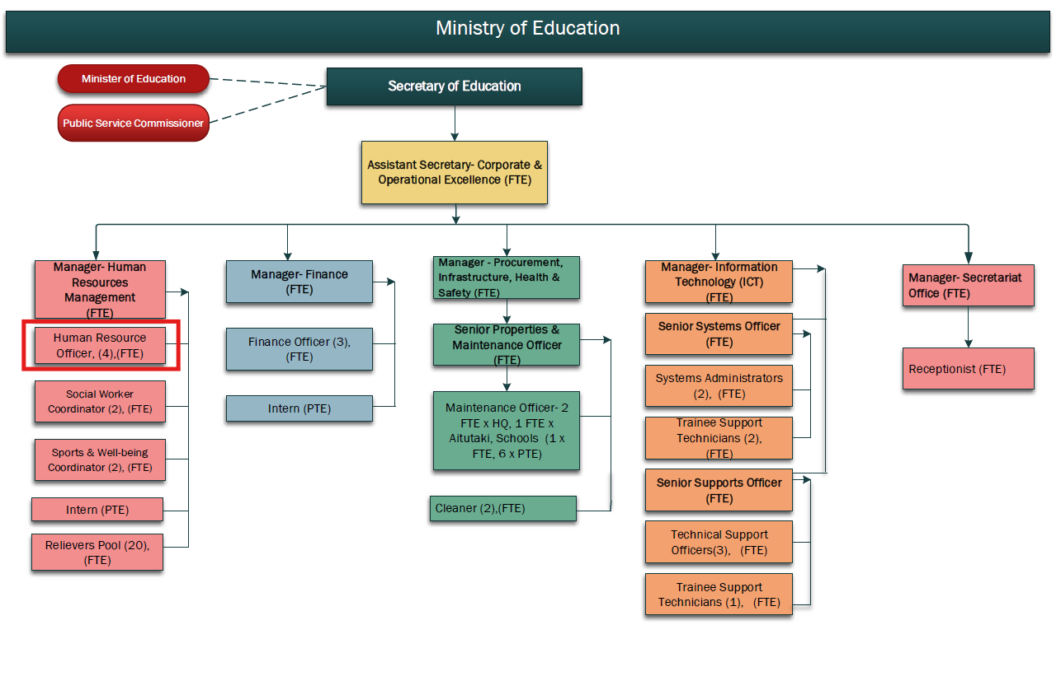

**KEY RESULTS AREA:**

|  |  |
| --- | --- |
| ***K.R.A*** | ***Key Performance Indicators*** |
| **KRA 1: Recruitment**   1. To advise Principals, Directors and senior managers on recruitment plan, responsibilities and processes. 2. To lead and advise recruitment panels on the process of selection – shortlisting, interviews, reference checking, offers and appointments. 3. To review and ensure all recruitment documentation is well prepared and accessible including JD, application forms & information, referee reports, shortlisting templates and interview questionnaires. 4. To prepare and deploy advertisements to internal or external markets in local media, Government website, NZ Education Gazette, overseas media (NZ, Fiji), Seek. 5. To monitor and carry out an evaluation of the recruitment and selection process. | * Recruitment and selection processes are professional, efficient and responsive and instil confidence in both the Ministry and candidate. * Shortlisting, grading, selection, panel selection and interview processes are clear, transparent and appropriate. * Pa Enua recruitment processes are conducted from Rarotonga to ensure integrity consistency and confidentiality is maintained. * Job advertisements are clear, transparent and fair and are posted to the local media, website and overseas media. |
| **KRA 2: Administration**   * To prepare and send all completed appointments documentation to PSC and MFEM. * To manage the processing of work and entry permits, customs forms, travel bookings and to ensure all financial documents are in order. * To communicate and liaise with relevant agencies and rental accommodation to ensure relocation and settlement needs of overseas employees are met. * To plan and facilitate staff orientation and induction programs, advising Directors, Principals and managers of the process in their schools and divisions. * To process appointment notices for casual employees (relief teachers) in a timely manner, liaising with schools to confirm details of timesheets; employee adjustments and ceasing employment. * To prepare vouchers for payment of staff who are entitled to arrears, final annual leave payments and allowances. * To administer the recruitment budget allocation for local and overseas staff. | * Appointments information is processed accurately and forwarded to PSC, MFEM & CINSF * Overseas staff complete health and police clearances, Ministry of Health medical clearance is obtained, travel dates confirmed. * Shipping agent processes freight, forms for customs clearance completed * A list of rental accommodation compiled, house visits completed - including details of location, building particulars, rental price etc. * MOE orientation and induction program, including key agencies; school/division programs implemented as planned and reviewed. * NOA forms, vouchers, NEA, NCE are processed accurately, details confirmed and according to PSC schedule. |
| **KRA 3: Effective implementation and management of Scholarship Programmes**   * Liaison with regional and international providers and development partners over recipient placements. * Administer the distribution of funds with regular follow up with the Finance Division and MFEM. | * Study awards are widely advertised and promoted through the media, in schools and the general community (PSC, HOMs, Chamber, Island Administration). * Provide training, advice and guidance to the scholarship committee and applicants. * Process applications in a timely manner (collation, verification, registration). * Secretariat to the Scholarship Committee – ensuring that all relevant policies are adhered to within the process (shortlisting, interviewing, selection). |
| **KRA 4: Pastoral care and support provision to scholarship applicants and recipients**   * Provide a comprehensive induction programmes for scholarship recipients prior to departure. * Strengthen the performance control system, including support services to monitor student progress and to assist with matters relating to study program and employment opportunities in the CI. | * Assist Careers/Guidance Advisor to support and promote Guidance and Career pathway programmes for senior secondary and adult learners. * Attends the Annual Careers Expo and promote the exposure of learners to a range of career pathways and scholarship opportunities. * Provides timely and accurate responses to information and requests for advice on scholarships and training opportunities. * Maintains ongoing and regular contact with scholarship recipients, including an annual visit. * Issues/decision and pastoral care reports sent to Scholarship Committees for application of policy. |
| **KRA 5: HR Communication**   * To ensure that all stakeholder communications are clear, responsive, and professional and expectations are clearly defined, agreed and monitored. * To develop and maintain collaborative and productive relationships with service areas, colleagues and establishing professional credibility. * To facilitate feedback from clients about the HR services offered. | * Enquiries are dealt with in an efficient, professional and courteous manner. * Maintaining the effectiveness of HR systems and processes which produce clear working papers and documentation of processes for audit. * Conduct surveys and contribute to the annual HRM report. |
| **KRA 6: Performance Management**   * To support, facilitate, and maintain the performance management and development process (PDS) within the Ministry. * To provide assistance and guidance to Directors, Principals and managers on the implementation of the PDS process, conducting professional development for staff. * To receive and process PDS documentation and recommendations in consultation with the Director P&D. * To refer staff for further guidance and support as a result of performance review report outcomes. * To assist in investigations into staff conduct, complaints and performance related matters, appeals, providing final outcomes report in consultation with the Director. | * Ensuring all employees have PDS documentation aligned to the MOE plans, teaching standards or competencies and that the PDS appraisal cycle is implemented in all schools, training establishments and divisions. * Manage the annual processing of documentation according to stated timelines. * Poor performers and skill gaps will be identified, high performers will be evident and will require recognition, succession planning will be practised. * With P&D, to manage the non-performance of staff with regards to supplementary reviews, performance improvement plans, final phase of the review and to ensure all involved are aware of their responsibilities. * Investigation process is maintained and reviewed; final outcomes documentation is of a high quality and is well researched. |
| **KRA 7: Employment Relations & Administration**   * To lead in the management of casework involving conduct, performance and disputes, giving advice and support to managers, making recommendations, liaising with other agencies, review and discipline meetings * To provide HR advisory input into service area projects, change management programmes and working groups as required. * Keep up to date with developments in employment legislation and human resources best practice; knowledge sharing within the team to ensure continuous development and improvement in the service offered. | * The resolution of all HR issues in accordance with Ministry policies and procedures, in line with current employment law requirements (performance reviews). * HR issues are dealt with promptly, effectively and according to agreed actions. * Contribution to the development & review of the annual HR business plan (budget tracking, monthly HRM Team reports). * Job evaluation training and contributing to the review of position descriptions across the Ministry |

**WORK COMPLEXITY:**

|  |  |
| --- | --- |
| *Indicate Most challenging duties typically undertaken:* | |
| 1 | Manage the recruitment, selection and induction process from deciding on MOE staffing requirements (with HOM), advertisement campaign, receiving and vetting applications, panel selection, interviews, selections, appointments, processing documentation to a high standard for PSC and MFEM. |
| 2 | Manage the transfer process of expatriate staff – assisting with immigration and customs requirements, updating list of rental homes, making travel and freight arrangements, assist with finding first home and providing ongoing assistance. |
| 3 | Ensure the Ministry’s Human Resources practices comply with the appropriate policies and procedures and current employment legislation, effective contribution to policy development, review and monitoring; workforce planning. |
| 4 | Clear and effective communication with schools/providers, stakeholders, staff and applicants to ensure the recruitment and appointments process is understood and meets with PSC guidelines; monitor recruitment budget and milestones. |
| 5 | Manage and effectively implement the Scholarship/Grants program “Te Reinga Akataunga’anga”, providing advice and guidance to HOM and Scholarships Committee, seeking timely resolution of all issues, monitor budget, track expenditure. |
| 6 | Liaison with tertiary providers on placement of scholarship recipients, student welfare, fees payment and student loan (Study Link). |
| 7 | Manage the PDS process of the Ministry advising senior management and staff on requirements, providing development opportunities. Processing final appraisal outcomes including referrals to appropriate MOE staff for staff recuing support and guidance. Carrying out investigations into complaints, conduct and performance matters maintaining confidentiality and integrity’ reports are clear, unbiased and well researched. |

**AUTHORITY:**

Authority levels expressed in terms of routine expenditure, granting loans, and recruiting and dismissing staff. (*Explain the authority if any*)

|  |  |
| --- | --- |
| **Financial** | Will assist Manager Human Resources to monitor budget. |
| **Staff** | No direct reports but Advise both local and expatriate staff on appointment processes, PMS process, outcomes and Principals on school staffing needs. |
| **Contractual** | Will assist Manager Human Resources to negotiate and draft employment contracts. |

**FUNCTIONAL RELATIONSHIPS:**

The requirement for human relations skills in dealing with other personnel and external contacts. *(List the external and internal types of functional relationships)*

|  |  |  |  |
| --- | --- | --- | --- |
| **Internal** | **Nature of Contact** | **External** | **Nature of Contact** |
| School Principals & line Managers | Vacancies, policy advice, appointments, induction of new staff and other matters as required **(Heavy)** | Community Services – accommodation, airlines, shipping agencies, banks, media outlets | Travel arrangements (overseas, local), freight, temporary/permanent accommodation, banking, advertising (**Routine**) |
| School, CITTI, MOE Administration staff | Respond to queries, appointment documentation, induction, employment relations **(Heavy)** | Government Agencies – MOH, MFAI, MFEM, OPSC | Immigration matters, health and police clearance, customs clearance, appointment’s documentation, (**Routine)** |
| Corporate Services | Finance - payments, reimbursements, payroll, leave, ITC – set up of staff accounts, training, and other matters as required.  **(Heavy)** | General Public | Respond to vacancy queries, inform status of applications and other matters (Routine) |
|  |  | Overseas Agencies – NZ Gazette, NZTC | Advertising, teacher registration (**Minimal)** |
| National Scholarship Committee | Program implementation & administration, sharing information, seeking consensus, reporting. Director HRM – employment matters  **(Heavy)** | School/providers, government and private sector employers | Scholarship and grant program information, implementation, advertising, responding to queries; MFEM – payments of allowances. (**Routine**) |

**QUALIFICATION:**

###### Level of education required to perform the functions required of the position. This combines formal and informal levels of training and education.

|  |  |
| --- | --- |
| **Essential: (least qualification to be competent)** | **Desirable: (specific qualification for job)** |
| * A bachelor’s Degree in a Humanities field with studies in HRM, Business, Psychology or Education | * A post graduate qualification in the stated fields |

**Knowledge / Experience**

The length of practical experience and nature of specialist or managerial familiarity required. This experience is in addition to formal education.

|  |  |
| --- | --- |
| **Essential: (least number of years to be competent)** | **Desirable: (target number of years you are looking for)** |
| * Maturity and a minimum of 5 years relevant work experience inclusive of   + Recruitment, selection and appointments   + Staff induction   + Provision of high quality documentation; finance administration * 2 years’ management experience in an institution or business * Ability to communicate effectively in both Cook Islands Maori and English | * At least 5 years’ relevant work experience * Experience in an HRM middle management position * Education sector. experience * Contract processing and law |

**Key Skills /Attribute / Behaviours**

|  |  |
| --- | --- |
| **Level of ability required for the job** |  |
| **Expert** | * **Recruitment and appointments services and solutions -** Good understanding of requirements of all processes. Ability to provide, administer and support staff in the recruitment and induction process * **Problem Solving -** Ability to work methodically through problems, manage pressure and resolve issues to the satisfaction of staff and external stakeholders * **Customer Relations** - Working to achieve total customer satisfaction (includes internal and/or external customers) * **Communication Skills** - Expressing ideas effectively in individual and group situations; adjusting language or terminology to the characteristics and needs of the audience. Keeps information confidential. * **Collaboration** - Working effectively with others in the HRM Division to accomplish team goals. Highly articulate with ability to communicate with management and clients. |
| **Advanced** | * **Quality and Accuracy of documentation**- Accomplishing tasks with concern for the standard produced; checking own work to ensure accuracy, adherence to procedures and completeness. Improves processes to ensure improvement in quality of outputs over time. * **Interpersonal Skills** - Establishing and maintaining relationships with staff and external agencies to improve the overall effectiveness of the position. * **Attention to detail** – ability to accurately check processes, tasks and /or information no matter how small over time yet still showing concern for all the other aspects of the job. * **Decision making** - Making timely decisions; judgements; taking action when appropriate and committing to and supporting decisions made. Able to work to negotiated timetable and meet deadlines * Ability to deal with risk and crisis management in a structured and calm manner |
| **Working:** | * Good research & report writing skills (including the collection of both quantitative and qualitative data) * Sensitivity towards and understanding of Cook Islands culture. * Good computer skills and knowledge of basic software, IT Level 3 competency * Actively participating in own professional development * An ability to respond to changing situations in a flexible manner in order to meet current needs. |
| **Awareness** | **Education Awareness** - Awareness of the links of tasks to MOE policies, manuals and statutes. Considers implications and risk of proposed actions/decisions in regard to meeting education outcomes. |

**Approved:**

Head of Ministry – Secretary of Education Date

Employee Date