**Schedule B: Position Description**

**Government of the Cook Islands**

**Phone: (682) 29 - 357 Fax: (682) 28 - 357**

**MINISTRY OF EDUCATION**

**P.O. Box 97, Rarotonga, Cook Islands**

**POSITION DESCRIPTION**

|  |  |
| --- | --- |
| **Position Title:** | **Quality Assurance Coordinator- Tertiary** |
| **Division:** | Learning and Educational Excellence |
| **Responsible To:** | Manager- Quality Assurance, Assessment & Review |
| **Responsible For:** | n/a |  |
| **Job Purpose:** | To have oversight of the development, coordination and monitoring of all quality assurance processes of CITTI to maximise opportunity for learners to gain internationally recognised tertiary qualifications. To manage office administration and support staff at all CITTI campuses and centres. |  |
| **Job classification:** |  |  |
| **Date:** | 30 April 2025 |  |

**MINISTRY VISION:**

Akamatutuanga i te au karape, kite, te tu tangata e te irinakianga o te iti tangata Kuki Airani kia rauka ia ratou i taangaanga i ta ratou au tareni ki roto i to ratou oraanga.

Building the skills, knowledge, attitudes, and values of Cook Islanders to put their capabilities to best use in all areas of their lives.

**ORGANISATION CHART:**

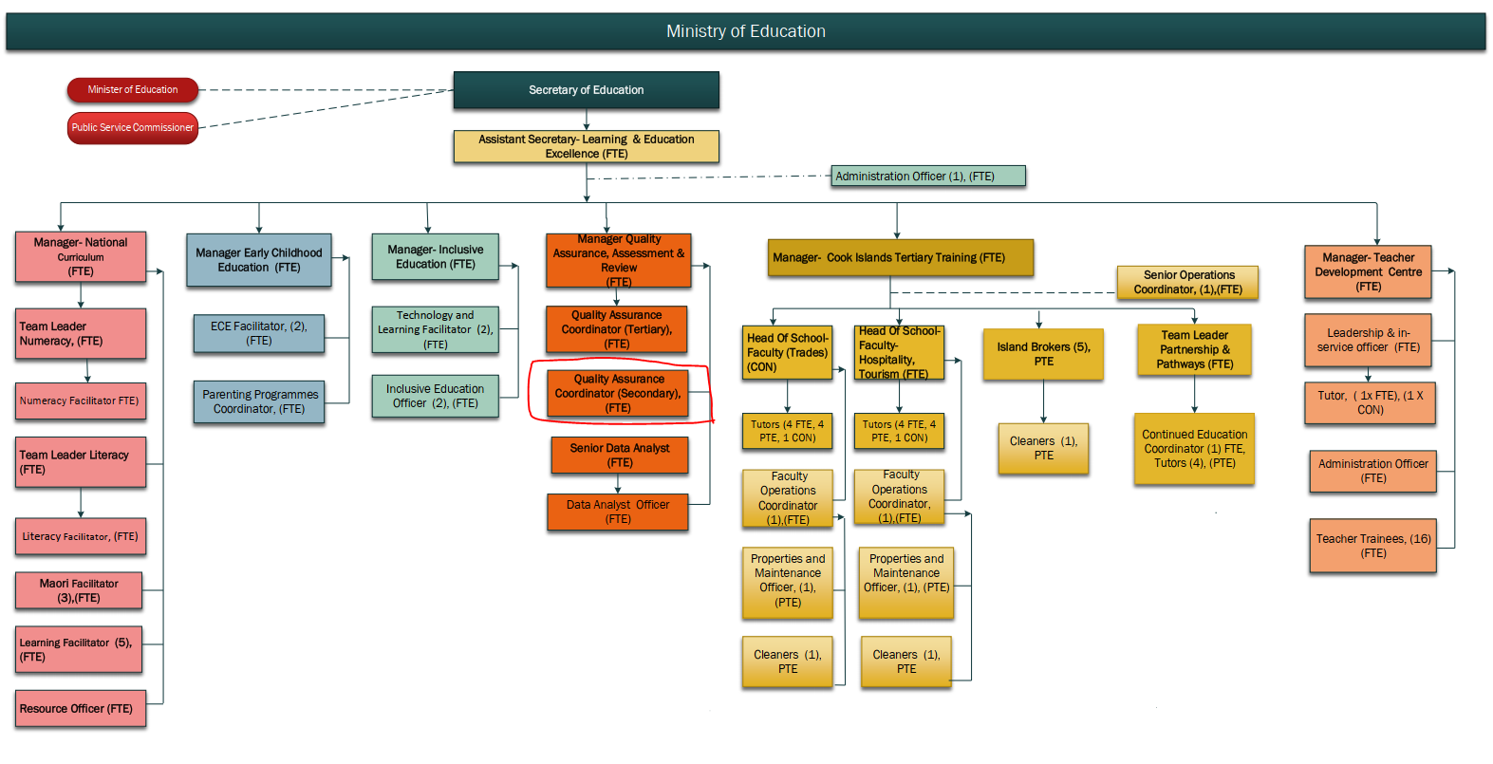

**KEY RESULTS AREA:**

|  |  |
| --- | --- |
| ***K.R.A*** | ***Key Performance Indicators*** |
| **1. Quality Assurance**  Develop, implement and manage quality assurance processes within specific programmes focussed on relevant, quality outcomes for students | * QA processes are developed and monitored in consultation with different stakeholder groups. * Learning modalities are coordinated and implemented with student cohorts. * Pa Enua learners are supported through a range of different strategies including blended learning. |
| **2. Quality Assurance Review and Evaluation** Work with relevant standard setting bodies (NZQA, C&G) in program development, accreditation and review.  Manage external review processes with respective SSB & ITO (EER, MOE). | * EER reviews reports indicative of implementation and progress of QA processes * Response to review are planned and implemented; staff capability development * Pa Enua and online learning progression reports. |
| **3. Student Management System** Manage Institute data collection, recording and reporting including academic achievement data.  Oversight of student recruitment and student academic and pastoral care support services. | * Student reporting/ recording of standards achieved is robust and reliable * Qualification, progression and annual enrolled achievement rates are monitored and met * Information for decision making by CITTI and MoE management is collated and readily available. * Specific support for low achievers is planned for and delivered. |
| **4. Staff Development**  Development of teaching and administration staff to enable successful implementation of quality assurance processes.  Proactive in the appointment of staff for positions. Manage effective staff induction programs. | * Teaching and professional development is effectively managed. * Specific tutor training is identified and appropriately sourced and supported from training needs review. * Tutors meet the required standard of delivery including those of external ITOs. * New staff induction program. |

**WORK COMPLEXITY:**

|  |  |
| --- | --- |
| *Indicate Most challenging duties typically undertaken:* | |
| 1 | Implement and manage quality assurance processes for specific programmes in response to change in tertiary training needs regionally and internationally |
| 2 | Manage and respond to external review processes with respective SSB & ITO (EER, MOE) |
| 3 | Implement staff and tutor training and development programmes to enable successful implementation of quality assurance processes |
| 4 | Developing and implementing solutions for individual learner pathways to ensure completion of qualifications and skills attainment |
| 5 | Data tracking and analysis to inform decision making at the institute level and for senior management of the Ministry. |

**AUTHORITY:**

Authority levels expressed in terms of routine expenditure, granting loans, and recruiting and dismissing staff. (*Explain the authority if any*)

|  |  |
| --- | --- |
| **Financial** | Nil |
| **Staff** | Nil |
| **Contractual** | Nil |

**FUNCTIONAL RELATIONSHIPS:**

The requirement for human relations skills in dealing with other personnel and external contacts. *(List the external and internal types of functional relationships)*

|  |  |  |  |
| --- | --- | --- | --- |
| Internal | Nature of Contact | External | Nature of Contact |
| Manager – QA, Assessment & Review | Direction, oversight, reporting | NZQA (New Zealand Qualifications Authority) | Submission of entries, results, moderation, and compliance |
| School Principals and NCEA Coordinators | Day-to-day operational support and guidance | School-based NCEA Moderators | Coordination and support for internal assessment quality |
| QA Officers and Senior Data Analyst | Alignment on assessment and data integrity | Pacific education partners (if relevant) | Sharing practices, attending NCEA updates or workshops |
| Learning & Curriculum Teams | Advice on learning pathway planning and subject selection |  |  |

**QUALIFICATION:**

###### Level of education required to perform the functions required of the position. This combines formal and informal levels of training and education.

|  |  |
| --- | --- |
| **Essential: (least qualification to be competent)** | **Desirable: (specific qualification for job)** |
| * Diploma or degree in Education, Assessment, Data Management, or Administration * Familiarity with the NCEA system and school assessment processes * High computer literacy, especially in data systems and reporting tools | * Training in NZQA systems or experience working with NCEA moderation * Background in secondary education or school assessment administration * Knowledge of Pacific or small-island education contexts |

**Knowledge / Experience**

The length of practical experience and nature of specialist or managerial familiarity required. This experience is in addition to formal education.

|  |  |
| --- | --- |
| **Essential: (least number of years to be competent)** | **Desirable: (target number of years you are looking for)** |
| * At least 4 years’ senior management experience in the TVET/senior secondary education sector including the development and delivery of programmes that utilise standards based assessment with Quality assurance management experience, Staff and performance management. * Management of student databases. * 8 years’ experience with TVET programme delivery and content areas. | * More than 4 years Senior management experience in the education sector managing a faculty or department |

**Key Skills /Attribute / Behaviours**

|  |  |  |
| --- | --- | --- |
| **Level of ability required for the job** |  | |
| **Advanced** | Assessment System Knowledge | Understands NCEA requirements, processes, and compliance expectations. |
|  | Data Accuracy and Integrity | Ensures student records are complete, timely, and error-free. |
| **Working** | Communication and Stakeholder Support | Provides clear, supportive advice to school staff and leaders. |
|  | Technical Proficiency | Confident in digital platforms, data systems, and troubleshooting. |
| **Awareness** | Policy and System Alignment | Understands how national qualification changes affect school-level practices. |

**Approved:**

Head of Ministry – Secretary of Education Date

Employee Date