

**MINISTRY OF EDUCATION**

**P.O. Box 97, Rarotonga, Cook Islands**

**Government of the Cook Islands**

**Phone: (682) 29 - 357 Fax: (682) 28 - 357**

**POSITION DESCRIPTION**

|  |  |
| --- | --- |
| **Position Title:** | Tutor |
| **Division:** | Learning & Educational Excellence |
| **Responsible To:** | Head of School Faculty or Manager TDC |
| **Responsible For:** | n/a |  |
| **Job Purpose:** | To provide quality and effective learning and teaching to students enrolled in a specific programme of study; including developing course and assessment materials relevant to industry in the Cook Islands ensuring. |  |
| **Job classification:** |  |  |
| **Date:** | 30 June 2025 |  |

**MINISTRY VISION:**

Akamatutuanga i te au karape, kite, te tu tangata e te irinakianga o te iti tangata Kuki Airani kia rauka ia ratou i taangaanga i ta ratou au tareni ki roto i to ratou oraanga.

Building the skills, knowledge, attitudes, and values of Cook Islanders to put their capabilities to best use in all areas of their lives.

**ORGANISATION CHART:**

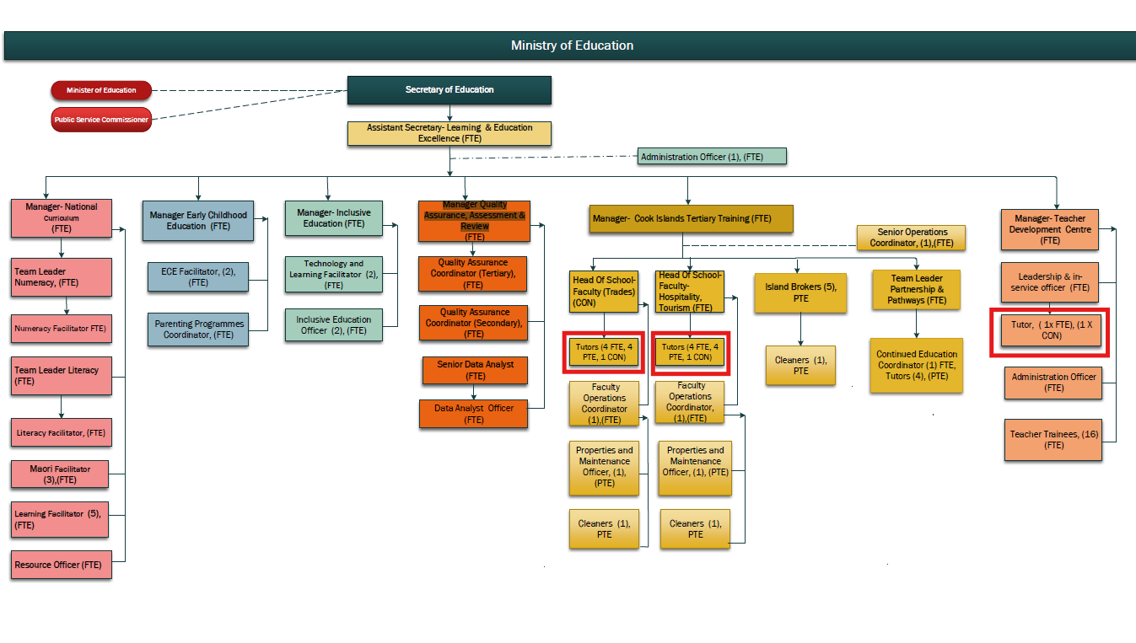

**KEY RESULTS AREA:**

|  |  |
| --- | --- |
| Key Results Area | Key Performance Indicators |
| **KRA 1: Teaching Practice**   * To plan, prepare and deliver quality programmes as prescribed by the curriculum * Supply effective teaching and learning strategies to promote effective learning consistent with individual student learning needs * Use assessment data to inform future planning and intervention strategies * To provide regular and meaningful feedback on student progress and achievement. * To utilise and manage all learning and teaching resources, effectively and efficiently | * Plans, prepares, implements and evaluates programs that incorporate unit and Standards Based Assessment standards * A high standard of learning & teaching is maintained, informed through a range of assessment practices at a level appropriate to the ability of all students * Students receive tutorial support that is individualized to their learning styles. * Student progress and achievement are regularly analysed and intervention strategies implemented to raise achievement levels to meet expected student and program goals – credit tracking * Students receive appropriate feedback on their progress and level of achievement and are informed of areas where extra support would be beneficial * Students’ learning opportunities are maximised through access to appropriate and properly maintained resources |
| **KRA 2: Quality Management Systems (Managing International Qualifications)**   * To verify/moderate assessment materials in area of expertise according to service provider processes * To ensure the institute maintains its accreditation to offer accredited programs of learning according to scope of accreditation and relevant MOU. * To develop, review and implement programmes of learning and respond to feedback | * Complies with external audit requirements and guidelines including pre, post and external moderation, Further Assessment Opportunities, records retention and reporting guidelines * Verified results entered in SMS and submitted, students receive record of learning and/or achieve qualification. * Implements outcomes of external audit reviews and requirements within given timelines * Assist new staff with meeting the requirements of service provider. * Participates in the institutes QMS committees and external audit reviews * Programs are evaluated and reviewed, coursework is developed and implemented. |
| **KRA 3: Administration**   * Discharge administrative responsibilities integral to Tutors work including keeping up to date records and evidence of student achievement * To operate within the policy framework and legislative obligations of CITTI * To maintain good networks with the local industry | * All teaching plans, assessment procedures and teaching resources are completed and up to date * The CITTI Quality Management System is upheld and all accreditation is maintained; All policy and procedures are abided by * Training is industry appropriate, industry is consulted six monthly |
| **KRA 4: Professional Knowledge and Development**   * To have current knowledge of content and best practice principles and pedagogy that can be applied to the learning situation. * To be competent and to keep up to date in the subject area | * Keeps abreast of changes in subject area through subject associations, advisors, colleagues in other institutes * Regularly reflects on and reviews personal performance * Demonstrates a commitment to personal growth and knowledge development * Contributes to ongoing curriculum, assessment and policy review and evaluation. * If applicable, to work towards and gain an adult teaching qualification. |
| **KRA 5: Student Management**   * To initiate and manage recruitment of students * Provides a supportive, creative, stimulating and safe environment for students * To monitor student attendance, progress and achievement. * To implement sound strategies in managing student behaviour effectively and within CITTI policy | * Programs commence with a full complement of students * Uses positive reinforcement to encourage desired behaviors * Effective classroom layout, displays; health and safety procedures are implemented * Responds effectively and in a timely manner to individual student needs * Communicates effectively with students, staff and parents and caregivers * Establishes and maintains clear and effective classroom routines |
| **KRA 6: Professional Conduct**   * Demonstrate professional conduct as expected by an employee of the Cook Islands Public Service * Participate fully and effectively in the institutes performance management system | * Demonstrates professional conduct at all times * Complies with the values and code of conduct of the CIPS * Complies with the requirements of the MOE performance management system * Meets all expected deadlines and reporting requirements as directed by the Senior Managers. |

**WORK COMPLEXITY:**

|  |  |
| --- | --- |
| *Indicate Most challenging duties typically undertaken:* | |
| 1 | A comprehensive knowledge and understanding of relevant curricula and demonstrating effective pedagogical practice. |
| 2 | Self-reflection to inform planning and alternative delivery approaches and methodologies. |
| 3 | Establishing and organising programme of courses including learning plans, course content and assessments. |
| 4 | Ensuring diverse needs of learners are met; recruiting students and maintaining enrolment numbers. |
| 5 | Demonstrate planning skills that provide connections to prior learning and experiences, and display competency in evaluation for future planning. |
| 6 | Managing relationships with industry, employers, community groups and relevant government agencies. |
| 7 | Ability to contextualise students’ learning to their own environment to give it relevance and enhance student understanding. |
| 8 | Able to use a range of assessment methods (eg norm referenced, standards based etc) for diagnostic, formative and summative evaluation of student achievement to inform interventions which will improve student outcomes. |
| 9 | Comply with moderation and assessment requirements accrediting bodies and the service providers. |

**AUTHORITY:**

Authority levels expressed in terms of routine expenditure, granting loans, and recruiting and dismissing staff. (*Explain the authority if any*)

|  |  |
| --- | --- |
| **Financial** | Nil |
| **Staff** | Nil (Tutors in technical subjects may supervise the work of technicians assisting in work-shops, kitchens and job sites. Senior tutors may supervise and support beginning tutors & other tutors requiring up skilling to ensure they meet the standards required by accrediting bodies) |
| **Contractual** | Nil |

**FUNCTIONAL RELATIONSHIPS:**

The requirement for human relations skills in dealing with other personnel and external contacts. *(List the external and internal types of functional relationships)*

|  |  |  |  |
| --- | --- | --- | --- |
| Internal | Nature of Contact | External | Nature of Contact |
| Senior Management Team | Institute operations and management, compliance, reporting, attendance, leave, student management, area of responsibility, other matters as required (Light) | Community Services, government agencies, NGOs | Resource provision, learning enhancement opportunities, health & safety and other matters as required (**Routine**) |
| Other institute staff including support staff | Provision of administration, collegial and professional support, planning, student progress & achievement, pastoral care, other relevant matters(Medium) | Industry and Employers | Training programs, student placements, administration specific to the curriculum area, and other matters as required.(Routine) |
| Students | Learning and Teaching, pastoral care, other relevant matters(Heavy) | External Tertiary Providers | Subject specific resources, assessment support and current initiatives **(Routine)** |
| Ministry of Education central administration office | Employment matters including payroll, leave, professional development, performance, competency, and curriculum support and other matters as required. (Medium) | Accrediting and standard setting bodies | Policy and processes, subject specific support, reporting and other matters(Minimal) |

**QUALIFICATION:**

###### Level of education required to perform the functions required of the position. This combines formal and informal levels of training and education.

|  |  |
| --- | --- |
| **Essential: (least qualification to be competent)** | **Desirable: (specific qualification for job)** |
| * Bachelor’s Degree with majors in specific teaching area * Cook Islands teacher registration (with adult teaching qualification) | Post graduate qualification in teaching area. |

**Knowledge / Experience**

The length of practical experience and nature of specialist or managerial familiarity required. This experience is in addition to formal education.

|  |  |
| --- | --- |
| **Essential: (least number of years to be competent)** | **Desirable: (target number of years you are looking for)** |
| * 3 or more years’ experience in delivery of industry training. * 7 or more years practical industry experience at an advanced level. | * At least 3 years’ experience in delivery of industry training including standards based assessment (SBA) |

**Key Skills /Attribute / Behaviours**

|  |  |
| --- | --- |
| **Level of ability required for the job** |  |
| **Expert** | * Effective delivery of curricula relevant to specialist teaching area * The relevant and appropriate application of learning and assessment theory * Clear and effective communication in a range of situations * The relevant contextualisation of teaching and learning to students’ own environment |
| **Advanced** | * A range of student behaviour and pastoral care management strategies * Ongoing monitoring, evaluation and self-review of one’s own performance and practice * Collaborative and collegial teaching style; honest, motivated, flexible, adaptable, innovative and reliable * Managing institute resources effectively * High level of oral and written communication and reporting skills * Always assessing and planning to minimise risks to students’ physical safety and taking appropriate action * Promoting indigenous culture and language |
| **Working:** | * Further developing one’s own knowledge and skills * Actively participating in professional development * Undertaking professional reading relevant to education. * IT Level 3 competency achievement * Ability to be professional and approach challenges professionally |
| **Awareness** | * Knowledge of external developments and innovation in education that are relevant to the specialist subject area * Government legislation and policies particularly those related to education |

**Approved:**

Head of Ministry – Secretary of Education Date

Employee Date