MINISTRY OF EDUCATION
P.O. Box 97, Rarotonga, Cook Islands

Government of the Cook Islands
Phone: (682) 29 - 357 Fax: (682) 28 - 357

POSITION DESCRIPTION

Position Title: | Head of School – Trades
Division: | Cook Islands Tertiary Training
Responsible To: | Manager – Cook Islands Tertiary Training
Responsible For: | Trade Tutors
Job Purpose: | To provide strategic and operational leadership for the School of Trades, ensuring high-quality, industry-aligned technical and vocational training across electrical, construction, automotive, plumbing, and other trades disciplines. The role leads curriculum design, staff development, and industry engagement to meet national workforce priorities and support Cook Islands infrastructure and economic development goals
Job classification: | FTE
Date: | NOV 2024

MINISTRY VISION:

Akamatutuanga i te au karape, kite, te tu tangata e te irinakianga o te iti tangata Kuki Airani kia rauka ia ratou i taangaanga i ta ratou au tareni ki roto i to ratou oraanga.

Building the skills, knowledge, attitudes, and values of Cook Islanders to put their capabilities to best use in all areas of their lives.

ORGANISATION CHART:

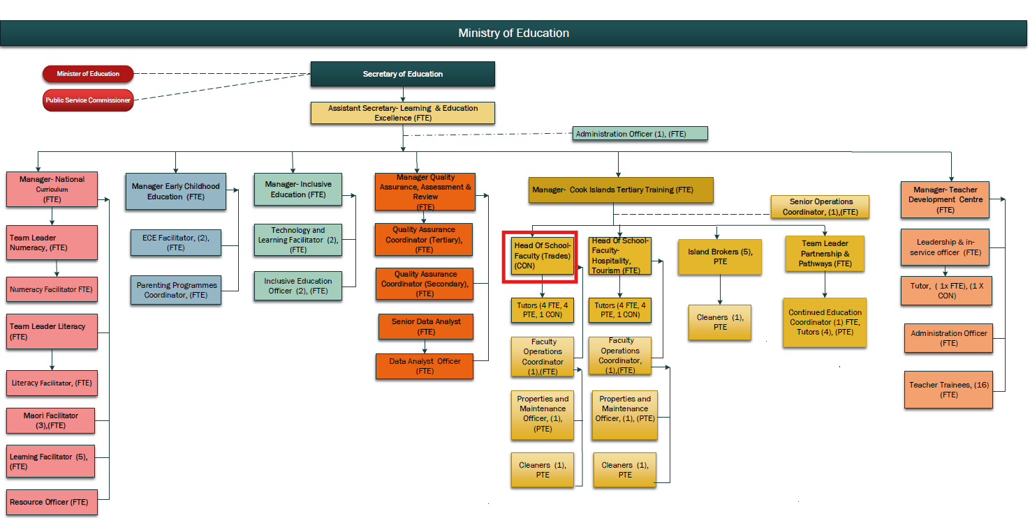

KEY RESULTS AREA:

K.R.A | Key Performance Indicators
 | • Annual plans implemented and reviewed annually.  • Graduate employability and apprenticeship participation increased.  • Programmes address national infrastructure and skills development goals
  Strategic Leadership in Trades Education
  Lead the direction and growth of the Trades School to meet national workforce needs and align with the Education Masterplan
Curriculum Design & Quality Assurance  Ensure trades training programmes meet national and international competency standards (e.g. NZQA, Pacific Qualifications Framework). | • Course Material updated regularly with industry input.  • Accreditation and compliance maintained.  • Employer satisfaction and student outcomes monitored.
Industry & Apprenticeship Partnerships  Build partnerships with employers, industry associations, and government agencies to support apprenticeship and workforce training pathways | • Active partnerships with industry sectors.  • Increased number of apprenticeships and on-the-job placements.  • Industry feedback integrated into curriculum
Staff Leadership & Capability Development  Support and mentor trades tutors and trainers to deliver applied, safe, and effective learning experiences. | • Annual appraisals and PD plans completed.  • Staff competence in assessment and training strengthened.  • Positive and safe teaching culture evident.
Student Learning, Safety & Employability  Ensure high-quality training outcomes, workplace readiness, and safety in all practical learning environments. | • High course completion and employment outcomes.  • Student wellbeing and safety standards upheld.  • Graduate tracking and employer feedback collected.

WORK COMPLEXITY:

Indicate Most challenging duties typically undertaken:
1 | Leads a national vocational division providing practical training critical to infrastructure, trades, and technical workforce development.
2 | Manages curriculum reform and industry accreditation processes across multiple trade disciplines.
3 | Balances workshop operations, safety compliance, and industry standards with resource and facility constraints.
4 | Builds and maintains partnerships with industry employers, government, and development partners to align training with national projects and labour needs.
 | Oversees high-risk training environments, ensuring compliance with health, safety, and quality assurance frameworks.

AUTHORITY:
Authority levels expressed in terms of routine expenditure, granting loans, and recruiting and dismissing staff. (Explain the authority if any)

Financial | Managing budgets related to trade education programs.
Staff | Supervision of trade tutors.
Contractual | Authority to engage with industry partners for curriculum development and resource support.

FUNCTIONAL RELATIONSHIPS:
The requirement for human relations skills in dealing with other personnel and external contacts. (List the external and internal types of functional relationships)

Internal | Nature of Contact | External | Nature of Contact
Trade Tutors | Providing guidance and support for the delivery of trade education programs. | Industry Partners | Engaging with industry stakeholders to align programs with workforce needs.
Manager – Cook Islands Tertiary Training | Reporting on program outcomes and resource needs. | Government Agencies (Infrastructure, Energy, Marine, etc.) | Coordination of national workforce initiatives.
Other Heads of School | Collaboration on shared facilities, safety, and cross-disciplinary training. | Regional Training Institutions & Accreditation Bodies | Alignment with Pacific and NZ qualifications standards.

QUALIFICATION:

Level of education required to perform the functions required of the position. This combines formal and informal levels of training and education.

Essential: (least qualification to be competent) | Desirable: (specific qualification for job)
Trade certification or Bachelor’s degree in Vocational Education or related field. | Master’s degree in Educational Leadership, Vocational Training, or related discipline.

Knowledge / Experience
The length of practical experience and nature of specialist or managerial familiarity required. This experience is in addition to formal education.

Essential: (least number of years to be competent) | Desirable: (target number of years you are looking for)
Minimum of 5 years of experience in trade education or vocational training. | 7+ years with a focus on curriculum development and industry engagement.

Key Skills /Attribute / Behaviours

Level of ability required for the job
Expert | Trade Program Management, Curriculum Development, Staff Development
Advanced | Industry Engagement, Student Support
Working: | Cross-Departmental Collaboration, Program Implementation
Awareness | Industry Standards in Trades

Approved:

Head of Ministry – Secretary of Education Date

Employee Date

