MINISTRY OF EDUCATION
P.O. Box 97, Rarotonga, Cook Islands

Government of the Cook Islands
Phone: (682) 29 - 357 Fax: (682) 28 - 357

POSITION DESCRIPTION

Position Title: | Faculty Operations Coordinator
Division: | Cook Islands Tertiary Training Institute
Responsible To: | Head of Faculty
Responsible For: | Not applicable
Job Purpose: | To coordinate, organise and administer the operations of the Faculty and institute, providing quality student and tutor support services, data collection and entry and administration services.
Job classification:
Date: | 30 July 2025

MINISTRY VISION:

Akamatutuanga i te au karape, kite, te tu tangata e te irinakianga o te iti tangata Kuki Airani kia rauka ia ratou i taangaanga i ta ratou au tareni ki roto i to ratou oraanga.

Building the skills, knowledge, attitudes, and values of Cook Islanders to put their capabilities to best use in all areas of their lives.

ORGANISATION CHART:

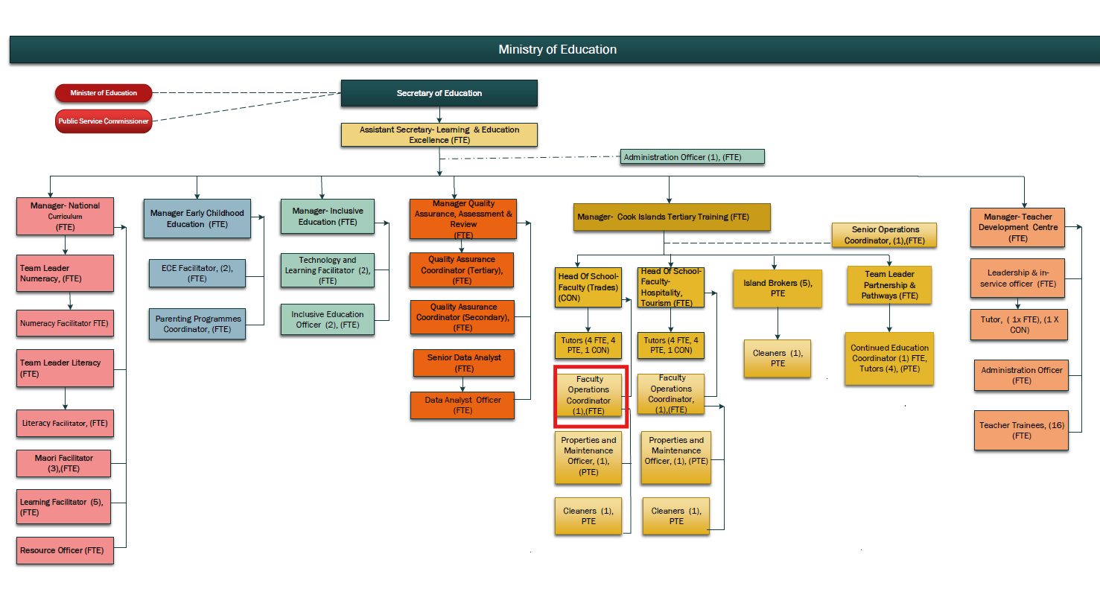

KEY RESULTS AREA:

K.R.A | Key Performance Indicators
KRA 1: Administration & Reception  - To ensure visitors or callers to the institute are greeted appropriately and enquiries dealt with efficiently and with maturity.  - To provide secretarial and administrative support and assistance to the senior management team as appropriate  - To ensure that all administrative material produced is of a high standard and appropriately reflects the institutes aim for excellence.  - To ensure that the photocopying equipment printers and other office equipment are functioning effectively. | - Visitors to the institute are treated professionally, with courtesy and respect.  - Incoming calls and inquiries are answered promptly and professionally.  - Office and surroundings are maintained in a clean, tidy and safe state in collaboration with cleaning/maintenance staff.  - All files are accessible, secure and managed according to the OIA.  - Faculty mail is handled in an efficient manner  - Secretarial and administrative duties for the senior management team are performed to a high standard – correspondence, minutes of meetings etc  - Newsletters, resources, reports and other educational material are of a high standard.  - Faults are reported immediately to technicians and repairs are carried out.
KRA 2: Tutor/Curriculum Support  - To ensure that teaching staff have access to printed resources for their classes.  - To communicate with relevant standards accrediting organisations regarding faculty programs.  - To assist tutors with the ordering and transportation of resources to other centres.  - To provide support for tutors. with regards to room setup, exam supervision and deployment of IT resources.  - Assist with raising awareness and the marketing of courses including online. | - All photocopying for staff is completed to schedule and to a high standard.  - All correspondence is professional, concise and a record of decisions made with SSB.  - Resources, rooms are available in a timely manner ensuring programs are delivered accordingly.  - Course information, prospectus, community education information disseminated.
KRA 3: Student Management Systems and Support  - To ensure that the CITTI student management database is current and accurately records student data.  - To ensure that student attendance is monitored in order to meet course attendance & participation requirements.  - To contact students or caregivers to verify absenteeism or in case of an emergency.  - To ensure that the use of student management software is maximised to aid the administrative functions of the institute.  - To ensure that technology is used to its full potential to aid the smooth operations of the institute. | - Tutors and students are recruited for each programme being delivered; All programmes of study meet minimum participation levels and have competent Tutorial staff.  - Course evaluation conducted, improvements made to courses; a CE course database is maintained.
KRA 4: Student Management  - To plan, co-ordinate and manage recruitment of students.  - Provide pastoral care, advice and guidance to students, ensuring they meet individual learning goals.  - To keep records of student achievement data, inputting into SMS database. | - Database is current and information is used for school wide monitoring and planning - admissions, results, pastoral, exam times etc.  - (EDGE/Tertiary Based Student Management System).  - All student management systems entry and output deadlines are adhered to.  - Students’ timetables, attendance and progress records are accessible, accurate and up-to-date.  - Students and the institute have up to date records and access to Records of Learning.  - Provide support to staff with the use of EDGE/Tertiary Based Student Management System.  - Faults with software are reported and repairs arranged.
KRA 5: Financial Management  - To operate sound financial cash management systems and practices  - To keep and provide sound and accurate financial records which show a true and fair view of the financial situation of the institute.  - To ensure that interested parties have access to current and accurate financial data.  - All institute assets and inventory are recorded, tracked and maintained according to MOE asset management processes. | - Balance the receipt book with the banking.  - All banking is regular and large amounts of money are not kept on the premises.  - Institute and bank records are reconciled.  - All payments are supported with receipts and monitored, including following up on due fees  - There are current financial records of inwards and outwards cash that are kept electronically.  - Assets/ Inventory register.
KRA 6: QMS Support  - Contribute to institutional committees including but not limited to quality assurance and health and safety.  - Monitor and review the progress of students through questionnaires and discussions with tutors and managers. | - Attendance at full staff and committee meetings, taking minutes of meetings.  - Program evaluation questionnaires are administered and summative reports produced  - Calendar of meetings and events adhered to and supported
KRA 7: Professional Conduct  - Demonstrate professional conduct as expected by an employee of the Cook Islands Public Service.  - Participate fully and effectively in the teachers’ performance management system. | - Demonstrates professional conduct at all times.  - Complies with the values and code of conduct of the CIPS.  - Complies with the requirements of the MOE performance management system.  - Meets all expected deadlines and reporting requirements as directed by Senior Managers.

WORK COMPLEXITY:

Indicate Most challenging duties typically undertaken:
1 | Collecting, recording and maintaining student data and records - results, assessment/ moderation evidence and personal/ pastoral care
2 | Ensuring diverse needs of students are met, provide a student support function/service, advice and guidance on pastoral care matters
3 | Inwards and outwards correspondence - organising office files and information either electronically, digitally or with paper filing systems
4 | Maintaining accurate records of various faculty wide meetings
5 | Sound working knowledge of computerised student management systems (SMS) for student record keeping, achievement, programs etc.
6 | Ensuring the operation of sound financial management systems and practices with regards to fees/funds management, purchasing, inventory control and asset management
7 | Customer service skills are essential as the first point of contact for enquiries, public relations and issues regarding the school’s staff, students and services. Receptionist duties - responsible for operating the phone system used at the institute.

AUTHORITY:
Authority levels expressed in terms of routine expenditure, granting loans, and recruiting and dismissing staff. (Explain the authority if any)

Financial | Nil (Comply with the financial practices as set down by the Ministry of Education with regard to fees/funds management, purchasing, inventory control and asset management).
Staff | Nil
Contractual | Nil

FUNCTIONAL RELATIONSHIPS:
The requirement for human relations skills in dealing with other personnel and external contacts. (List the external and internal types of functional relationships)

Internal | Nature of Contact | External | Nature of Contact
Manager, Head of Faculty | Administrative support, student management, leave, performance, PD and other matters as required (Light) | Community services, government agencies, NGOs | Administration and curriculum support, health and safety and other matters as required (Routine)
Tutors and other CITTI staff | Administrative support, photocopying, schedules, resources and other matters as required (Medium) | Industry and employers | Administration support for student placements, tutor enquiries other matters as required.  (Routine)
Students | Administrative support – attendance, financial administration, pastoral care, relaying messages other matters as required (Heavy) | Local and overseas suppliers | Request quotes, invoices, collection and contact to resolve administration matters (Routine)

QUALIFICATION:

Level of education required to perform the functions required of the position. This combines formal and informal levels of training and education.

Essential: (least qualification to be competent) | Desirable: (specific qualification for job)
- A Diploma in Business Administration/Computing | - A Degree in Business Administration/Computing or Accounting

Knowledge / Experience
The length of practical experience and nature of specialist or managerial familiarity required. This experience is in addition to formal education.

Essential: (least number of years to be competent) | Desirable: (target number of years you are looking for)
- Minimum of 5 years administration experience with an understanding of the indigenous language and culture.  - Knowledge of administrative policies and procedures.  - Organisational and planning skills.  - Sound leadership and motivational skills.  - Sound computer skills. | - More than 3 years’ experience in a Senior Administrative position.  - Experience working in an educational establishment in senor secondary/TVET

Key Skills /Attribute / Behaviours

Level of ability required for the job
Expert | Customer Focus - Working to achieve total customer satisfaction (includes internal and/or external customers).  Database management – sound working knowledge of student and financial management systems operating in a tertiary institute.
Advanced | Quality and Accuracy - Accomplishing tasks with concern for the standard produced; checking own or others’ work to ensure accuracy, adherence to procedures and completeness. Improves processes to ensure improvement in quality of outputs over time.  Interpersonal Skills - Establishing and maintaining relationships with staff, customers and suppliers to improve the overall effectiveness of the position.  Communication Skills - Expressing ideas effectively in individual and group situations; adjusting language or terminology to the characteristics and needs of the audience. Keeps information confidential.  Decision making /Problem Solving - Making timely decisions; judgements; taking action when appropriate and committing to a position or direction.
Working: | Collaboration - Working effectively with others in the institute, the wider community and stakeholders to accomplish institute goals.  Safety Awareness - Acting to improve conditions that affect employee safety.  Attention to detail – ability to accurately check processes, tasks and /or information no matter how small over time yet still showing concern for all the other aspects of the job.  ITC - be able to carry out word processing, use spreadsheets, databases or other software as appropriate, to Level 3.  An ability to respond to changing situations in a flexible manner in order to meet current needs.
Awareness | Commercial Awareness - Considers financial implications and risk of proposed actions/decisions, applies business, accounting and marketing models to decisions.  Knowledge of Education Sector mandates (Education Act, EMP, SOI)

Approved:

Head of Ministry – Secretary of Education Date

Employee Date

