MINISTRY OF EDUCATION
P.O. Box 97, Rarotonga, Cook Islands

Government of the Cook Islands
Phone: (682) 29 - 357 Fax: (682) 28 - 357

POSITION DESCRIPTION

Position Title: | Finance Officer
Division: | Corporate & Operational Excellence
Responsible To: | Finance Manager
Responsible For: | Nil Staff
Job Purpose: | Responsible for the effective and efficient monitoring of Accounts Payable, Accounts Receivable, Bank, Donor funding, POBOCs and management of staff timesheet and leaves.  The incumbent is expected to have basic accounting skills and excellent customer service skills.
Job classification: | Corporate/Finance Support
Date: | 17 March 2025

MINISTRY VISION:

Akamatutuanga i te au karape, kite, te tu tangata e te irinakianga o te iti tangata Kuki Airani kia rauka ia ratou i taangaanga i ta ratou au tareni ki roto i to ratou oraanga.

Building the skills, knowledge, attitudes, and values of Cook Islanders to put their capabilities to best use in all areas of their lives.

ORGANISATION CHART:
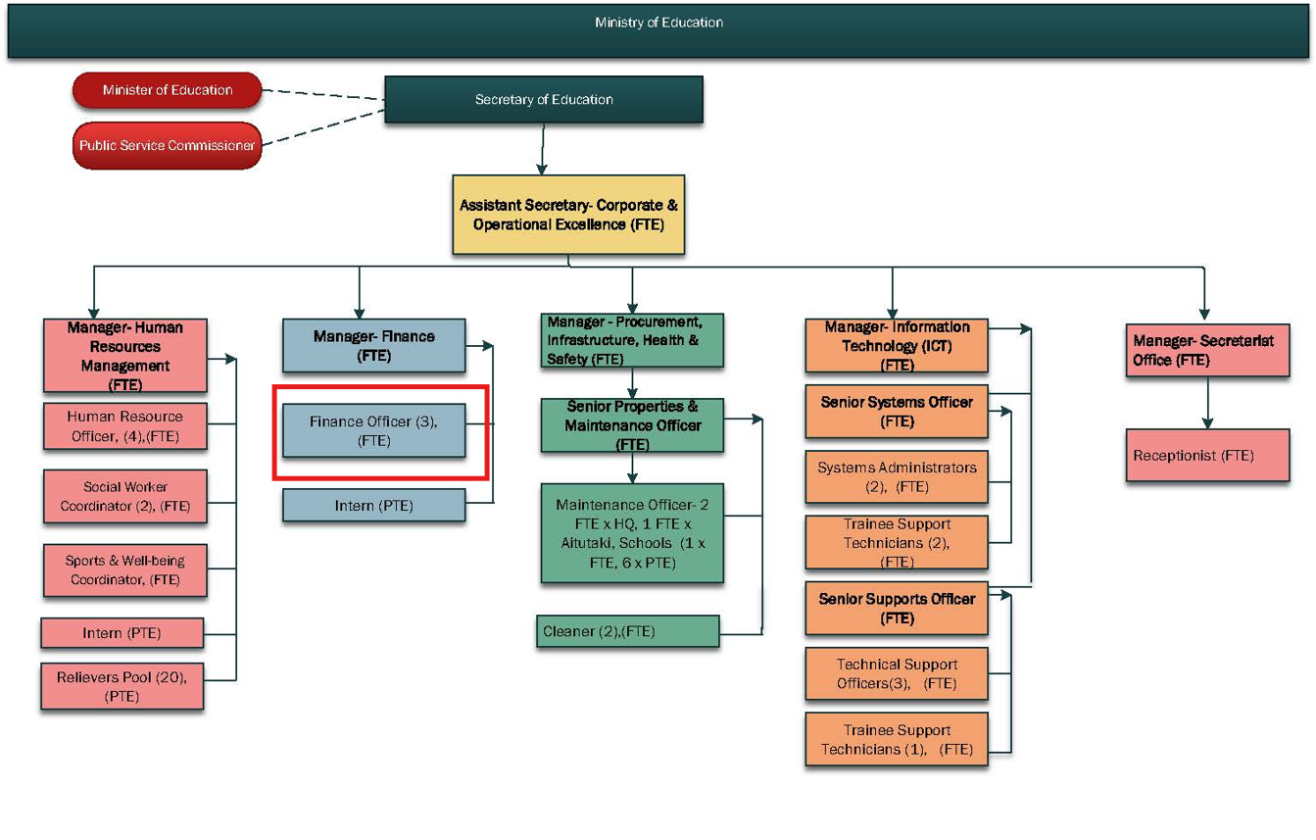

KEY RESULTS AREA:

K.R.A | Key Performance Indicators
KRA 1: Accounts Payable and Accounts Receivables  - Ensure expenditures comply with acceptable standards of accountability and transparency.  - Ensure that all payments adhere to the Cook Islands Financial Policy and Procedure Manual.  - Maintain accounts receivables systems in order to ensure that accurate records of all funds are kept. | - Ensure delegated authorities are within the limits of that authority.  - Ensuring all works orders are properly authorised and presented with invoices for payment.  - Ensure all operating expenses and payment vouchers are paid against invoices and works orders and are correctly entered into MYOB EXPO or FMIS. All Accounts Payable are correctly reflected.  - Arrange delivery of cheque/electronic (Telegraphic Transfer) payments in a timely manner.  - Ensure suppliers are promptly notified of payments.  - Ensure monthly reconciliation between MOE accounting records and Supplier Statements are carried out  - Maintain a financial cost analysis on a monthly basis for telephone, fuel, electricity.  - Ensure all suppliers (cash basis) are paid within 5 days following receipt of invoice.  - Ensure receipting, banking of funds are done in a timely manner.  - Ensure all payments received are applied correctly to the Student Management or Accounts Receivables list.
KRA 2: Personnel  - Ensure full accountability for each personnel payment from Ministry.  - Ensure consistent process for remuneration, wages and salary adjustments.  - Ensure that the physical operation of the payroll is efficient and follows best business practice.  - Ensure all timesheet, leaves are correctly implemented in the system.  - Ensure the effective and efficient operation of the ESS Payroll Software System. | - Verify all remuneration and adjustments to remuneration entitlements are approved by the Head of Ministry with appropriate justification and/or supporting documents.  - Verify and confirm remuneration rates for each employee against Notice of new appointments, notice of adjustments and payroll summary on a quarterly basis and report anomalies to HRM and the Finance Manager.  - Ensure all timesheets/payroll is properly verified, checked and authorised by delegated authority and Head of Ministry.  - Ensure leave is applied on ESS and recorded on timesheets. In the absence of ESS, ensure authorised leave forms accompany timesheets.  - Provide payslips to staff upon request (those who don’t have access to computer or receive payslips through email).  - Ensure the Payroll data and details have been entered correctly into the PAYE excel spread sheet on a fortnightly basis.  - Ensure all Personnel records i.e. payroll records are correctly maintained with proper supporting documents for HRM and Audit purposes.  - Complete leave reconciliations (annual and sick) with Principals, Directors, Managers and those in Charge against ESS.  - Conduct regular ESS training with all employees of the Ministry.
KRA 3: Finance Division Administration  - To ensure Division objectives are met in accordance with the divisional objectives and annual business plan.  - To assist in the management of donor funds.  - To assist in receipting and reviewing bank deposits.  - Monitor and purchase canteen and cleaning supplies for MOE office/Schools.  - Ensure office supplies are managed appropriately (including ordering of paper, stationeries, kitchen and cleaning supplies).  - Assist staff with accessing ministry policies and processes in relation to code of conduct, grievances and disputes resolution.  - Ensure proper records management system exists for all finance records. | - Quarterly training on accessing ministry policies organised.  - Ensure funds utilised for the donor projects are spent within scope.  - Ensure adequate supply of office supplies/cleaning supplies are maintained in stock for schools/MoE Office.  - Ensure all records for the last 7 years are labelled and kept in chronological order in the MoE storage.
KRA 4: Internal and External Audits  - Ensure procedures for Schools/ MoE Operating are compliant to financial policy i.e. CIGFPPM.  - Ensure assets are verified and update in the Fixed Asset Register.  - Support the auditors with the necessary requests during the MoE Audit. | - Conduct quarterly spot checks for Schools to verify compliance and report to Manager Finance/Assistant Secretary for Corporate Services (Bank, Donor/Trust funding, Accounts Payable/POBOC/School Operating).  - Ensure necessary documentation is provided to Auditors in a timely manner.  - Report any non-compliance issues to Director with recommendations for improvement.  - Follow up with Manager Finance/Assistant Secretary for Corporate Services on progress of recommendations and implementation.
KRA 5: Professional Development and Conduct  - Compliance with Code of Conduct and all policies (internal and PSC).  - Positively contributes to improvement in output delivery by the team, efficiency of processes, procedures and behaviours.  - Assist Manager and other team members to learn new skills and share knowledge.  - Perform other duties aligned to achieving job-related objectives as instructed by the Manager Finance/Assistant Secretary for Corporate Services. | - Mid-Year and Annual self-assessments of performance are completed in a timely manner and areas of improvement agreed.  - Full attendance and contribution to team meetings as recorded in minutes  - Contributes to staff and team learning.

WORK COMPLEXITY:

Indicate Most challenging duties typically undertaken:
1 | Development and maintenance of financial systems to ensure there is adequate internal controls over the payment of funds.
2 | Strong monitoring and financial analysis of information
3 | Accountability for the management and use of Crown funds in the Ministry of Education
4 | Financial and accounting software applications and implementing Cook Islands Government Financial and Procedure regulations

AUTHORITY:
Authority levels expressed in terms of routine expenditure, granting loans, and recruiting and dismissing staff. (Explain the authority if any)

Financial | Will be the issuing officer for works order and processing payments as per the instruction provided by Finance Manager and Assistant Secretary –Corporate.
Staff | Will be training school administration staff or other administration staff on the financial processes.
Contractual | No authority

FUNCTIONAL RELATIONSHIPS:
The requirement for human relations skills in dealing with other personnel and external contacts. (List the external and internal types of functional relationships)

Internal | Nature of Contact | External |  | Nature of Contact
Assistant Secretaries, Finance Manager & other Corporate staff | Financial management procedures, payroll & leave matters, team work, collaboration and other matters as required  (Heavy) | Local and overseas suppliers |  | Significant and regular discussions and contact to resolve day to day administration and financial management issues (Routine)
Other Divisional staff | Financial support with budget, payments, leave, timesheets, pay roll & other matters as required (Medium) | Other Public Sector agencies, SOEs |  | Administration and financial management support and other matters as required (Routine)
Principals and school office finance personnel, PTA treasurer | Financial support with budget, payments, leave, timesheets, pay roll & other matters as required (Medium)
School staff | Payroll, leave and other matters as required (Light)

QUALIFICATION:

Level of education required to perform the functions required of the position. This combines formal and informal levels of training and education.

Essential: (least qualification to be competent) | Desirable: (specific qualification for job)
- Diploma in Accounting or Business related subjects. | - Bachelor of Accounting or Commerce

Knowledge / Experience
The length of practical experience and nature of specialist or managerial familiarity required. This experience is in addition to formal education.

Essential: (least number of years to be competent) | Desirable: (target number of years you are looking for)
- 8 to 9 years of working experience in the area of finance  - Knowledge and experience in all aspects of the Cook Islands Government budget process and financial reporting requirements.  - Good understanding of financial management and Accounting practices  - Knowledge and skills in reconciliation  - Knowledge and skills in internal audit  - Thorough knowledge of accounting systems  - Computer literate with basic knowledge of the Microsoft packages and adaptable to system changeover for improvement and/or upgrade  - Demonstrate conceptual and analytical skills and proven problem solving and negotiation skills with the ability to respond quickly and effectively.  - Ability to work productively in a team environment.  - Excellent standard of written and spoken English and an ability to communicate in Cook Islands Maori. | - 10 years or more working experience in the area of finance.  - Knowledge and understanding MFEM Act, PSC Act, PERCA Act.  - Knowledge and understanding of the Cook Island Government planning, policy and funding management cycles.  - Good understanding of General Accepted Accounting Practice (GAAP) and International Public Sector Accounting Standards (IPSAS)  - Experience in government account reconciliation  - Experience in conducting internal auditing in government account  - Knowledge in accounting systems such as MYOB, FMIS.  - Knowledge and experience of the Med-tech system  - Thorough knowledge of Microsoft Package such as Access and adaptable to system changeover for improvement and/or upgrade.  - Experience of team work involvement and contribution  - Fluent at an advanced level in oral and written in both English and Cook Islands Maori.

Key Skills /Attribute / Behaviours

Level of ability required for the job
Expert | Financial Understanding – has a very good understanding of Finance & Accounting principles and application in all tasks  Communication Skills – Provides concise information effectively to individuals recognising seniority of position in both English and Cook Islands Maori. Keeps information confidential.
Advanced | Quality and Accuracy - Accomplishing tasks with concern for the standard produced; checking own or others’ work to ensure accuracy, adherence to procedures and completeness. Improves processes to ensure improvement in quality of outputs over time.  Decision making /Problem Solving - Making timely decisions; judgements; taking action when appropriate and committing to a position or direction.  Interpersonal Skills - Establishing and maintaining good relationships with staff, customers and suppliers to improve the overall effectiveness of the position.
Working: | Collaboration - Working effectively with others in Division and Ministry and stakeholders to accomplish Divisional goals. Works with little supervision required.  Commercial Awareness - Considers financial implications and risk of proposed actions/decisions, applies accounting and business models to decisions.  Attention to detail – ability to accurately check processes, tasks and /or information no matter how small yet still showing concern for all the other aspects of the job.  ITC - be able to carry out word processing, use spreadsheets, databases or other software as appropriate, to Level 3  Flexibility - An ability to respond to changing situations in a flexible manner in order to meet current needs.
Awareness | Knowledge of MFEM procedures (keeping current) & Education Sector mandates (Education Act, EMP, SOI)

Approved:

Head of Ministry – Secretary of Education Date

Employee Date

