MINISTRY OF EDUCATION
P.O. Box 97, Rarotonga, Cook Islands

Government of the Cook Islands
Phone: (682) 29 - 357 Fax: (682) 28 - 357

POSITION DESCRIPTION

Position Title: | Education Review Officer
Division: | Policy Development & Innovation
Responsible To: | Team Leader – Compliance & Educational Standards
Responsible For: | Nil
Job Purpose: | To conduct reviews of schools and registered private learning establishments (primary, secondary, and tertiary) to ensure quality delivery of education, alignment with national policies, and compliance with legislative and regulatory requirements. This role provides evaluative insights on teaching, learning, leadership, and institutional performance, contributing to continuous improvement across the education sector.
Job classification:
Date: | 30 June 2025

MINISTRY VISION:

Akamatutuanga i te au karape, kite, te tu tangata e te irinakianga o te iti tangata Kuki Airani kia rauka ia ratou i taangaanga i ta ratou au tareni ki roto i to ratou oraanga.

Building the skills, knowledge, attitudes, and values of Cook Islanders to put their capabilities to best use in all areas of their lives.

ORGANISATION CHART:

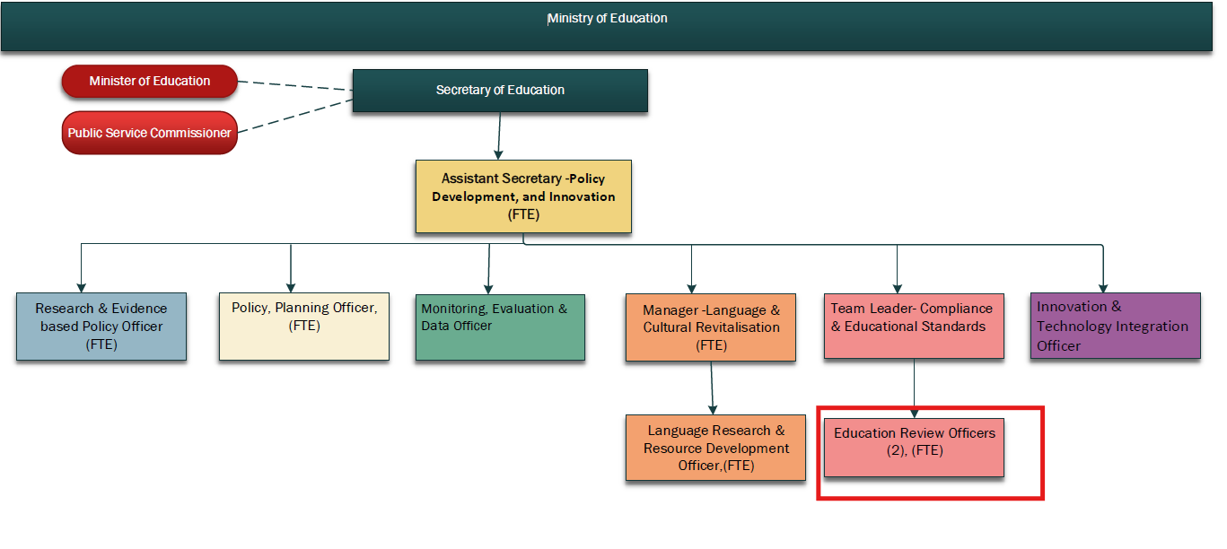

KEY RESULTS AREA:

K.R.A | Key Performance Indicators
School and Institutional Reviews  Conduct structured, evidence-based reviews of education providers. | Annual review schedule completed; compliance issues documented; improvement plans initiated
Reporting and Analysis  Deliver high-quality, objective reports following reviews. | Reports produced within 30 days of review; endorsed by Team Leader; shared with institutions and Ministry leadership
Compliance Monitoring  Assess institutional adherence to the Education Act and MoE regulations. | Non-compliance risks flagged; action plans monitored.
Stakeholder Engagement  Work collaboratively with schools, private providers, and internal teams | Schools understand expectations; professional relationships maintained.
Quality Improvement Advice  Provide recommendations to support better teaching, learning, and management | Recommendations embedded in school plans; follow-up demonstrates progress

WORK COMPLEXITY:

Indicate Most challenging duties typically undertaken:
1 | Conducting impartial and evidence-based evaluations across varied school contexts
2 | Managing sensitive discussions with school leadership and Boards
3 | Producing detailed, objective, and useful review reports
4 | Staying current with education policies, curriculum frameworks, and legal compliance requirements

AUTHORITY:
Authority levels expressed in terms of routine expenditure, granting loans, and recruiting and dismissing staff. (Explain the authority if any)

Financial | Nil
Staff | Nil
Contractual | Nil

FUNCTIONAL RELATIONSHIPS:
The requirement for human relations skills in dealing with other personnel and external contacts. (List the external and internal types of functional relationships)

Internal | Nature of Contact | External | Nature of Contact
Team Leader – Compliance & Educational Standards | Reporting and oversight | Private school proprietors | Review and compliance engagement
Policy, Curriculum, and QA staff | Coordination on school and system-wide issues | Tertiary providers | Institutional quality assurance liaison
School Principals and Boards | Review facilitation and feedback | Community stakeholders | Observation and interview during reviews

QUALIFICATION:

Level of education required to perform the functions required of the position. This combines formal and informal levels of training and education.

Essential: (least qualification to be competent) | Desirable: (specific qualification for job)
Bachelor’s degree in Education, Evaluation, or relevant field | Postgraduate qualification in Educational Leadership, Quality Assurance, or similar

Knowledge / Experience
The length of practical experience and nature of specialist or managerial familiarity required. This experience is in addition to formal education.

Essential: (least number of years to be competent) | Desirable: (target number of years you are looking for)
Minimum 5 years’ experience in school leadership, teaching, or system-level roles | Experience in school review, inspection, or audit roles
Knowledge of the Cook Islands Education Act and NZ-aligned curriculum | Familiarity with tertiary and private provider regulatory systems

Key Skills /Attribute / Behaviours

Level of ability required for the job
Expert | Conducting evidence-based evaluations; applying educational quality frameworks; report writing and data synthesis
Advanced | Knowledge of schooling and institutional improvement strategies; professional engagement with educators and leaders
Working | Analytical and critical thinking; collaboration across teams
Awareness | Ministry strategy, curriculum development, and compliance regulations

Approved:

Head of Ministry – Secretary of Education Date

Employee Date

