MINISTRY OF EDUCATION
P.O. Box 97, Rarotonga, Cook Islands

Government of the Cook Islands
Phone: (682) 29 - 357 Fax: (682) 28 - 357

POSITION DESCRIPTION

Position Title: | Tutor
Division: | Learning & Educational Excellence
Responsible To: | Head of School Faculty or Manager TDC
Responsible For: | n/a
Job Purpose: | To provide quality and effective learning and teaching to students enrolled in a specific programme of study; including developing course and assessment materials relevant to industry in the Cook Islands ensuring.
Job classification:
Date: | 30 June 2025

MINISTRY VISION:

Akamatutuanga i te au karape, kite, te tu tangata e te irinakianga o te iti tangata Kuki Airani kia rauka ia ratou i taangaanga i ta ratou au tareni ki roto i to ratou oraanga.

Building the skills, knowledge, attitudes, and values of Cook Islanders to put their capabilities to best use in all areas of their lives.

ORGANISATION CHART:

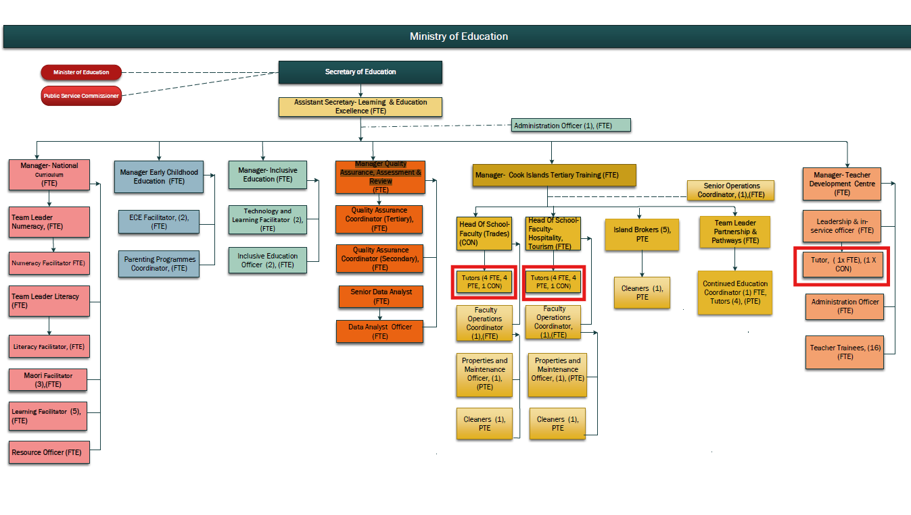

KEY RESULTS AREA:

Key Results Area | Key Performance Indicators
KRA 1: Teaching Practice  - To plan, prepare and deliver quality programmes as prescribed by the curriculum  - Supply effective teaching and learning strategies to promote effective learning consistent with individual student learning needs  - Use assessment data to inform future planning and intervention strategies  - To provide regular and meaningful feedback on student progress and achievement.  - To utilise and manage all learning and teaching resources, effectively and efficiently | - Plans, prepares, implements and evaluates programs that incorporate unit and Standards Based Assessment standards  - A high standard of learning & teaching is maintained, informed through a range of assessment practices at a level appropriate to the ability of all students  - Students receive tutorial support that is individualized to their learning styles.  - Student progress and achievement are regularly analysed and intervention strategies implemented to raise achievement levels to meet expected student and program goals – credit tracking  - Students receive appropriate feedback on their progress and level of achievement and are informed of areas where extra support would be beneficial  - Students’ learning opportunities are maximised through access to appropriate and properly maintained resources
KRA 2: Quality Management Systems (Managing International Qualifications)  - To verify/moderate assessment materials in area of expertise according to service provider processes  - To ensure the institute maintains its accreditation to offer accredited programs of learning according to scope of accreditation and relevant MOU.  - To develop, review and implement programmes of learning and respond to feedback | - Complies with external audit requirements and guidelines including pre, post and external moderation, Further Assessment Opportunities, records retention and reporting guidelines  - Verified results entered in SMS and submitted, students receive record of learning and/or achieve qualification.  - Implements outcomes of external audit reviews and requirements within given timelines  - Assist new staff with meeting the requirements of service provider.  - Participates in the institutes QMS committees and external audit reviews  - Programs are evaluated and reviewed, coursework is developed and implemented.
KRA 3: Administration  - Discharge administrative responsibilities integral to Tutors work including keeping up to date records and evidence of student achievement  - To operate within the policy framework and legislative obligations of CITTI  - To maintain good networks with the local industry | - All teaching plans, assessment procedures and teaching resources are completed and up to date  - The CITTI Quality Management System is upheld and all accreditation is maintained; All policy and procedures are abided by  - Training is industry appropriate, industry is consulted six monthly
KRA 4: Professional Knowledge and Development  - To have current knowledge of content and best practice principles and pedagogy that can be applied to the learning situation.  - To be competent and to keep up to date in the subject area | - Keeps abreast of changes in subject area through subject associations, advisors, colleagues in other institutes  - Regularly reflects on and reviews personal performance  - Demonstrates a commitment to personal growth and knowledge development  - Contributes to ongoing curriculum, assessment and policy review and evaluation.  - If applicable, to work towards and gain an adult teaching qualification.
KRA 5: Student Management  - To initiate and manage recruitment of students  - Provides a supportive, creative, stimulating and safe environment for students  - To monitor student attendance, progress and achievement.  - To implement sound strategies in managing student behaviour effectively and within CITTI policy | - Programs commence with a full complement of students  - Uses positive reinforcement to encourage desired behaviors  - Effective classroom layout, displays; health and safety procedures are implemented  - Responds effectively and in a timely manner to individual student needs  - Communicates effectively with students, staff and parents and caregivers  - Establishes and maintains clear and effective classroom routines
KRA 6: Professional Conduct  - Demonstrate professional conduct as expected by an employee of the Cook Islands Public Service  - Participate fully and effectively in the institutes performance management system | - Demonstrates professional conduct at all times  - Complies with the values and code of conduct of the CIPS  - Complies with the requirements of the MOE performance management system  - Meets all expected deadlines and reporting requirements as directed by the Senior Managers.

WORK COMPLEXITY:

Indicate Most challenging duties typically undertaken:
1 | A comprehensive knowledge and understanding of relevant curricula and demonstrating effective pedagogical practice.
2 | Self-reflection to inform planning and alternative delivery approaches and methodologies.
3 | Establishing and organising programme of courses including learning plans, course content and assessments.
4 | Ensuring diverse needs of learners are met; recruiting students and maintaining enrolment numbers.
5 | Demonstrate planning skills that provide connections to prior learning and experiences, and display competency in evaluation for future planning.
6 | Managing relationships with industry, employers, community groups and relevant government agencies.
7 | Ability to contextualise students’ learning to their own environment to give it relevance and enhance student understanding.
8 | Able to use a range of assessment methods (eg norm referenced, standards based etc) for diagnostic, formative and summative evaluation of student achievement to inform interventions which will improve student outcomes.
9 | Comply with moderation and assessment requirements accrediting bodies and the service providers.

AUTHORITY:
Authority levels expressed in terms of routine expenditure, granting loans, and recruiting and dismissing staff. (Explain the authority if any)

Financial | Nil
Staff | Nil (Tutors in technical subjects may supervise the work of technicians assisting in work-shops, kitchens and job sites. Senior tutors may supervise and support beginning tutors & other tutors requiring up skilling to ensure they meet the standards required by accrediting bodies)
Contractual | Nil

FUNCTIONAL RELATIONSHIPS:
The requirement for human relations skills in dealing with other personnel and external contacts. (List the external and internal types of functional relationships)

Internal | Nature of Contact | External | Nature of Contact
Senior Management Team | Institute operations and management, compliance, reporting, attendance, leave, student management, area of responsibility, other matters as required (Light) | Community Services, government agencies, NGOs | Resource provision, learning enhancement opportunities, health & safety and other matters as required  (Routine)
Other institute staff including support staff | Provision of administration, collegial and professional support, planning, student progress & achievement, pastoral care, other relevant matters  (Medium) | Industry and Employers | Training programs, student placements, administration specific to the curriculum area, and other matters as required.  (Routine)
Students | Learning and Teaching, pastoral care, other relevant matters  (Heavy) | External Tertiary Providers | Subject specific resources, assessment support and current initiatives  (Routine)
Ministry of Education central administration office | Employment matters including payroll, leave, professional development, performance, competency, and curriculum support and other matters as required. (Medium) | Accrediting and standard setting bodies | Policy and processes, subject specific support, reporting and other matters  (Minimal)

QUALIFICATION:

Level of education required to perform the functions required of the position. This combines formal and informal levels of training and education.

Essential: (least qualification to be competent) | Desirable: (specific qualification for job)
- Bachelor’s Degree with majors in specific teaching area  - Cook Islands teacher registration (with adult teaching qualification) | Post graduate qualification in teaching area.

Knowledge / Experience
The length of practical experience and nature of specialist or managerial familiarity required. This experience is in addition to formal education.

Essential: (least number of years to be competent) | Desirable: (target number of years you are looking for)
- 3 or more years’ experience in delivery of industry training.  - 7 or more years practical industry experience at an advanced level. | - At least 3 years’ experience in delivery of industry training including standards based assessment (SBA)

Key Skills /Attribute / Behaviours

Level of ability required for the job
Expert | - Effective delivery of curricula relevant to specialist teaching area  - The relevant and appropriate application of learning and assessment theory  - Clear and effective communication in a range of situations  - The relevant contextualisation of teaching and learning to students’ own environment
Advanced | - A range of student behaviour and pastoral care management strategies  - Ongoing monitoring, evaluation and self-review of one’s own performance and practice  - Collaborative and collegial teaching style; honest, motivated, flexible, adaptable, innovative and reliable  - Managing institute resources effectively  - High level of oral and written communication and reporting skills  - Always assessing and planning to minimise risks to students’ physical safety and taking appropriate action  - Promoting indigenous culture and language
Working: | - Further developing one’s own knowledge and skills  - Actively participating in professional development  - Undertaking professional reading relevant to education.  - IT Level 3 competency achievement  - Ability to be professional and approach challenges professionally
Awareness | - Knowledge of external developments and innovation in education that are relevant to the specialist subject area  - Government legislation and policies particularly those related to education

Approved:

Head of Ministry – Secretary of Education Date

Employee Date

