MINISTRY OF EDUCATION
P.O. Box 97, Rarotonga, Cook Islands

Government of the Cook Islands
Phone: (682) 29 - 357 Fax: (682) 28 - 357

POSITION DESCRIPTION

Position Title: | Media and Communications Officer
Division: | Secretariat
Responsible To: | Secretary of Education
Responsible For: | Nil
Job Purpose: | To coordinate and deliver the Ministry’s media, communications and public relations functions, manage digital and print communications, manage website and multimedia content, support compliance with the Official Information Act, and promote Ministry initiatives through effective stakeholder engagement.
Job classification: | Communications
Date: | 02 April 2025

MINISTRY VISION:

Akamatutuanga i te au karape, kite, te tu tangata e te irinakianga o te iti tangata Kuki Airani kia rauka ia ratou i taangaanga i ta ratou au tareni ki roto i to ratou oraanga.

Building the skills, knowledge, attitudes, and values of Cook Islanders to put their capabilities to best use in all areas of their lives.

ORGANISATION CHART:
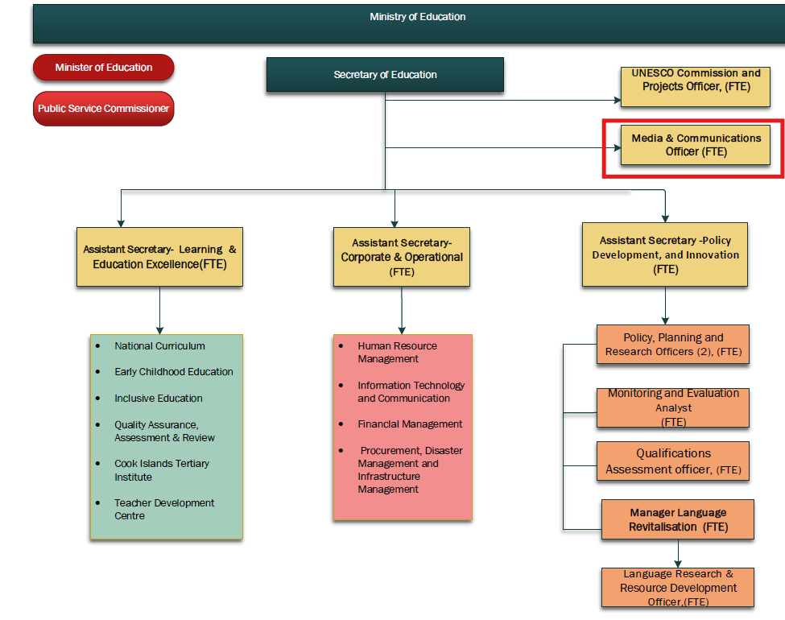

KEY RESULTS AREA:

K.R.A | Key Performance Indicators
KRA 1: Media & Communications Management  • Develop and manage an annual media programme.  • Coordinate media releases and communication campaigns.  • Market and promote Ministry initiatives and achievements. | • Minimum five new multimedia campaigns/advertisements per year.  • School and Ministry events promoted and shared with the community.  • Regular stakeholder feedback collected and analysed.
KRA 2: Digital Content & Website Management  • Create and manage content for the Ministry website.  • Maintain accurate and up-to-date online information.  • Monitor website performance and recommend improvements. | • Website content updated regularly.  • Monitoring plan implemented to improve content and format.  • Increased awareness of Ministry services and information.
KRA 3: Official Information & Records Management  • Support compliance with the Official Information Act.  • Facilitate records management policies, plans and filing systems.  • Assist management with information requests. | • Required templates and procedures available.  • OIA requests supported in a timely manner.  • Quality assurance audits completed and recommendations implemented.
KRA 4: Multimedia Production & Stakeholder Engagement  • Produce newsletters, gazettes, brochures and publications.  • Develop multimedia resources and presentations.  • Liaise with schools, communities, NGOs and media organisations. | • Monthly newsletter and quarterly gazette produced.  • Educational and promotional resources developed.  • Strong stakeholder relationships maintained.
KRA 5: Professional Conduct & Development  • Contribute positively to the Ministry and Division.  • Represent the Ministry professionally.  • Maintain current communications and media skills. | • Positive contribution to team objectives.  • Attendance at training and professional development activities.  • Ministry values consistently demonstrated.

WORK COMPLEXITY:

Indicate Most challenging duties typically undertaken:
1 | Managing communications across multiple platforms while ensuring consistency and accuracy.
2 | Responding to media enquiries and public information requests within tight timeframes.
3 | Balancing stakeholder expectations while maintaining a positive public profile for the Ministry.
4 | Producing high-quality multimedia and digital content with competing priorities.

AUTHORITY:
Authority levels expressed in terms of routine expenditure, granting loans, and recruiting and dismissing staff. (Explain the authority if any)

Financial | Not applicable
Staff | No direct staff supervision; may coordinate project teams, consultants and service providers.
Contractual | May liaise with media organisations, designers, printers and suppliers and assist with communications-related procurement.

FUNCTIONAL RELATIONSHIPS:
The requirement for human relations skills in dealing with other personnel and external contacts. (List the external and internal types of functional relationships)

Internal | Nature of Contact | External | Nature of Contact
Secretary of Education, Assistant Secretaries and Ministry Management | Media planning, communications advice, reporting and information sharing. | Local Media (CI News, CITV, Radio) | Media releases, interviews and dissemination of public information.
Schools, CITTI and Ministry Staff | Collection and promotion of educational stories, achievements and events. | Government Ministries and Agencies | Information sharing, public awareness campaigns and stakeholder engagement.
ICT, HRM, Finance and Administration Staff | Website content, publications, branding and internal communications. | NGOs, Community Groups and Private Sector | Partnerships, consultation and programme promotion.
School Principals and Management Teams | Promotion of school initiatives and educational outcomes. | Regional and International Organisations | Provision of information and promotion of education initiatives.
Consultants and Contractors | Coordination of communications projects and publications. | Media and Design Service Providers | Production of publications, campaigns and multimedia content.

QUALIFICATION:

Level of education required to perform the functions required of the position. This combines formal and informal levels of training and education.

Essential: (least qualification to be competent) | Desirable: (specific qualification for job)
Bachelor’s degree in Communications, Journalism, Public Relations, Marketing or related field. | Professional certification or postgraduate qualification in Communications, Public Relations, Digital Media or Marketing.

Knowledge / Experience
The length of practical experience and nature of specialist or managerial familiarity required. This experience is in addition to formal education.

Essential: (least number of years to be competent) | Desirable: (target number of years you are looking for)
Minimum 2–3 years’ experience coordinating communications, media or public relations projects. | 5+ years’ experience, preferably within government, education or the Pacific region.

Key Skills /Attribute / Behaviours

Level of ability required for the job
Excellent written and verbal communication, report writing | Advanced
Media relations, public relations and stakeholder engagement | Advanced
Website management, social media and digital communications | Advanced
Multimedia production, photography, video editing and graphic design | Working

Approved:

Head of Ministry – Secretary of Education Date

Employee Date

