MINISTRY OF EDUCATION
P.O. Box 97, Rarotonga, Cook Islands

Government of the Cook Islands
Phone: (682) 29 - 357 Fax: (682) 28 - 357

POSITION DESCRIPTION

Position Title: | Team Leader – Numeracy
Division: | Learning and Educational Excellence
Responsible To: | Manager – National Curriculum
Responsible For: | 1 x FTE staff - Numeracy Facilitator
Job Purpose: | To lead the national strategy for improving numeracy across all schooling levels, ensuring structured, evidence-based teaching practices, aligned assessment tools, and targeted professional learning. The role supports teachers and schools to raise student achievement in numeracy and ensure equitable access to high-quality numeracy education across the Cook Islands
Job classification:
Date: | 08 May 2025

MINISTRY VISION:

Akamatutuanga i te au karape, kite, te tu tangata e te irinakianga o te iti tangata Kuki Airani kia rauka ia ratou i taangaanga i ta ratou au tareni ki roto i to ratou oraanga.

Building the skills, knowledge, attitudes, and values of Cook Islanders to put their capabilities to best use in all areas of their lives.

ORGANISATION CHART:

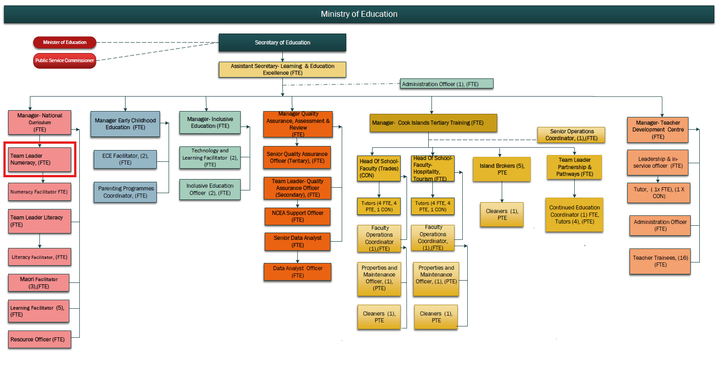

KEY RESULTS AREA:

K.R.A | Key Performance Indicators
KRA 1: Strengthen National Numeracy Achievement  Lead the development and implementation of a national strategy to raise numeracy achievement across all levels of schooling. | - Structured and consistent numeracy teaching approaches adopted nationally;  - measurable improvement in national assessment results;  - enhanced numeracy outcomes in e-Astle and other tools.
KRA 2: Build Teacher Capability in Numeracy  Support teachers through sustained, high-quality professional learning and development to improve numeracy pedagogy and instructional practice. | - Professional learning programmes delivered through TDC;  - positive teacher feedback;  - observed improvements in classroom practice and student learning.
KRA 3:Ensure Alignment of Resources and Assessment Tools  Curate, develop, and implement numeracy resources and assessment systems aligned with curriculum levels and learner progressions. | - Resources used effectively by schools;  - consistent application of tools such as  e-Asttle;  regular review and refinement of materials.
KRA 4:Drive Data-Informed Planning and Interventions  Use student and school-level data to inform teaching, target interventions, and support individualised learning pathways. | - Analysis of data informs school planning;  - student learning plans reflect numeracy needs;  - clear progress demonstrated in learner achievement.
KRA 5: Foster Collaboration and Strategic Support  Coordinate across teams and stakeholders to deliver integrated, culturally relevant numeracy strategies. | - Effective collaboration with curriculum, ECE, Māori language and inclusive education teams;  - strong school partnerships; feedback indicates strategic alignment.
KRA 6: Promote Innovation and Best Practice  Lead and trial innovative numeracy initiatives and digital tools that enhance learning engagement and equity. | - Initiatives tested and evaluated; successful innovations scaled;  - digital tools incorporated into classroom practice with positive learner outcomes

WORK COMPLEXITY:

Indicate Most challenging duties typically undertaken:
1 | Leading system-wide improvement in numeracy under varying school contexts across the Pa Enua and Rarotonga.
2 | Building teacher capacity in numeracy instruction through sustained PLD while navigating varying skill levels and resourcing.
3 | Interpreting and applying national assessment data to inform instructional shifts and system recommendations.
4 | Integrating culturally relevant numeracy learning approaches to enhance engagement and contextual learning

AUTHORITY:
Authority levels expressed in terms of routine expenditure, granting loans, and recruiting and dismissing staff. (Explain the authority if any)

Financial | Nil (Assist Curriculum Manager in preparing a budget for area of responsibility, sourcing / ordering of relevant resources).
Staff | Support Curriculum Manager in managing the performance the Numeracy facilitator.
Contractual | Nil

FUNCTIONAL RELATIONSHIPS:
The requirement for human relations skills in dealing with other personnel and external contacts. (List the external and internal types of functional relationships)

Internal | Nature of Contact | External | Nature of Contact
Manager – National Curriculum | Direct reporting and strategic direction | School Principals and Teachers | Capacity building and guidance
Learning Facilitators | Collaborative support and professional learning delivery | NZ & Pacific Education Experts | Sharing expertise, research alignment
Literacy and ECE Teams | Alignment of pedagogy and early numeracy outcomes | Community/Parents (where relevant) | Supporting home numeracy learning
Quality Assurance & Data Teams | Sharing and analysing school/student data
Policy Development & Innovation Division | Integrating research, innovation, and curriculum alignment

QUALIFICATION:

Level of education required to perform the functions required of the position. This combines formal and informal levels of training and education.

Essential: (least qualification to be competent) | Desirable: (specific qualification for job)
Bachelor of Education (Primary or Secondary) or relevant teaching qualification. | Postgraduate qualification in Mathematics Education, Curriculum Design, or Educational Leadership

Knowledge / Experience
The length of practical experience and nature of specialist or managerial familiarity required. This experience is in addition to formal education.

Essential: (least number of years to be competent) | Desirable: (target number of years you are looking for)
- Minimum of 5 years’ teaching experience with demonstrated success in numeracy outcomes.  - Experience in professional development delivery or teacher mentoring.  - Strong knowledge of the NZ Curriculum, numeracy learning progressions, and effective pedagogy. | - Prior experience in educational leadership, system change, or curriculum development.  - Familiarity with numeracy assessment tools such as e-Asttle or PAT.  - Knowledge of culturally responsive pedagogy and Cook Islands education context

Key Skills /Attribute / Behaviours

Level of ability required for the job
Expert | - Numeracy Pedagogy  Deep understanding of numeracy concepts and learning progressions, with the ability to model, coach, and embed best practices in teaching and learning.  - Instructional Leadership  Ability to lead and influence teaching practice system-wide by modelling effective strategies, guiding professional learning, and driving a culture of excellence in numeracy.
Advanced | - Data Interpretation and Use  Competence in analysing student and school data to identify trends, inform planning, and measure the effectiveness of interventions.  - Communication and Coaching  Strong interpersonal and facilitation skills to mentor, support and professionally develop teachers across diverse contexts.  - Innovation and Adaptability  Ability to lead change, introduce new tools or strategies, and adapt to emerging trends in numeracy education.  - Cultural Responsiveness  Understanding of local context, culture, and language to ensure numeracy learning is inclusive, respectful, and engaging for all learners.
Working: | - Programme Management  Ability to plan, coordinate, and report on national numeracy initiatives, ensuring timelines, objectives, and quality standards are met.  - Technology Integration  Practical knowledge of integrating technology into teaching and learning environments, including the use of digital tools to enhance numeracy instruction.
Awareness | - Policy and Curriculum Alignment  General understanding of national curriculum direction, assessment systems, and education policy to ensure numeracy programmes support wider Ministry goals.

Approved:

Head of Ministry – Secretary of Education Date

Employee Date

