MINISTRY OF EDUCATION
P.O. Box 97, Rarotonga, Cook Islands

Government of the Cook Islands
Phone: (682) 29 - 357 Fax: (682) 28 - 357

POSITION DESCRIPTION

Position Title: | Cleaner
Division: | Corporate & Operational Services
Responsible To: | Cleaner
Responsible For: | N/A
Job Purpose: | To provide an efficient and effective cleaning service that contributes towards the Ministry of Education’s professional environment and surroundings.To maintain a healthy and safe work and learning environment for employees, students, clients and visitors.
Job classification: | Corporate/ Administration Support
Date: | 14 June 2025

MINISTRY VISION:

Akamatutuanga i te au karape, kite, te tu tangata e te irinakianga o te iti tangata Kuki Airani kia rauka ia ratou i taangaanga i ta ratou au tareni ki roto i to ratou oraanga.

Building the skills, knowledge, attitudes, and values of Cook Islanders to put their capabilities to best use in all areas of their lives.

ORGANISATION CHART:

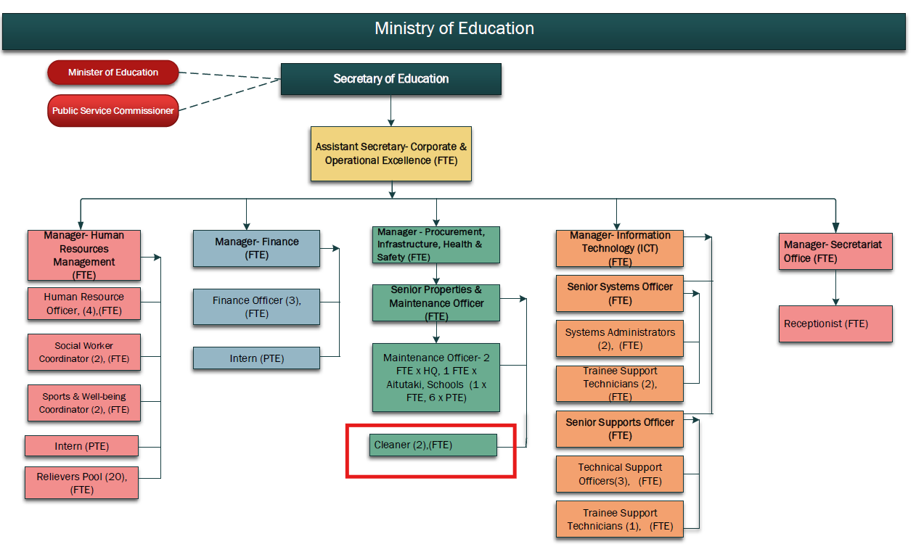

KEY RESULTS AREA:

K.R.A | Key Performance Indicators
KRA 1:  To provide an efficient and effective cleaning service that contributes towards the Ministry goal of professional services, in a professional environment and surroundings  - Performs various cleaning and maintenance activities including floors - sweep, mop, vacuum, polishing as necessary; other floor work may be required – scrubbing and waxing  - Rest rooms to include disinfecting toilets, sinks, countertops, floors, mirrors etc and re- stocking rest room supplies as needed.  - Break rooms/kitchenettes – cleans & disinfects sinks, countertops, dishes, tables, chairs, refrigerators, etc.  - Technical training rooms/laboratory – clean floors, countertops, equipment, dispose of rubbish  - Ensure all trash cans are emptied on a daily basis and disposes of trash in designated areas (follow green environment practice guidelines)  - Dusts all counter tops, fixtures, equipment, partitions and furniture as needed  - Washes windows and window coverings in all rooms as needed.  - Other duties - Cleans rugs, carpets, and upholstered furniture using vacuum cleaner; wash walls and any woodwork and furniture required; clean vehicles; general gardening | - Weekly buildings and grounds cleaning and maintenance plan.  - Weekly disposal of general and recyclable waste.  - Weekly vehicle cleaning schedule.
KRA 2:  Maintains a healthy and safe working environment:  - Monitors building and grounds to ensure a neat and clean presentation and environment.  - Maintains all equipment to include vacuum cleaners, polishers, trash cans, mop buckets, and cleaning supplies.  - Ensures security of building during and after completed jobs and reports any security violations to management.  - Adheres to ministry policies and procedures paying special attention to health and/or safety procedures.  - To contribute to a culture of excellence throughout the Ministry through the coordination, support and delivery of a cleaning service.  - Follow all written and verbal instructions. | - Weekly buildings and grounds cleaning and maintenance plan.  - Maintenance schedule and reports of equipment wear and tear, damage, repair and/or replacement.  - Breach of security reports.
KRA 3:  Reports the need for any major repairs to management.  - Emergency maintenance problems and/or environmental hazards are reported immediately.  - Reports any security concern.  - Reports any replacement of cleaning equipment/tools required.  - Provide monthly budget forecast for cleaning products to Procurement, Health and Safety Officer (National Office) or the respective manager and assist with the procurement of cleaning materials for general ongoing maintenance | - Maintenance reports and plan  - Breach of security reports  - Budget forecast
KRA 4: Professional Conduct  - Demonstrate professional conduct as expected by an employee of the Cook Islands Public Service  - Participate fully and effectively as part of the Division staff and in the performance management system | - The Public Service is not brought into disrepute by inappropriate staff performance and/or behaviour  - Performance is reviewed annually and development opportunities provided to enhance effectiveness

WORK COMPLEXITY:

Indicate Most challenging duties typically undertaken:
1 | Managing multiple tasks in terms of specialized office cleaning work efficiency
2 | Managing and compliance with green environment practices
3 | Have a good understanding of technology, cleaning/sanitising processes, user instructions/manuals of chemical application, equipment and machinery (vacuum cleaners, floor polisher) used in the cleaning process and basic maintenance of equipment including kitchen; numeracy skills
4 | Ability to work without supervision – set daily work plan, complete tasks effectively and efficiently, exhibit verbal and written communication skills in English and CI Maori
5 | Physical Demands; while performing cleaning duties the employee is regularly required to Walk and stand  - Climb, Bend forward, Kneel down, Crawl  - Reach and grasp, Push and pull objects  - Lift and/or move, sometimes over shoulders.  - Repetitive bending and lifting of items  - Repetitive arm movements

AUTHORITY:
Authority levels expressed in terms of routine expenditure, granting loans, and recruiting and dismissing staff. (Explain the authority if any)

Financial | N/A
Staff | N/A
Contractual | N/A

FUNCTIONAL RELATIONSHIPS:
The requirement for human relations skills in dealing with other personnel and external contacts. (List the external and internal types of functional relationships)

Internal | Nature of Contact | External | Nature of Contact
Managers, Principals, & Section/school staff, Secretary and Assistant Secretaries | Cleaning and maintenance support; set and communicate good cleaning/sanitising practice in different areas – office, kitchen, lavatories, classrooms, laboratories, play areas; team work and other matters as required  (Heavy) | Local suppliers | Cleaning products and advice specific to the needs of the tasks that impact on health and safety and other matters as required (Minimal)
Other areas of the MOE when directed | MOE cleaning and maintenance support e.g MoE/school functions involving catering as required (Light)

QUALIFICATION:

Level of education required to perform the functions required of the position. This combines formal and informal levels of training and education.

Essential: (least qualification to be competent) | Desirable: (specific qualification for job)
NCEA Level 2 or Sixth Form Certificate with passes in Computing and English/CI Maori | - Certificates in Commercial Cleaning/Sanitisation  - Current First Aid certificate

Knowledge / Experience
The length of practical experience and nature of specialist or managerial familiarity required. This experience is in addition to formal education.

Essential: (least number of years to be competent) | Desirable: (target number of years you are looking for)
- Maturity and a minimum of 2 years’ experience working in a commercial cleaning environment.  - A reasonable degree of physical fitness.  - Requires a willingness to work a flexible schedule. | - 3 or more years’ experience, including handling & maintaining commercial cleaning equipment & supplies

Key Skills /Attribute / Behaviours

Level of ability required for the job
Expert | - Has initiative and an ability to assess any situation and take steps to achieve a positive outcome for the Division or School.  - Able to apply appropriate cleaning/sanitising practice in any given situation or area of the building
Advanced | - Establishes and maintains good working relationships with staff and suppliers to improve the overall effectiveness of the position.  - Ability to communicate effectively including providing advice on good cleaning and maintenance practice  - Good work ethics, with a sound understanding and skills in a commercial cleaning environment
Working: | - Working effectively with others in the Division/School and with stakeholders to accomplish Divisional/School goals. Works with little supervision required.  - An ability to respond to changing situations in a flexible manner in order to meet current needs.  - Able to understand maintenance manuals, follow instructions and carry out minor machine repairs and maintenance.
Awareness | - Taking an active interest in up-skilling and applying new knowledge to complete tasks  - MOE/School mandates and programs

Approved:

Head of Ministry – Secretary of Education Date

Employee Date

